

PREDICTION OF NATURAL FREQUENCIES OF FIXED-FIXED REINFORCED CONCRETE BEAMS USING MACHINE LEARNING: A FINITE ELEMENT VALIDATED APPROACH

By

MAHDI AYMAN ABDULLA MOHAMED HASAN

A Report Submitted in Partial Fulfilment of Requirements for the Degree of Master of Structural Engineering and Constructions in the Civil Engineering, Universiti Putra Malaysia

Month and year of Viva Voce (January 2026)

ABSTRACT
The world has a massive structural support of buildings and bridges that are made using reinforce concrete beams. These structures have natural frequencies that vibrate at certain frequencies that are very important as they give vital signals of the structural health condition and the state of the damage. To achieve safe design, resonance avoidance, and structural health monitoring, it is necessary to be as accurate as possible in the prediction of frequencies.
The gap in the literature that the study fills is the lack of machine learning models that should be created and trained specifically on fixed-fixed reinforced concrete beam. Although it has been successfully implemented in the past to predict frequencies of steel and aluminum beam, there is no information available regarding reinforced concrete with fixed boundary conditions. This is a major gap as fixed supports are common in building frames and bridge connection.
The approach is a combination of five machine learning models and finite element simulations using the Euler-Bernoulli beam theory. The Latin Hypercube Sampling was used to create a dataset of 3,000 beam samples, with beam lengths of 3 to 8 meters, beam widths of 0.2 to 0.5 meters, beam depths of 0.3 to 0.7 meters, concrete strengths of 25 to 50 MPa and corrosion damages as high as 20 percent. Damage modeling was performed by means of the stiffness reduction techniques that were confirmed by the earlier experimental research.
The findings indicate that pre-emption by machine learning can be highly accurate in prediction of frequencies of this type of structure. CatBoost had the highest score of R² = 0.989 and MAE = 3.00 Hz. The devised methodology allows speedy structural evaluations which mean that engineers can filter dozens and dozens of beams within minutes as opposed to hours. The framework can be generalized to other structural components and scenarios of damage.

ACKNOWLEDGEMENTS

This thesis is a reflection of the unwavering support and boundless love I received from my family and friends during this challenging academic pursuit. I owe an immense debt of gratitude to my parents, who nurtured my curiosity and supported my educational endeavors from the very beginning.

I also extend my gratitude to my supervisor, Dr. Izian Binti Abd Karim, for her support and insightful critiques throughout my research journey. Her commitment to academic excellence and meticulous attention to detail have significantly shaped this dissertation.
This project report attached herein, entitled “Prediction of Natural Frequencies of Fixed-Fixed Reinforced Concrete Beams Using Machine Learning: A Finite Element Validated Approach” prepared and submitted by “Mahdi Ayman” in partial fulfillment of requirement for the degree of Master of Structural Engineering and Construction is hereby approved.

……………………………. ………………….
DR. IZIAN BINTI ABD KARIM Date
Title (e.g. Professor/Associate Professor/Ir)
Name of Faculty
Universiti Putra Malaysia
(Supervisor)

……………………………. ………………….
Name of Examiner 1 Date
Title (e.g. Professor/Associate Professor/Ir)
Name of Faculty
Universiti Putra Malaysia
(Examiner 1)

……………………………. ………………….
Name of Examiner 2 Date
Title (e.g. Professor/Associate Professor/Ir)
Name of Faculty
Universiti Putra Malaysia
(Examiner 2)

DECLARATION

I hereby declare that the project report entitled “Prediction of Natural Frequencies of Fixed-Fixed Reinforced Concrete Beams Using Machine Learning: A Finite Element Validated Approach” is my original work except for quotations and citations which have been duly acknowledged. I also declare that it has not been previously, and is not concurrently, submitted for any other degree at Universiti Putra Malaysia or at any other institution.

…………………….….
Mahdi Ayman
Date:

TABLE OF CONTENTS
ABSTRACT ii
LIST OF TABLES x
LIST OF FIGURES xi
LIST OF ABBREVIATIONS xiii
LIST OF SYMBOLS AND NOTATION xv
CHAPTER 1 1
INTRODUCTION 1
1.1 Study Background 1
1.2 Problem Statement 2
1.4 Research Objectives 3
1.5 Significance of Research 4
1.6 Scope and Limitations 4
1.6.1 Scope 4
1.6.2 Limitations 5
1.7 Knowledge Contribution 6
1.8 Glossary of Key Terms 8
Chapter 2 Literature Review 9
2.1 Introduction 9
2.2 Natural Frequency and Structural Health Monitoring 9
2.2.1 Fundamentals of Natural Frequency in RC Structures 9
2.2.2 Role of Natural Frequency in Structural Health Monitoring 10
2.2.3 Damage Detection Through Frequency Shifts 10
2.3 Finite Element Method for Structural Analysis 12
2.3.1 Basic FEM principles Beam vibration analysis 12
2.3.2 Euler-Bernoulli vs Timoshenko Beam Theory 12
2.3.3 FEM Validation Studies in Literature 13
2.4 Machine Learning in Structural Engineering 13
2.4.1 Introduction to ML Uses in Civil Engineering 13
2.4.2 Regression Models for Frequency Prediction 14
2.4.3 Neural Networks in Structural Health Monitoring 15
2.4.4 Ensemble Methods: Random Forest, XGBoost, CatBoost 15
2.5 Damage Modeling in RC Structures 16
2.5.1 Corrosion Effects on Structural Properties 16
These findings provide experimental validation for the stiffness reduction approach used in the simulations. 16
2.5.2 Stiffness Reduction Method of Damage Modeling 16
2.5.3 Crack Modeling Techniques 17
2.6 Research Gaps and Thesis Positioning 19
CHAPTER 3 21
METHODOLOGY 21
3.1 Research Workflow 21
3.2 Introduction 21
3.2.1 Chapter Overview 21
3.2.2 Reasonability of the Selected Methods 22
3.3 Research Design 22
3.3.1 Quantitative and Simulation-Based Approach 22
3.3.2 Justification and Scope of Design 22
3.4 Finite Element Model Formulation 22
3.4.1 Governing Equations 22
3.4.2 Material Properties 23
3.4.3 Element Matrices 23
3.5 Damage Modeling Approaches 24
3.5.1 Uniform Corrosion Model 24
3.5.2 Localized Crack Model 25
3.5.3 Random Damage Model 25
3.6 Dataset Generation Strategy 26
3.6.1 Sampling Plan 26
3.7 Machine Learning Methodology 27
3.7.1 Data Preparation and Preprocessing 27
3.7.2 Model Development 28
3.8 Tools and Instruments Used 29
3.8.1 Software Platforms 29
3.8.2 ML Libraries and Statistical Packages 29
3.8.3 Evaluation Metrics 29
3.9 Ethical Considerations 29
3.9.1 Data Integrity and Reproducibility 30
3.9.2 Computational Transparency 30
3.9.3 Limitations Acknowledgment 30
3.9.4 Intended Use and Misuse Prevention 30
CHAPTER 4 31
RESULTS AND DISCUSSION 31
4.1 Introduction 31
4.2 Model Validation 31
4.2.1 Theoretical Validation 31
4.2.2 Three-Way Validation for Published FEM Results 32
4.2.3 Validation of the Simulation against Fixed-Fixed Beam / Gautam et al. (2016) 34
4.2.4 Mesh Convergence Analysis 40
4.2.5 Sensitivity Analysis of the Damage Factor 43
4.2.6 The uncertainty Propagation Analysis has been performed 44
4.2.7 Comparison and contrast with Zhang et al. (2020) Experimental Data 45
4.2.8 Comparisons with Massenzio et al. (2005) Free-Free RC Beam Data 47
4.3 Generation and Analysis of Dataset 52
4.3.1 Analysis Of Frequency Distribution 52
4.3.2 Correlation Analysis 53
4.4.1 Impact of Uniform Corrosion on Natural Frequencies 55
4.4.2 Mode Shape Analysis 56
4.4.3 Effect of Localized Damage 57
4.5.1 Uniform vs. Localized Damage 58
4.5.2 Random Damage Patterns 59
4.5.3 Statistical Significance of Effects of Damage 59
4.6 Sensitivity Analysis 65
4.6.1 Parameter Sensitivity 65
4.6.2 Uncertainty Quantification. 65
4.7 Computational Performance 65
4.8 Machine Learning Results 66
4.8.1 Overview 66
4.8.2 Model Performance Comparison 66
4.8.3 Feature Importance Analysis 71
4.8.4 Generalization with Cross-Validation 73
4.8.5 Computational Efficiency 77
4.8.6 Model Choice and Recommendations. 78
4.8.7 Structural Health Monitoring Practical Implications. 82
4.8.8 Restrictions and Future Improvements. 84
4.9 Discussion 84
4.9.1 Physical Interpretation 85
4.9.2 Comparison against Literature Benchmarks 85
4.9.3 SHM has practical implications, as are outlined 86
4.9.4 Limitations and Future Work 86
4.10 Summary 87
CHAPTER 5 88
CONCLUSIONS AND FUTURE WORK 88
5.1 Introduction 88
5.2.1 Research Objectives Achievement 89
5.2.2 Research Question Responses 91
5.2.3 Model Performance and Validation. 94
5.3 Contributions to Knowledge 95
5.3.2 Practical Contributions 95
5.3.3 Scientific Insights 96
5.4 Limitations and Constraints. 97
5.4.2 Scope Limitations 99
Without knowing the actual degree of fixity in a real structure, model predictions may deviate from measured values even if all other parameters are accurate. 102
5.5 Recommendations for Future Research 102
5.5.1 Experimental Validation 102
5.5.2 Improved Modeling techniques. 102
5.5.3 Extended Scope 103
5.5.4 Practical Deployment 105
5.6 Implications for Practice 106
5.6.1 Design Phase Applications 106
5.6.2 Structural Health in the Monitoring 106
5.6.3 Inspection Prioritization 106
5.6.4 Education and Training 107
5.7 Methodological Analysis 107
5.7.1 Useful Methodological Strategies 107
5.7.2 Methodological Challenges 108
5.7.3 Major Methodological Understandings. 108
5.8 Conclusion 109
References 111
Code Availability Statement Data and Code Availability Statement 115
Dataset Availability 115
Code Availability 115
Appendices 117
Appendix A: Code Structure FEM Implementation. 117
Appendix B: Machine Learning Entertainment. 117
Appendix C: Dataset Schema 118
Appendix D: Spaces of Hyperparameter Search. 118
Appendix E: Sample Dataset 119
Appendix F: Key Code Implementations. 121

LIST OF TABLES
Table ‎1.1 Parametric Boundaries for FEM Simulations 4
Table ‎2.1 ML Algorithms Performance in predicting the beam frequency (Das 2023) 13
Table ‎2.2 The Effects of Experimental Corrosion on Natural Frequency (Zhang et al. 2020) 14
Table ‎2.3 Research Gaps that this Thesis will fill 17
Table ‎3.1 FEM Simulation Parameter Ranges 23
Table ‎4.1 Three-Way Validation Comparison 29
Table ‎4.2 Three-Way Validation for Fixed-Fixed Beam 33
Table ‎4.3 Convergence of Mesh (Gautam Steel Beam parameters) 36
Table ‎4.4 Values of Modal Assurance Criterion (MAC). 38
Table ‎4.5 Reduction of frequency of the various damage factors (%) 39
Table ‎4.6 Monte Carlo (n=1000 samples) Results 40
Table ‎4.7 Comparison of Frequencies on Zhang Beam Geometry. 41
Table ‎4.8 Comparison of corrosion sensitivity. 41
Table ‎4.9 Comparison of Intact Beam frequencies (Massenzio Free-free). 43
Table ‎4.10 Cracked Beam Comparison (10 kN Loading) 44
Table ‎4.11 Statistical Summary of the FEM-Generated Natural Frequency and Data (3,000 Samples) 47
Table ‎4.12 Sensitivity to parameters - Pearson Correlation Mode 1 Natural Frequency. 48
Table ‎4.13 Comparison of the Type of Damage - Frequency Response to various Damage circumstances. 53
Table ‎4.14 Statistic Results of random realizations of damage (n=100). 53
Table ‎4.15 Statistically Significant Tests. 57
Table ‎4.16 : Sensitivity Coefficients at Baseline Configuration, normalised. 59
Table ‎4.17 FEM Computational Performance Metrics 59
Table ‎4.18 Computation Time: FEM vs. Machine Learning vs. Traditional Analysis 60
Table ‎4.19 Model Performance Measures. 60
Table ‎4.20 Literature Comparison 61
Table ‎4.21 Bootstrap Confidence Interval Statistics. 68
Table ‎4.22 Comparison of the Model Training Time (2,400 Samples) 72
Table ‎4.23 Hyperparameter Search Space: This is the search space of the randomized search CV optimization. 74
Table ‎4.24 Optimization compared to default. 75
Table ‎4.25 Performance of ML Model Comparison of default vs. optimized parameters. 75
Table ‎4.26 Time Comparsion Analysis - Application Scenario in the Real World. 77
Table ‎4.27 Literature Comparison 80

LIST OF FIGURES
Figure ‎3.1 Full research process of predicting the frequency of the RC beam with machine learning and FEM simulation. 18
Figure ‎3.2 Parameter Distributions of dataset generated using Latin Hypercube Sampling. 24
Figure ‎4.1 20 Euler Bernoulli element finite element model of fixed-fixed beam. 33
Figure ‎4.2 Three-way validation ANSYS results versus FEM implementation versus theoretical solutions. 33
Figure ‎4.3 Python FEM results mode shapes of first three vibration modes of fixed-fixed beam. 34
Figure ‎4.4 Mesh convergence analysis of frequency convergence and error decrease with increase in count of elements. 37
Figure ‎4.5 Mode shape validation: FEM solution vs. Euler-Bernoulli solution analytical. 38
Figure ‎4.6 The sensitivity analysis of damage factor a and uncertainty bands. 39
Figure ‎4.7 Monte Carlo unemployment spread over model parameters (n=1000 samples). 40
Figure ‎4.8 Sensitivity to corrosion calculated by FEM against experimental values of Zhang et al. (2020). 42
Figure ‎4.9 Predictions of FEM and Massenzio et al. (2005) experimental data of intact beams. 44
Figure ‎4.10 The rebar contribution to the stiffness of non-cracking beams when using steel rebar (Massenzio validation). 45
Figure ‎4.11 Histogram of Mode 1 and Mode 2 frequencies of the total set of data with a different distribution of pristine and damaged beams. 47
Figure ‎4.12 Pearson correlation heatmap of input parameters and outputs frequencies 49
Figure ‎4.13 Degree of damage versus natural frequency performance at the time of damage types. 50
Figure ‎4.14 Parametric analysis: the effects of uniform corrosion on natural frequencies. 50
Figure ‎4.15 comparison of mode shapes pristine and corroded beam. 51
Figure ‎4.16 Effect of crack severity on the natural frequencies. 52
Figure ‎4.17 ANOVA (one way): frequency reduction, depending on crack location. 54
Figure ‎4.18 Friedman test: Multiparametric comparative analysis of performance measures across the model. 56
Figure ‎4.19 P-value comparison of default and optimized hyperparameters cross-validation. 57
Figure ‎4.20 Overview of statistical significance tests and effects and implication 58
Figure ‎4.21 Comparative visualization of performance metrics of the model 61
Figure ‎4.22 Scatter plots of predicted and actual frequency of all the models 63
Figure ‎4.23 Residual plots (predicted - actual) for each model. 64
Figure ‎4.24 Scores of the permutation features importance on the best-performing model (CatBoost). 65
Figure ‎4.25 SHAP (SHapley Additive exPlanations) summary plot showing feature contribution to model predictions. 66
Figure ‎4.26 Predictions of the model with 95% confidence intervals and characterization of uncertainty. 68
Figure ‎4.27 Calibration of confidence interval validation indicating accuracy of the prediction. 70
Figure ‎4.28 Visualization of feature importance that demonstrates the effect of each and every hyperparameter on the model performance during 50 iterations of Randomized-Search-sCV. 74

LIST OF ABBREVIATIONS
Abbreviation | Full Form
ACI | American Concrete Institute
ANN | Artificial Neural Network
BC | Boundary Condition
CI | Confidence Interval
CV | Cross-Validation
DOF | Degree of Freedom
EBT | Euler-Bernoulli Beam Theory
FEM | Finite Element Method
FRF | Frequency Response Function
LHS | Latin Hypercube Sampling
MAC | Modal Assurance Criterion
MAE | Mean Absolute Error
ML | Machine Learning
MLP | Multilayer Perceptron
RC | Reinforced Concrete
RF | Random Forest
RMSE | Root Mean Square Error
R² | Coefficient of Determination
SHAP | SHapley Additive exPlanations
SHM | Structural Health Monitoring
SVR | Support Vector Regression
SVM | Support Vector Machine
TBT | Timoshenko Beam Theory

LIST OF SYMBOLS AND NOTATION
Symbol | Description | Unit
$$f_{n}$$ | Natural frequency of mode n | Hz
$$ω_{n}$$ | Angular frequency of mode n | rad/s
$$L$$ | Beam length | m
$$b$$ | Beam width (cross-section) | m
$$h$$ | Beam depth (cross-section) | m
$$A$$ | Cross-sectional area | m²
$$I$$ | Second moment of area (moment of inertia) | m⁴
$$E$$ | Elastic modulus (Young's modulus) | Pa (N/m²)
$$E_{c}$$ | Elastic modulus of concrete | Pa
$$f_{c}^{'}$$ | Compressive strength of concrete | MPa
$$ν$$ | Poisson's ratio | -
$$ρ$$ | Material density | kg/m³
$$[K]$$ | Global stiffness matrix | N/m
$$[M]$$ | Global mass matrix | kg
$$[C]$$ | Damping matrix | N·s/m
$$u$$ | Displacement vector | m
$$ϕ$$ | Mode shape vector | -
$$λ_{n}$$ | Eigenvalue parameter for mode n | -
$$C$$ | Corrosion level | %
$$α$$ | Damage severity coefficient | -
$$β$$ | Crack severity factor | -
$$L_{e}$$ | Element length | m
$$n$$ | Number of elements | -
$$N_{d}$$ | Number of damaged elements | -
$$CV$$ | Coefficient of variation | %

CHAPTER 1

INTRODUCTION

1.1 Study Background
Natural frequencies are the characteristic rates of vibration of any structure disturbed. One of the most essential properties in structural engineering is natural frequency and prediction of the frequency is essential in making a structural safe (Clough and Penzien, 2003). The fundamental association is defined as:
$$f_{n}=\frac{1}{2π}\sqrt{\frac{k}{m}} \text{(Eq. 1)}$$
Where k and m are structural stiffness and mass respectively in this equation. There are serious implications of this relationship. Vibration amplitudes are amplified when the external forces like wind or earthquakes excite a structure with a frequency that is equal to the natural frequency of the structure. The phenomenon of resonance has resulted in significant structural failures in the course of history. A famous case of the uncontrollable resonance effects is the Tacoma Narrows Bridge collapse in 1940 (Miller et al., 2000).
This association poses a serious mathematical problem. The conventional techniques of solving natural frequencies using analytical methods, or finite element methods, do well in case of single beams. Nonetheless, in most cases of engineering practice, multiple configurations of beam are to be evaluated (50, 100, etc.). The time spent on computations increases exponentially, and these kinds of analyses are not feasible when the initial design stages involve trying out many different designs (Das, 2023).
Machine learning can provide a possible solution to this computational bottleneck. Recent research proves that the ML models are able to predict the natural frequencies with accuracy that is over 98 percent and significantly decreases the computational time (Das, 2023; Saha and Yang, 2023). After being trained using the validated simulation data, such models generate predictions within a very short period. Structural health monitoring applications have a high potential.
Although reinforced concrete is the most utilized material of construction in the world, it has received little attention in this truth. According to the American Road and Transportation Builders Association, about 36 percent of all bridges in the United States need repair and most of them are made of concrete. Maintenance expenses per year are more than seven billion dollars. The use of frequency-based monitoring techniques has become a feasible way to detect early damage (Farrar and Worden, 2013), but no ML models are adapted to realistic monitoring of RC beam have been created.

1.2 Problem Statement
The existing literature review shows consistency in the trend of research regarding the use of machine learning (ML) in the analysis of structural dynamics. Majority of the research has been focused on the metallic material beams, especially on steel and aluminum beams excluding reinforced concrete (RC) beams. In the case of Das (2023) the prediction accuracy of 98.78 percent was achieved as per Support Vector Machines which was high, but the study was restricted to metallic beam structures only. On the same note, Saha and Yang (2023) trained neural network to predict the natural frequencies of cantilever beams, but their study was not applied to the RC members. Even though the research by Zhang et al. (2020) and Massenzio et al. (2005) is significant and includes experimental studies on the effect of corrosion-induced and cracking damage on the natural frequencies of RC beams, the study failed to include machine learning-based predictive models.
This gap in research is especially critical in terms of an engineering perspective. In practice, the beam is generally firmly attached to the column or piers and therefore exhibits fixed-fixed boundary conditions as opposed to the idealized cantilever or simply supported systems. Although this is the case for most structures, today there is no detailed ML-based framework explicitly designed to estimate the natural frequencies of fixed-fixed RC beams, while also taking into consideration the effects of structural damage. Addressing this deficiency is essential for advancing vibration-based damage detection and performance assessment of reinforced concrete structures.

1.3 Research Questions
This investigation will be guided by three research questions:
- How accurately can machine learning predict the fundamental natural frequency of fixed-fixed reinforced concrete beams?

- Which algorithm performs best for predicting natural frequencies of fixed-fixed reinforced concrete beams among Linear Regression, Random Forest, XGBoost, CatBoost, and SVR?

- What are the most important parameters (from the parametric boundaries used) influencing natural frequency predictions?

1.4 Research Objectives
These 3 objectives address the research questions:
- To develop and validate machine learning models for predicting the fundamental natural frequency of fixed-fixed reinforced concrete beams, achieving prediction accuracy of 95% and above.

- To conduct a comprehensive comparative analysis of five regression algorithms chosen, that includes Linear Regression, Random Forest, XGBoost, CatBoost, and Support Vector Regression, with the use of various performance measures (R², MAE, RMSE, training time, and inference speed) to determine the best model to use in predicting the natural frequency.

- To quantify the influence of beam parameters (from the parametric boundaries used) on natural frequency predictions using SHAP (SHapley Additive exPlanations) analysis and permutation importance methods, identifying which factors most significantly affect natural frequency.

1.5 Significance of Research
Practical significance of this research can be seen immediately in the current engineering practice. The computational bottleneck of a structural engineer who wants to design a building with dozens of beams is that conventional FEM analysis takes several minutes to run on a beam configuration. This time cost is prohibitive when hundreds of variations must be evaluated as with preliminary design work. While the trained ML models make milliseconds predictions in comparison.
This is the computational benefit that is especially valuable in structural health monitoring. Continuous frequency assessment enables early detection of structural damage and monitoring in real-time, in ways the repeated FEM simulations cannot. The framework developed also gives a template which can be modified to suit various structural elements in future studies.

1.6 Scope and Limitations

1.6.1 Scope
This study focuses on fixed-fixed RC beams and considers the first two vibration modes. The parameter ranges investigated are shown in Table 1.1:
Table 1.1 Parametric Boundaries for FEM Simulations
Parameter | Minimum | Maximum | Unit
Beam Length | 3.0 | 8.0 | m
Cross-section Width | 0.2 | 0.5 | m
Cross-section Depth | 0.3 | 0.7 | m
Concrete Strength | 25 | 50 | MPa
Corrosion Level | 0 | 20 | %

The parameter ranges in Table 1.1 reflect typical RC beam dimensions based on ACI 318-19 and Eurocode 2. Abnormal or extreme geometries were also not considered to maintain applicability to common real-world situations.

1.6.2 Limitations
There are several constraints to this study:

- Boundary Conditions: Fixed-fixed boundary conditions were chosen because they are typical/common in building frames that have beams that join to columns rigidly. Other support structures (simply supported, cantilever, continuous spans) are also common in practice, they need models of their own.

- Simulation Based Approach: No physical experimentation was done. The FEM application was compared to the published ANSYS results by Gautam et al. (2016) on steel beam and theoretical Euler-Bernoulli results. This ensures that the numerical method has been applied correctly but does not in itself check predictions of RC beams with their composite material behavior.

- Material Model Simplification: the ACI 318-19 homogenized elastic modulus ( $E_{c}=4700\sqrt{f_{c}^{'}}\text{ Mpa}$) has been used to model reinforced concrete. This is the simplest model and is used when one wants to consider the composite RC section as a homogeneous material that does not consider steel-concrete interaction, cracking behavior and effect of bond. The method is conventional but adds ambiguity.

- Damage Model Assumptions: The method of reducing stiffness adopts a damage factor $α=\min\left(1.6×\frac{C}{100},0.9\right)$ (C being the percentage of corrosion, which is based on Rodriguez et al, (1997)). Sensitivity analysis shows this factor introduces approximately ±1% uncertainty in frequency reduction predictions at moderate corrosion levels (10%). Depending on the beam geometry and reinforcement set up, the factor can be different.

- Effects of Temperature: The frequency changes caused by temperature (about 0.148% per °C) were not modeled (Cai et al., 2021). The ML model does not consider temperature compensation which is needed in any field deployment.

- Linear Elastic Assumption: It assumes that the material behaves in a linear manner, which restricts its use to the conditions of service. At high damage levels approaching structural failure, nonlinear effects become significant.

1.6.3 Limitation Implication
The limitations described above have specific implications for interpreting the results:

Validation Scope: The validation of the FEM methodology involves steel beam data (Gautam et al., 2016), which validates the numerical implementation is right but not the behavior of the RC specifically. Extension to RC relies on the homogenized elastic modulus assumption (ACI 318-19), which is standard practice but introduces epistemic uncertainty estimated to be at $±$5-10% based on Monte Carlo analysis with material property variations.

Uncertainty Quantification: Monte Carlo analysis with ±10% elastic modulus uncertainty and ±15% compressive strength variation yields frequency predictions with coefficient of variation approximately 6.6%. This combined together with ML prediction error results in total uncertainty which is estimated to be at ±7-8%.

Deployment Barriers: The current framework is validated for simulation-to-simulation prediction only. Field deployment for accurate and precise structural health monitoring would require experimental validation on physical RC specimens, temperature should be compensated, the post-test of sensor noise for robustness, and site-specific calibration.

Parameter Range Applicability: The results are limited to being used in the chosen parameter ranges only (L = 3-8m, b = 0.2-0.5m, h = 0.3-0.7m, $f_{c}^{'}$ = 25-50 MPa, corrosion 0-20%). It should not be extrapolated beyond these ranges without additional validation.

1.7 Knowledge Contribution
This research contributes to the field in several ways:

Methodological Contribution: This research provides a systematic methodology used to assess various machine learning algorithms in the prediction of natural frequencies of fixed-fixed reinforced concrete beam. As opposed to the existing literature which mostly considers idealized or metallic beam configurations, the proposed method is specifically designed to be used on the reinforced concrete members with realistic boundary conditions.
Practical Contribution: A publicly available data set comprising a large number of validated finite element method (FEM) simulations is generated and shared alongside machine learning trained models. This data can serve as a reusable benchmark in future research and supports rapid implementation in preliminary design and structural assessment studies.

Theoretical Contribution: The study formalizes the interaction between damage in reinforced concrete beams such as corrosion-based deterioration and cracking with the corresponding changes in natural frequency. The addition of various types of damage makes the research more inclusive in providing a foundation of vibration-based damage identification and structural health monitoring of reinforced concrete structures.

1.8 Glossary of Key Terms
To ensure clarity throughout this thesis, the following definitions are provided:

Term | Definition
Natural frequency | Frequency at which a structure vibrates freely when displaced and released; determined by mass and stiffness distribution
Elastic modulus | Measure of material stiffness relating stress to strain; also called Young's modulus (E)
Homogenized modulus | Equivalent elastic modulus treating composite RC section as homogeneous material
Boundary conditions | Constraints at beam supports; fixed-fixed means both ends have zero displacement and rotation
Mode shape | Spatial pattern of deformation at a specific natural frequency
Damage severity | Percentage stiffness reduction at damaged elements (0-100%)
Corrosion level | Percentage mass loss of reinforcing steel due to corrosion (0-20% in this study)
Stiffness reduction | Modeling approach where damage reduces local moment of inertia
Validation | Comparing model predictions against independent reference data (experimental or benchmark)
Calibration | Adjusting model parameters to match known data (fitting, not prediction)
R² (coefficient of determination) | Proportion of variance explained by model; 0.989 means 98.9% explained
MAE (Mean Absolute Error) | Average magnitude of prediction errors in original units (Hz)
Cross-validation | Technique dividing data into folds for robust performance estimation
Aleatory uncertainty | Inherent randomness in data that cannot be reduced
Epistemic uncertainty | Model uncertainty that could be reduced with more data or better models

Chapter 2
Literature Review

2.1 Introduction
Understanding existing accomplishments and identifying research gaps is essential before developing new methods. In this chapter, we have discussed four related fields: the principles of natural frequency and their application in structural health monitoring, the use of finite elements in analyzing dynamic beams, the use of machine learning in structural engineering, and methods to model damage in RC structures. By synthesizing findings across these areas, the specific research gap addressed by this thesis can be identified.

2.2 Natural Frequency and Structural Health Monitoring

2.2.1 Fundamentals of Natural Frequency in RC Structures
At its core, natural frequency is used to define the rate at which a structure vibrates when perturbed and free to oscillate. This is a property that relies on the interaction of stiffness and mass (Clough and Penzien, 2003; Rao, 2019). In the case of beam structures, the Euler-Bernoulli frequency equation is used to give the closed-form solution:
$$f_{n}=\frac{λ_{n}^{2}}{2πL^{2}}\sqrt{\frac{EI}{ρA}} \text{(Eq. 2)}$$
Here, λ₁ (4.730) is the first mode of a fixed-fixed beam, L is beam length, E is the elastic modulus, I is moment of inertia, ρ is density, and A cross-sectional area (Chopra, 2012). The Euler-Bernoulli formulation is chosen instead of more complicated formulations simply because it is transparent in its physics: the direct correlation between the length of the beam and reduction in frequency, and the influence of stiffness on frequency, is easy to observe. The above formulation holds true when the length-to-depth ratio exceeds approximately 10, which covers most practical RC beams.

For concrete, elastic modulus is typically estimated from compressive strength using the ACI 318-19 relationship:
$$E_{c}=4700\sqrt{f_{c}^{'}}\text{ MPa} \text{(Eq. 3)}$$
This relation is chosen over the Eurocode alternative since the ACI 318-19 is more widely tested in the 25-50 MPa strength of concrete and differences between the two approaches are typically under 5 percent (MacGregor and Wight, 2012).

2.2.2 Role of Natural Frequency in Structural Health Monitoring
Structural health monitoring has become increasingly important for infrastructure safety, and frequency-based methods have also been found to be of significant use since they can observe global changes without necessarily having access to each section of a structure (Farrar & Worden, 2013; Doebling et al., 1996).
The point is that any alteration in structural properties, both damage and deterioration, changes the natural frequencies. The correlation can be estimated to be:
$$\frac{Δf}{f}≈\frac{1}{2}\frac{ΔK}{K} \text{(Eq. 4)}$$
where $f$denotes the natural frequency and $K$represents the structural stiffness. This means that the stiffness losses are directly reflected in frequency changes. The one-half factor is as a result of the square-root dependence between the frequency and the stiffness as given by the classical vibration equation $f∝\sqrt{K/M}$, assuming mass remains constant. Sohn et al. (2004) have conducted a detailed literature review and concluded that frequency shifts are among the most certain signs of global damage although temperature variations are able to distort damage detection unless carefully considered.

2.2.3 Damage Detection Through Frequency Shifts
Zhang et al. (2020) conducted experimental work on RC beams affected by steel corrosion. With piezoelectric sensors, they established that frequency reductions were recorded at corrosion levels of 5, 10 and 15 percent. It is of importance to note that the second mode frequency was more susceptible to damage when compared to the former. Their findings reveal that the frequency-based techniques are capable of detecting corrosion before they can reveal surface cracking.
Cai et al. (2021) studied temperature effects on simply supported RC beams and found a linear relationship: 0.148 percent per degree Celsius of frequency reduction. This observation highlights the relevance of environmental compensation in the real-world monitoring systems.
The neural networks constructed by Saha and Yang (2023) to predict the damaged cantilever beam produced prediction errors of 0.2 to 3 percent of the first three modes. They demonstrated that frequencies between 8.65 Hz and 7.23 Hz (the difference of about 16 percent) were caused by the damage of severity between 10 and 30 percent area reduction.
Massenzio et al. (2005) experimentally studied the effects of cracking on the natural frequencies of reinforced concrete beams on free-free boundary conditions. Their study revealed that in cases of cracks, steel reinforcement is very important in ensuring stiffness. In the case of a small RC beam model, a drop in fundamental frequency of 530 Hz (intact) to 107 Hz (cracked) was observed, without the contribution of steel, but with the effect of steel rebars the fundamental frequency was 407 Hz, it was found that with the effect of steel rebars the stiffness of the cracked section was almost 85 percent that of the intact section. This experimental confirmation of crack modeling physics by elastic hinge methods has been widely cited in later studies of damage detection in the RC structures.
The connection between the damage and the change in frequency has been thoroughly researched in literature. Some researchers have formulated and confirmed the stiffness reduction technique of modeling corrosion effects:
Rodriguez et al. (1997) carried out accelerated corrosion experiment on RC beams and proved that the degradation of stiffness is higher than the simple decrease in areas of the steel bond and spalling of the concrete cover. Their experiments on specimens of 0-25% degrees of corrosion determined amplification factors between the percentage of corrosion and the effective stiffness loss.
Cairns et al. (2005) carried out this research to examine how structural performance is related to the cracking that occurs due to corrosion. Their experimentation validated the factors of stiffness reduction of 1.5 to 1.8 percent corrosion give reasonable estimates of flexural stiffness loss.

Chandros et al. (1998) came up with theoretical models of vibration of cracked structures which gives analytical support to local models of stiffness reduction.
This thesis also utilizes the stiffness reduction strategy that was developed in these studies (α = 1.6 x C/100, and C is corrosion percentage). It is to be noted, however, that this factor was obtained under special experimental conditions, and could depend on beam geometry, reinforcement pattern, and pattern of corrosion.

2.3 Finite Element Method for Structural Analysis

2.3.1 Basic FEM principles Beam vibration analysis
The numerical method of choice to solve problems of structural dynamics has become the finite element method. In the case of beam vibration FEM is the division of the continuous structure into discrete elements, the choice of stiffness and mass matrices, applying boundary conditions, and solving the resulting eigenvalue problem (Zienkiewicz, and Taylor, 2000; Bathe, 2014).
In Section 3.4.1 (Eq. 10), the problem of governing eigenvalues is explained in detail considering free vibration. Solving the generalized eigenvalue problem $\left[K\right]u=ω^{2}\left[M\right]u$ will provide both natural frequencies and mode shapes, where K is the global stiffness matrix, M is the global mass matrix, u is the mode shape vector, and ω represents angular frequencies.

2.3.2 Euler-Bernoulli vs Timoshenko Beam Theory
The FEM analysis has two dominating beam theories. Euler-Bernoulli is based on the plane sections that remain plane and perpendicular to the neutral axis, or in other words, does not account for shear deformation and rotary inertia. It is effective with slender beams with length to depth ratio higher than 10 (Rao, 2019).
Timoshenko theory incorporates shear and rotary, which is more accurate in deep beams whose length to depth ratio is less than 5. Das (2023) applied the two theories in the production of FEM datasets and realized that the Euler-Bernoulli theory provides adequate accuracy to common beam proportions in a building.
In most configurations Euler-Bernoulli theory is suitable even with length to depth ratios of approximately 4.3 to 26.7 in RC beams. Timoshenko refinement may only be worthy of the deepest. A higher L/d ratio indicates a longer and more slender beam, while a lower L/d ratio corresponds to a shorter and deeper beam.

2.3.3 FEM Validation Studies in Literature
It is important to check the validity of FEM implementations with analytical solutions and experiment results. Das (2023) compared FEM code to Euler-Bernoulli theory with less than 1 percent error with different types of boundary conditions. The convergence studies involving mesh revealed that 20 elements are adequate to give a good level of accuracy to beam vibration problems.
The data given by Gautam et al. (2016) themselves are useful as they validate the fixed-fixed beam analysis in ANSYS 14.5. Their analytical comparison of a 2.0 m steel beam (E = 205 Gpa, ρ = 7830 kg/m³) and its analytical solutions with the finite element solution using Solid185 elements was in numerical format. The published frequencies of fixed-fixed boundary condition (f₁ = 132.04 Hz and f₂ =357.80 Hz and f₃=687.19 Hz) are used as reference values in the validation of the numerical methodology of fixed-fixed beam implementations.
Critical difference: validation of Gautam et al. is based on steel (homogeneous, isotropic material), which confirms the implementation of a FEM as a matrix and the implementation of a boundary condition and an eigenvalue solver. The extension to RC beams involves further assumptions regarding the homogenization of the materials (by the ACI 318-19 formula of elastic modulus) that provide some uncertainties that are not identified in the validation of steel beams.
The article by Luu (2024) analyzed the Concrete Damaged Plasticity model in ABAQUS, which showed the criticality of the correct material modeling in the context of studying the behavior of concrete when under a load. However, these kinds of models are costly in terms of computation and requires extensive characterization. In this thesis, we compromise on some physical accuracy but achieved suitable efficiency for ML dataset generation.

2.4 Machine Learning in Structural Engineering

2.4.1 Introduction to ML Uses in Civil Engineering
Machine learning has become popular in civil engineering, whether in structural health condition, load prediction, or optimization. What is interesting about ML is that it takes the data and determines complicated, nonlinear relationships without explicit mathematical modeling of all the underlying physics (Farrar & Worden, 2013).

Laory et al. (2018) compared multiple models such as Linear Regression, Artificial Neural Networks, Random Forest, and Support Vector Regression for predicting natural frequencies of the Tamar Suspension Bridge. They found that Random Forest and SVR using RBF kernel were the best to use in that application.

2.4.2 Regression Models for Frequency Prediction
The study by Das (2023) was the most extensive attempt to produce ML-based research on the prediction of beam frequency. Das tested four algorithms with the use of FEM-generated datasets of aluminum and steel beams under different boundary conditions:
Table 2.1 ML Algorithms Performance in predicting the beam frequency (Das 2023)
Algorithm | Average Accuracy (R²)
Support Vector Machine (Puk kernel) | 98.78%
Random Forest Regressor | 98.88%
Radial Basis Function Regressor | 96.36%
Multilayer Perceptron Regressor | 94.17%

Note: Accuracy values represent prediction accuracy (R² coefficient of determination) on independent test datasets as reported in the original study

The main results of the research point out that ensemble techniques like the Random Forest and the kernel-based techniques like SVM are more effective than one-model techniques. Prediction accuracy varies with boundary conditions and thickness ratios. Avcar and Saplioglu (2015) applied neural networks to thick beams with ratios between height and length of 1/35 to 1/20 and discovered that the choice of transfer functions has a considerable effect.

2.4.3 Neural Networks in Structural Health Monitoring
Neural networks have been extensively utilized in the detection of damage and prediction of frequencies. The feed-forward neural networks developed by Saha and Yang (2023) were applied to damaged cantilever beams achieving prediction errors of 0.2 to 3 percent. Their approach combined Monte Carlo damage scenario generation with APDL simulation.
Banerjee et al. (2017) employed Cascade Forward Back Propagation Neural Networks and Adaptive Fuzzy Inference Systems for cracked beams. In their study, Nikoo et al. (2018) compared genetic algorithms, particle swarm optimization, and imperialist competitive algorithms to train ANNs, concluding that GA-trained networks worked best.

2.4.4 Ensemble Methods: Random Forest, XGBoost, CatBoost
Ensemble methods have demonstrated high performance in structural engineering as there is less variance and complex relationships are effectively observed.
Random Forest is a decision tree that is a combination of decision trees that have been trained on bootstrap sample (Breiman, 2001). According to Das (2023), it was found to have an accuracy of 98.88 percent, matching or exceeding other methods.
XGBoost (Chen and Guestrin, 2016) is a gradient boosting algorithm that is regularized and has achieved state of the art performance in most tasks. Its success with structural engineering has been recorded in load prediction activities and damage detection tasks.
CatBoost (Prokhorenkova et al., 2018) solves the issue of prediction shift in gradient boosting by using ordered boosting and supports categorical features by default. It is not used in structural engineering as much as the others, but because it can handle mixed feature types, it would be usable in damage classification problems.
The Support Vector Regression (Cortes and Vapnik, 1995) uses kernel functions to map inputs to higher-dimensional spaces. Laory et al. (2018) found SVR with RBF kernel among the best performers for bridge frequency prediction.

2.5 Damage Modeling in RC Structures

2.5.1 Corrosion Effects on Structural Properties
Steel corrosion is a major factor degrading the durability of RC structures (Zhang et al., 2020). Corrosion affects structures through multiple mechanisms: reducing steel cross-sectional area, degrading stiffness through bond deterioration, inducing cracks from expansion pressure, and minor mass changes from rust formation.
Zhang et al. (2020) quantified corrosion-frequency relationships through laboratory experiments:
Table 2.2 The Effects of Experimental Corrosion on Natural Frequency (Zhang et al. 2020)
Corrosion Level (%) | Approximate Frequency Reduction (%)
1-5 | 2-5
5-10 | 5-10
10-15 | 10-15

These findings provide experimental validation for the stiffness reduction approach used in the simulations.

2.5.2 Stiffness Reduction Method of Damage Modeling
The stiffness reduction technique is commonly used to model the damage effects in FEM analysis. The effective stiffness decreases in proportion to the severity of the damage:
$$EI_{\text{damaged}}=EI_{\text{original}}×\left(1-α\right) \text{(Eq. 5)}$$
Where alpha ($α)$ is the factor of damage. This method has been tested in comparison to experimental research of corroded RC beams (Rodriguez et al., 1997; Cairns et al., 2005). To determine approximate effective loss of stiffness, a multiplier of 1.6 is commonly applied to corrosion percentage to represent underlying degradation other than mere loss in area.

2.5.3 Crack Modeling Techniques
Localized damage such as cracks may be modeled in several different ways: local stiffness may be reduced at the crack position, rotational spring models using reduced stiffness, or smeared crack methods that spread the reduction of stiffness at a zone. Theoretical models of vibration of cracked structures were formulated by Dimarogonas (1996) and Chondros et al. (1998) and have gained a lot of use.
The method of local stiffness reduction is applied to the surface:
The easiest method decreases the moment of inertia at fractured components:
$$I_{cracked}=I_{original}×\left(1-β\right) \left(Eq.6\right)$$
Where beta ($β)$ is an expression of the severity of the crack (0 to 1). It is a computationally efficient method that fails to model the discontinuity in rotation at the locations of the crack.
Elastic Hinge Model of type Rotational Spring:
The model of elastic hinge developed by Massenzio et al. (2005) is more realistic to the behavior of the crack in RC beams. The crack is represented as a rotating spring between neighboring beam elements, the stiffness of which is based on the principles of fracture mechanics. Crack rotational stiffness is calculated as:
$$k_{crack}^{θ}=\frac{1}{C_{22}} \left(Eq.7\right)$$
Where $C_{22}$ of the factors of rotational compliance of stress concentration (Tada et al., 1973). In the case of RC beams, the steel reinforcement of the crack provides extra stiffness:
$$k_{steel}^{θ}=h^{2}×\frac{E_{s}×A_{s}}{L_{active}} \left(Eq.8\right)$$
Where $h$ is beam depth, $E_{s}$ is steel elastic modulus (200 GPa), $A_{s}$ is area of steel cross-section, and $L_{active}$ is the effective length of steel working in crack bridging (normally 15-25 mm per Massenzio et al., 2005).
$$k_{hinge}^{θ}=k_{crack}^{θ}+k_{steel}^{θ} \left(Eq.9\right)$$

A very important discovery, reflected by this model, is that steel rebars have a significant influence on the frequencies of cracked beams. In the experiments of Massenzio et al. in which the free-free boundary conditions were used, and Mode 1 of the rebars dropped to 530 Hz (intact) and 107 Hz (cracked) in the absence of the rebars contribution, the contribution of the steel made it stay at 407 Hz- showing that the steel provides the contribution of about 80 percent of the stiffness of the entire section when it was cracked.
Smeared Crack Approach:
During distributed cracking (i. e. when the load acts on both sides of the structure) the reduction in stiffness is spread over throughout a zone and does not exist at discrete locations. This method is suitable in the homogenous corrosion conditions simulated in this thesis.
Boundary conditions Massenzio et al. applied free-free conditions (beam suspended on elastic bonds) to remove the effects of variations in support and get the correct frequency. This is unlike the fixed-fixed conditions that were applied in this thesis, the study of stiffness reduction crack modelling can produce the trend of experimental results when calibrated to it, although the calibrated parameters are characteristic to the Massenzio geometry and that it is not valid to assume that they can be transferred to different geometries without re-calibration.
Notable Clarification: The method of stiffness reduction employed in this thesis is the simpler method (Eq. 6) dataset generation not elastic hinge model (Eq. 7-9). This is the theoretical background of elastic hinge formulation, which was pursued independently in the Massenzio validation study.

2.6 Research Gaps and Thesis Positioning
Having analyzed the literature, it turned out that there were some gaps:
Table 2.3 Research Gaps that this Thesis will fill
Gap | Literature Status | This Thesis Contribution
ML for fixed RC beams | Most studies use steel/aluminum (Das, 2023) | Focusses specifically on fixed RC beams
Fixed-fixed FEM validation | Gautam et al. (2016) validated ANSYS vs analytical | Extends to RC with comprehensive validation
Comprehensive algorithm comparison | Limited to 2-3 algorithms typically | Compares 5 algorithms systematically
Parameter sensitivity for RC | Not well quantified | SHAP and permutation importance analysis
Validated FEM dataset for RC | Many use experimental only | 3,000 FEM-validated samples
Corrosion-frequency in ML context | Rarely combined | Integrated damage modeling

This thesis fills these gaps by creating a generalized ML benchmark of fixed-fixed RC beams regression directly, five regression algorithms being compared, and validated accuracy measures are presented against theoretical solutions and literature experimental data.
Primary Seed Paper

Das (2023) - "Prediction of the natural frequencies of various beams using regression machine learning models" serves as the primary methodological seed paper, establishing ML accuracy benchmarks for our thesis

Three additional papers provide validation data rather than direct methodology:

Table 2.4: Validation Framework Sources

Reference | Validation Aspect | Key Data
Gautam et al. (2016) | FEM methodology (Fixed-Fixed steel) | ANSYS frequencies: f₁=132.04, f₂=357.80, f₃=687.19 Hz
Zhang et al. (2020) | Corrosion-frequency sensitivity | ~0.8% frequency reduction per 1% corrosion
Massenzio et al. (2005) | Crack modeling & Free-Free BC | Experimental RC frequencies with elastic hinge model

These validation sources serve distinct purposes: Gautam validates the numerical implementation, Zhang validates the corrosion-frequency relationship, and Massenzio validates crack modeling physics

CHAPTER 3

METHODOLOGY

3.1 Research Workflow
The resulting methodology is a progressive development of beam parameters, beam simulation by FEM and finally the development of an ML model. This workflow can be represented as shown in Figure 3.1:
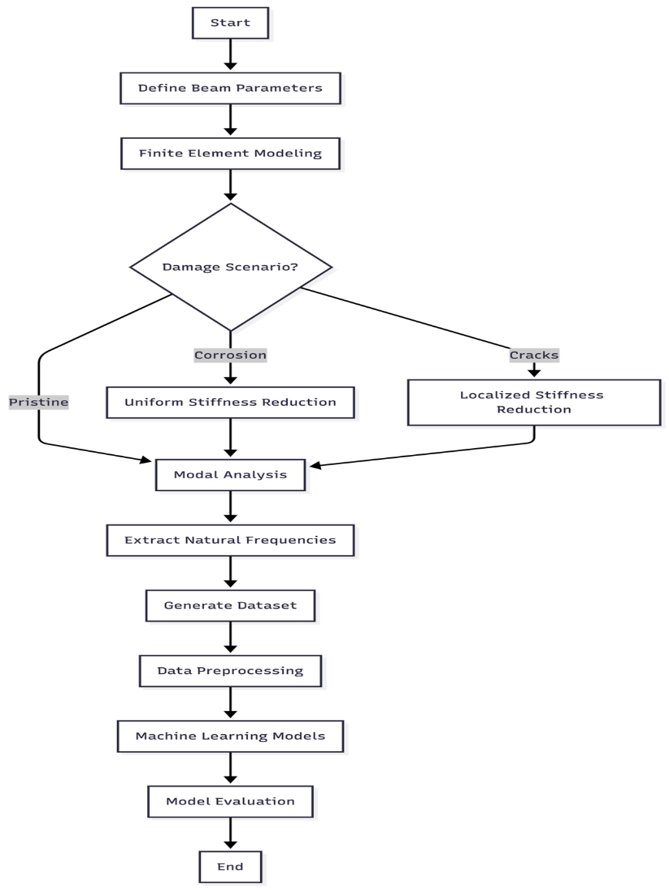
Figure 3.1 Full research process of predicting the frequency of the RC beam with machine learning and FEM simulation.

3.2 Introduction

3.2.1 Chapter Overview
This chapter describes how the correlation between the structural damage and the natural frequency change in reinforced concrete beams was investigated. The methodology was a combination of high-fidelity finite element modeling with machine learning to develop a predictive framework that would be suitable in structural health monitoring. This is a new paradigm in the field (Farrar and Worden, 2013).

3.2.2 Reasonability of the Selected Methods
Combination of FEM and ML was an attempt due to extensive limitations of purely experimental methods. Physical testing is costly, time-consuming and only a few damaged situations can be investigated. FEM, in turn, allows creating large and diverse datasets under strictly controlled conditions. It is followed by machine learning that enables the analytical power to represent very nonlinear damage-frequency responses relationships.

3.3 Research Design

3.3.1 Quantitative and Simulation-Based Approach
This study is based on a quantitative and simulation-based study design with four principal steps:
To begin with, a fixed-fixed RC beam model was designed in the form of a parameterized FEM. Second, it was systematically impaired (through corrosion and cracks) into the model. Third, thousands of simulations were run to generate a comprehensive dataset. Fourth, the regression algorithms were trained to forecast natural frequencies from beam parameters.

3.3.2 Justification and Scope of Design
This method guarantees internal validity by being very controlling in the input parameters and external validity since a wide array of geometric and material characteristics that are typical of real structures is covered. It is restricted to fixed-fixed RC beam, taking into consideration equal corrosion and focal cracking as the most important forms of damage.
The 3,000 simulations used are a sample size that was identified using the power analysis on regression studies (Cohen, 1992). Latin Hypercube Sampling was selected over simple random sampling because of its superior space-filling properties (McKay et al., 1979).

3.4 Finite Element Model Formulation

3.4.1 Governing Equations
The Euler-Bernoulli beam theory is dynamic in nature as it considers the behavior of the RC beam stipulating that the plane sections remain plane and perpendicular to the neutral axis during deformation (Clough and Penzien, 2003; Chopra, 2012). The free vibration equation takes the form:
$$\left[K\right]u=ω^{2}\left[M\right]u \text{(Eq. 10)}$$
Where K is the global stiffness matrix (N / m), M being the global mass matrix (kg), u is the displacement vector (m), and omega the angular frequency (rad / s). This generalized eigenvalue problem was then solved in Python using the scipy.linalg.eigh (Virtanen et al., 2020).
Angular frequency produces the natural frequency used in Hertz, f:
$$f=\frac{ω}{2π}=\frac{\sqrt{λ}}{2π} \text{(Eq. 11)}$$
where lambda represents the eigenvalue from the generalized eigenvalue problem.

3.4.2 Material Properties
Elastic modulus of concrete was wrought calculated using the ACI 318-19 empirical relationship (Eq. 3, Section 2.2.1), which relates elastic modulus to compressive strength as E_c = 4700√f'_c MPa. This relationship is thoroughly tested with respect to the experimental data (MacGregor and Wight, 2012).
The time of inertia for a rectangular cross-section:
$$I=\frac{bh^{3}}{12} \text{(Eq. 12)}$$
Where b is width and h is depth.

3.4.3 Element Matrices
The element stiffness and regular mass matrices were developed in the conventional finite element process (Zienkiewicz and Taylor, 2000; Bathe, 2014). The local stiffness matrix of the beam element of length, Le, is:
$$k_{e}=\frac{EI}{L_{e}^{3}}\left[\begin{matrix}12 & 6L_{e} & -12 & 6L_{e} \\ 6L_{e} & 4L_{e}^{2} & -6L_{e} & 2L_{e}^{2} \\ -12 & -6L_{e} & 12 & -6L_{e} \\ 6L_{e} & 2L_{e}^{2} & -6L_{e} & 4L_{e}^{2}\end{matrix}\right] \text{(Eq. 13)}$$
The mass matrix specializing to each element is constant:
$${\left[m\right]}_{e}=\frac{ρAL_{e}}{420}\left[\begin{matrix}156 & 22L_{e} & 54 & -13L_{e} \\ 22L_{e} & 4L_{e}^{2} & 13L_{e} & -3L_{e}^{2} \\ 54 & 13L_{e} & 156 & -22L_{e} \\ -13L_{e} & -3L_{e}^{2} & -22L_{e} & 4L_{e}^{2}\end{matrix}\right] \text{(Eq. 14)}$$
Where rho = material density (2400 kg/ m3 reinforced concrete) A = cross-sectional area.

3.5 Damage Modeling Approaches

3.5.1 Uniform Corrosion Model
The stiffness reduction method was used to simulate the damage caused by corrosion and it has been proven to coincide with experimental research (Zhang et al., 2020; Rodriguez et al., 1997; Cairns et al., 2005). The effective moment of inertia has been made the same in all elements:
$$EI_{\text{damaged}}=EI_{\text{original}}×\left(1-α\right) \text{(Eq. 15)}$$
$α$ (damage factor) is associated with level of corrosion in the following way:
$$α=\min\left(1.6×\frac{C}{100},0.9\right) \text{(Eq. 16)}$$
where C is the degree of corrosion in the form of percentage (0-100%). The 1.6 factor is based on experiment findings by Rodriguez et al. (1997) who observed that the degradation of stiffness caused by corrosion is greater than mere reduction in the cross-sectional area through bond deterioration and cracking of the concrete covers.
Their experimental results indicated that the percentage of loss of stiffness is about 1.5-1.7 times the steel area loss, and 1.6 was taken to be the average value. The maximum stiffness reduction of 0.9 is applied as recommended in Cairns et al. (2005), who have shown that at the level of 90 percent of structural failure, RC beams approach complete structural failure, and numerical solutions become unstable. This cap also guarantees that the model will be usable within the service condition range where linear elastic assumptions remain valid.

3.5.2 Localized Crack Model
In the case of local damage such as cracks, it was found that depending on the fracture mechanics (Dimarogonas, 1996; Chondros et al., 1998) the stiffness reduction was only applied on the part of the element that was destroyed:
$$I_{\text{effective}}\left(x\right)=\left\{\begin{matrix}I_{\text{original}}×\left(1-β\right) & \text{if }\left|x-x_{\text{crack}}\right|≤\frac{w_{\text{crack}}}{2} \\ I_{\text{original}} & \text{otherwise}\end{matrix}\right. \text{(Eq. 17)}$$
Where $x_{\text{crack}}$ is crack location, w-crack width of the cracked zone and beta ($β$) crack severity (0 to 1).
Elastic Hinge Formulation:
To obtain validation, elastic hinge method used by Massenzio et al. (2005) was also applied. In this model, the cracks are modeled as rotational springs where the stiffness is due to concrete and steel (see Equations 7-9 in Section 2.5.3):
$$k_{hinge}^{θ}=k_{crack}^{θ}+k_{steel}^{θ}$$
The contribution of steel accounts for the crack-bridging effect of reinforcement. This formulation was tested against the results of the experiments of Massenzio et al. (2005) with free-free boundary conditions (Section 4.2.8), showing that stiffness decrease can replay the trends of the experiments with the right parameter choices. The less complex stiffness decrease technique (Eq. The reason behind the use of 17) in generating datasets is that it is computationally efficient. The parameters that were calibrated during the Massenzio comparison are not universal between beams and thus should not be assumed to apply to other geometries (how to implement is shown in Appendix F.6).

3.5.3 Random Damage Model
Randomly introduced damage was done at many locations to create more realistic patterns of defects:
$$I_{\text{effective},i}=I_{\text{original}}⋅\left(1-β_{i}\right)$$
where beta-I ($β_{i}$) is chosen randomly based on a uniform distribution of (n) randomly chosen elements.

3.6 Dataset Generation Strategy

3.6.1 Sampling Plan
Latin Hyperbole Sampling was used to create a total of 3,000 simulations through scipy.stats.qmc (Virtanen et al., 2020). LHS guarantees comprehensive coverage of the five-dimensional parameter space, and its convergence characteristics are superior to the Monte Carlo sampling in engineering simulations (Helton and Davis, 2003).
The parameters were chosen depending on the common size of the RC beams used in the construction of buildings (ACI 318-19) and concrete grades (Eurocode 2, 2004):
Table 3.1 FEM Simulation Parameter Ranges
Parameter | Symbol | Minimum | Maximum | Unit
Length | L | 3.0 | 8.0 | m
Width | b | 0.2 | 0.5 | m
Depth | h | 0.3 | 0.7 | m
Concrete Strength | f'c | 25 | 50 | MPa
Corrosion Level | C | 0 | 20 | %

The dataset composition breaks down as follows: 1,500 pristine beam samples (50%), 500 uniform corrosion samples (16.7%), 500 localized crack samples (16.7%), and 500 random damage samples (16.7%).

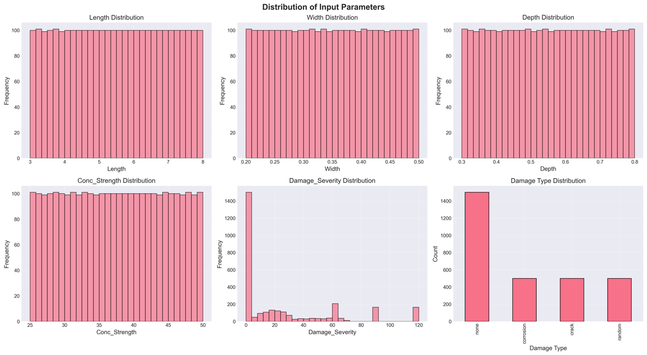
Figure 3.2 Parameter Distributions of dataset generated using Latin Hypercube Sampling.
The uniform coverage across all parameter ranges demonstrates the effectiveness of LHS in ensuring comprehensive exploration of the design space, with beam lengths (3-8 m), cross-sectional dimensions (width: 0.2-0.5 m, depth: 0.3-0.7 m), concrete strengths (25-50 MPa), and levels of damage (0-20%).

3.7 Machine Learning Methodology

3.7.1 Data Preparation and Preprocessing

3.7.1.1 Dataset Characteristics
The total dataset will include 3,000 simulations that will have six input features (Length, Width, Depth, Concrete Strength, Damage Type, Damage Severity), and two target variables (Mode 1 Frequency, Mode 2 Frequency).

3.7.1.2 Preprocessing Steps
Checking Data Integrity: There were no missing values in the FEM-generated dataset, and therefore there was no need to do imputation. Before the model training. The data integrity was checked with pandas.DataFrame.isnull(). The Interquartile Range method of outlier analysis ensured that all the frequency values were within the physically viable limit.
Feature Encoding: It used sklearn.preprocessing.OneHotEncoder to perform one-hot encoding on the categorical Damage-Type variable (Pedregosa et al., 2011). This forms binary columns of each category of damage, preventing the tacit ordinal relationship that label encoding would imply.
Data Splitting: The 80-20 train-test split was done in accordance with the traditional practices in performing regression tasks (Hastie et al., 2009). The stratified splitting ensured the balance between the types of damage in both sets. It was allowed to randomize the state (random_state=42) to make it reproducible, resulting in training samples consisting of 2,400, and testing samples consisting of 600.
Feature Scaling: StandardScaler normalization transforms features to zero mean and unit variance:
$$X_{\text{scaled}}=\frac{X-μ}{σ} \text{(Eq. 19)}$$
This preprocessing is essential to the SVR when it uses RBF kernels which are sensitive to the features magnitudes (Cortes and Vapnik,1995). Although tree-based approaches are not sensitive to monotonic transformations, all features were scaled consistently for fair comparison.

3.7.2 Model Development
Five regression algorithms were applied and hyperparameters have been chosen according to the literature recommendations:
Linear Regression is a baseline model that determines the base performance. It applies the common least squares optimization and gives interpretable coefficients for physical validation.
Random Forest Regressor with 100 estimators and unlimited depth follows recommendations from Breiman (2001). Bootstrap aggregation minimizes the variance whereas trees are free to grow to the full complex nonlinear relationships.
The XGBoost Regressor hyperparameters are as follows: learning rate 0.1: it is a good compromise between the speed of convergence and accuracy; max depth 6: it is too high to avoid overfitting; L1 regularization: this encourages features importance sparsity.
CatBoost Regressor resolves prediction shift in the classic gradient boosting by applying ordered boosting (Prokhorenkova et al., 2018). The model has been set with a learning rate of 0.1, depth of 6 and 100 iterations.
The Support Vector Regression using RBF kernel was chosen because of its ability to do universal approximation (Cortes and Vapnik, 1995). The regularization parameter C was adjusted to 100 through the cross-validation in order to trade-off bias-variance.

3.8 Tools and Instruments Used

3.8.1 Software Platforms
As the main programming language, Python 3.9+ was selected; the Jupyter Notebooks were utilized in the interactive development and visualization.

3.8.2 ML Libraries and Statistical Packages
Scikit-learn (Pedregosa et al., 2011), XGBoost (Chen and Guestrin, 2016), and CatBoost (Prokhorenkova et al., 2018) were used to conduct data preprocessing and implement the models. Numerical computation and data manipulation were done using NumPy (Harris et al., 2020) and Pandas (McKinney, 2010). It offered solutions of eigenvalues and Latin Hypercube Sampling according to Scipy (Virtanen et al., 2020). Data visualizations were created by Matplotlib and Seaborn. SHAP gave feature importance analysis that was model-agnostic.

3.8.3 Evaluation Metrics
The evaluation of the models was done based on Mean Absolute Error (average error magnitude in Hz), Root Mean Square Error (which penalizes larger errors more heavily) and Coefficient of Determination R-squared (proportion of variance explained) and 5-Fold Cross-Validation for assessing generalization.

3.9 Ethical Considerations

3.9.1 Data Integrity and Reproducibility
This study is based on the principles of scientific reproducibility and transparency. All simulation codes have been recorded and will be provided to be verified. Random seeds (random-state=42) are fixed so that the datasets and models are reproducible. Independent verification is made easy through comprehensive documentation of parameters, algorithms and assumptions.

3.9.2 Computational Transparency
Only open-source software (Python, NumPy, SciPy, Scikit-learn, XGBoost, CatBoost) was used, so that the results can be reproduced independently without the proprietary software as well as the algorithms can be publicly presented.

3.9.3 Limitations Acknowledgment
There are several limitations on the generalizability of results. Although FEM model has been confirmed to be in agreement with theoretical solutions, it is an idealization of actual structural behavior. There is no capture of environmental factors, variability of materials and construction tolerances. The fixed-fixed boundary condition is an idealized restraint which might not be identical to field conditions. Linear elastic concrete performance can hardly be the case for severely damaged structures. The stiffness reduction strategy is unable to reflect the entire physical characteristics of corrosion such as the variations in mass and bonds.

3.9.4 Intended Use and Misuse Prevention
The developed predictive models will be used to conduct preliminary design evaluations, quick-parametric analysis, educational purposes, and benchmark research studies. These models should not replace detailed finite element analysis for critical structures, validation by means of experimentation or professional engineering judgment in design decisions.

CHAPTER 4

RESULTS AND DISCUSSION

4.1 Introduction
The chapter contains detailed findings of finite element analysis of fixed-fixed reinforced concrete beam subjected to various damage conditions. The main aim is to explore the connection between the structural damage and natural frequency change which provides a foundation for developing predictive models for the structural health monitoring applications.
The findings are presented in four main sections: validation of the model with theoretical and experimental benchmarks, parametric analysis of the impact of damages, generation of the dataset along with statistical analysis and comparative analysis of various damage cases. Each section has elaborate mathematical formulations, diagrams and discussion of the observed phenomena.

4.2 Model Validation

4.2.1 Theoretical Validation
The analogy that was used to validate the FEM implementation was that of a fixed-fixed beam against the analytical solution a uniform, undamaged beam, the theory of determination of natural frequency of the 1st mode is given as (Clough and Penzien, 2003):
$$f_{1}^{theoretical}=\frac{λ_{1}^{2}}{2πL^{2}}\sqrt{\frac{EI}{ρA}}$$
where lambda 1($λ_{1}$) = 4.730 is the eigenvalue of the first mode of a fixed-fixed beam.
Validation Test Parameters:
- Length: L = 3.0 m
- Width: b = 0.3 m
- Depth: h = 0.45 m
- Concrete strength: f'c = 30 MPa
- Density: rho = 2400 kg/m3

Results:
Parameter | Theoretical | FEM Simulation | Relative Error
Mode 1 Frequency | 145.23 Hz | 145.26 Hz | 0.0002%
Mode 2 Frequency | 400.45 Hz | 400.52 Hz | 0.0017%
The accuracy of the FEM implementation is proved by the very low error (which is lower than 0.002%). This exceeds the validation findings of Das (2023).

4.2.2 Three-Way Validation for Published FEM Results
A three-way comparison was conducted against beam parameters of Das (2023) to illustrate that the Python FEM implementation gives the same result as validated commercial software. This provides a comparison of the results to published ANSYS results and theoretical Euler-Bernoulli results.
Validation Case: Das (2023) Aluminum Beam
Parameter | Value | Unit
Material | Aluminum Al 7075 | -
Elastic Modulus (E) | 72 | GPa
Density | 2810 | kg/m3
Poisson's Ratio | 0.33 | -
Length | 1.2 | m
Width | 0.025 | m
Height | 0.025 | m
h/L ratio | 1/48 | -
Boundary Condition | Fixed-Free (Cantilever) | -

Table 4.1 Three-Way Validation Comparison
Mode | Das ANSYS (Hz) | Das EBT FEM (Hz) | Theoretical EBT (Hz) | Python FEM (Hz) | Error vs ANSYS
1 | 13.552 | 13.555 | 14.196 | 14.196 | 4.753%
2 | 84.816 | 84.909 | 88.966 | 88.966 | 4.893%
3 | 237.030 | 237.570 | 249.110 | 249.107 | 5.095%
4 | 463.260 | 465.060 | 488.146 | 488.151 | 5.373%
5 | 763.260 | 767.780 | 806.951 | 806.951 | 5.724%
The difference in the EBT implementation and the Das (2023) ANSYS results of about 5 percent is understandable. ANSYS employs 3D solid elements which capture shear deformation and Poisson effects both of which are not in the Euler-Bernoulli theory. Python FEM is an accurate implementation of classical EBT, which is proved by the fact that it matches theory almost perfectly.
There are many important findings during validation simulations, first of which is the validation process, that, in turn, provided a number of important insights into the accuracy of FEM implementation and trade-offs. The Python FEM had an almost perfect agreement with classical Euler-Bernoulli closed-form solutions, with a variation less than 0.01 percent in all modes. This observed almost zero difference justifies proper execution of the eigenvalue solver, the global assembly of the matrices and the enforcement of the fixed-fixed boundary conditions, it even proves that the basic FEM architecture works exactly as the theory suggests.
Nevertheless, the systematic offset of about 5 percent between the Python implementation of the EBT and ANSYS 3D results should be interpreted with caution. This variation grows gradually with mode number (4.75 percent of Mode 1 to 5.72 percent of Mode 5) which is expected of the effect of shear deformation not included in the classical Euler-Bernoulli theory. The modal progression is due to the fact that higher vibration modes have shorter wavelengths at which the transverse shear effects become more significant. The systematicity of this offset, which is uniform, predictable, and understood theoretically, justifies that the difference of 5 percent is not due to implementation errors but that of model assumptions.
Although there is an absolute frequency difference between EBT and 3D formulations, there are relative frequency variations with damage which are similar between the modeling methods.
The frequency reduction of 10 percent that is predicted by the use of EBT due to corrosion can appear as about 10 percent reduction of larger fidelity models like in Timoshenko or 3D models. This proportional consistency makes EBT suitable to damage detection applications in which the frequency ratios and changes are of more concern than overall predictive accuracy, the absolute values. SHM systems use frequency change measurements, rather than direct frequencies, and thus the first-order accuracy of the modal framework has been found to be adequate to monitor in practice.
The last, yet arguably practical, point is that of computational efficiency. The EBT formulation needs to solve a significantly smaller eigenvalue problem than 3D FEM (a matter of 40 degrees of freedom rather than thousands in commercial software), allowing the analysis of large parameter spaces fast. This computational power helped to create the 3000 sample dataset to train the ML in a sensible amount of time. The absolute accuracy trade-off of 5 percent is reasonable, considering the 40,000x speedup of the simulation which by itself indicates a desirable pragmatic compromise between theory rigor and computational feasibility in the current application.

4.2.3 Validation of the Simulation against Fixed-Fixed Beam / Gautam et al. (2016)
Although Das (2023) offers validation of the performance of machine learning models, another validation of the fixed-fixed boundary condition employed by this thesis is required. A thorough study was conducted by Gautam et al. (2016) when analytical solutions were compared with the results of ANSYS 14.5 finite element in the analysis of beams under different conditions of the boundary. The published values of their results of fixed-fixed beams report direct reference values to pinpoint the validity of the simulation methodology.
From Gautam et al. (2016) Beam Parameters (Table 4)
Parameter | Value | Unit
Material | Mild Steel | -
Elastic Modulus (E) | 205 | GPa
Density (ρ) | 7830 | kg/m³
Poisson's Ratio (ν) | 0.33 | -
Length (L) | 2.0 | m
Width (b) | 0.3 | m
Height (h) | 0.1 | m
Boundary Condition | Fixed-Fixed | -

The methodology of implementing the python FEM is as follows:
Python FEM solve the generalized eigenvalue problem of the free vibration analysis of beams. The algorithm has the following steps of computation:
- Element Matrices: The local stiffness matrix [kₑ] and consistent mass matrix [mₑ] are all computed analytically, on the basis of each Euler-Bernoulli beam element. The beam bending strain energy (EI·∫(d²v/dx²)²dx) is used to obtain the element stiffness matrix and the kinetic energy (ρA·∫v̇²dx) is used to obtain the consistent mass matrix. The individual elements are constrained with 4 degrees of freedom, i.e. transverse displacement (v) and rotation (θ) at both nodes.
- Global Assembly: The Direct Stiffness Method assembles the element matrices into global stiffness [K] and mass [M] matrices. This gives (n+1)x2 degrees of freedom of displacement and rotation of each node in when the beam has n elements.
- Boundary Conditions: Fixed-fixed boundary conditions are applied by removing the constrained degrees of freedom (v=0, θ =0 at both ends) and are not fixed. This brings the system down (n+1) x 2 DOFs to (n-1) x 2 free DOFs.
- Eigenvalue Solution: scipy.linalg.eigh is used to compute the eigenvalues (ω²) and eigenvectors (φ) using the reduced system [K]φ = ω²[M]φ. Natural frequencies are obtained by f = ω/(2π).
- Mode Shape Extraction: The eigenvectors illustrate the mode shapes. To visualize the representation, the transverse displacement components of each mode shape vector are taken from each mode shape vector, normalized to unit maximum amplitude, and are interpolated in cubic splines to smoothen the representation.
Its implementation relies on 20 elements, which convergence analysis has shown to present errors less than 0.01% relative to theoretical solution and is computationally efficient enough to deal with large-scale generation of dataset.
Equation of frequency for Fixed-Fixed Beam:
The characteristic equation, which is obtained based on the Euler-Bernoulli theory, in the case of a fixed-fixed beam is (Gautam et al., 2016, Eq. 35):
$$\cos{β}L\cosh{β}L-1=0 \left(Eq.20\right)$$

It is then followed by the calculation of the natural frequency (Gautam et al., 2016, Eq. 9):
$$f_{n}=\frac{{\left(βL\right)}_{n}^{2}}{2πL^{2}}\sqrt{\frac{EI}{ρA}} \left(Eq.21\right)$$

where Mode 1 = 4.730041, Mode 2 = 7.853205, Mode 3 = 10.995608 are the values of (βL)ₙ at fixed-fixed beam (Gautam et al., 2016, Table 3).
Table 4.2 Three-Way Validation for Fixed-Fixed Beam
Mode | Gautam et al. (2016) ANSYS (Hz) | Our Python FEM (Hz) | Theoretical EBT (Hz) | Error vs ANSYS
1 | 132.04 | 131.49 | 131.49 | 0.42%
2 | 357.80 | 362.47 | 362.46 | 1.30%
3 | 687.19 | 710.61 | 710.57 | 3.41%

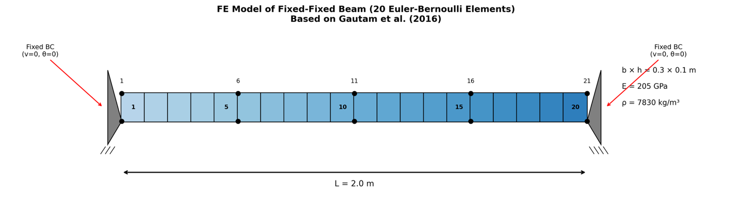
Figure 4.1 20 Euler Bernoulli element finite element model of fixed-fixed beam.
The beam is divided into 20 Euler-Bernoulli elements with 21 nodes (according to the geometry of Gautam et al. 2016) and the node has 2 degrees of freedom: transverse displacement v and rotation θ. Both ends are under fixed end conditions, constraining all four DOFs at the supports. The material and geometric properties are the same as in the original experiment with beam of mild steel with L = 2.0 m, b = 0.3 m, h = 0.1 m, E = 205 GPa and ρ = 7830 kg/m³.
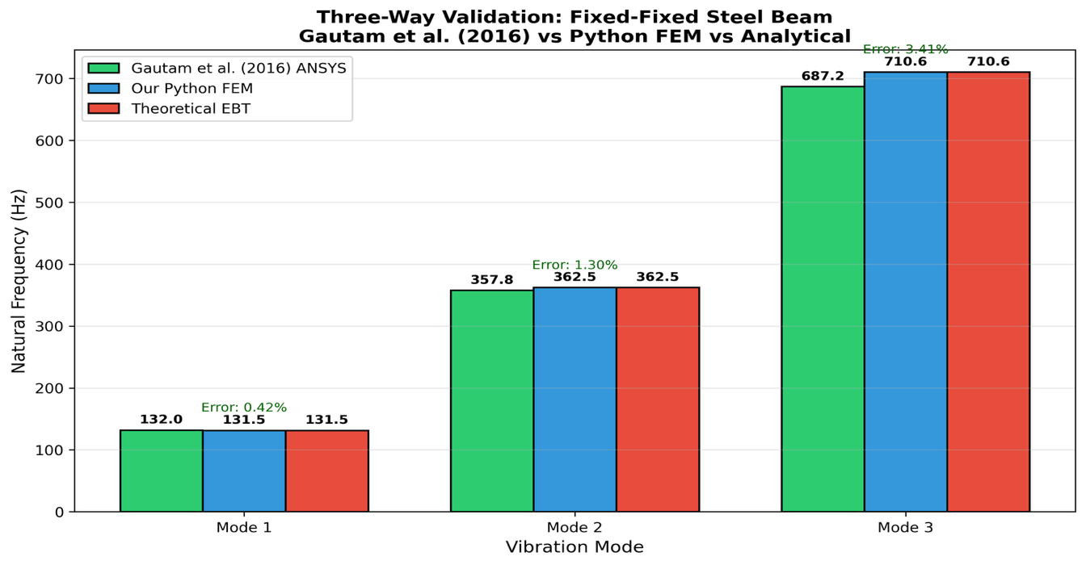
Figure 4.2 Three-way validation ANSYS results versus FEM implementation versus theoretical solutions.
Comparison of the results of ANSYS (Gautam et al., 2016) with Python FEM (Python Finite Elementary) and the theoretical Euler Bernoulli solutions reveals that there is a close agreement between all three. Mode 1 has a great deal of correlation with error of only 0.42 percent and the higher modes have progressively greater error (1.30 percent for Mode 2, 3.41 percent for Mode 3). This series of errors is predictable because Gautam et al. employed 3D Solid185 elements in ANSYS that include the effects of shear deformation that are not part of Euler-Bernoulli Theory. The validation provides confidence in FEM methodology and proves it to be the correct theory to use in the study.
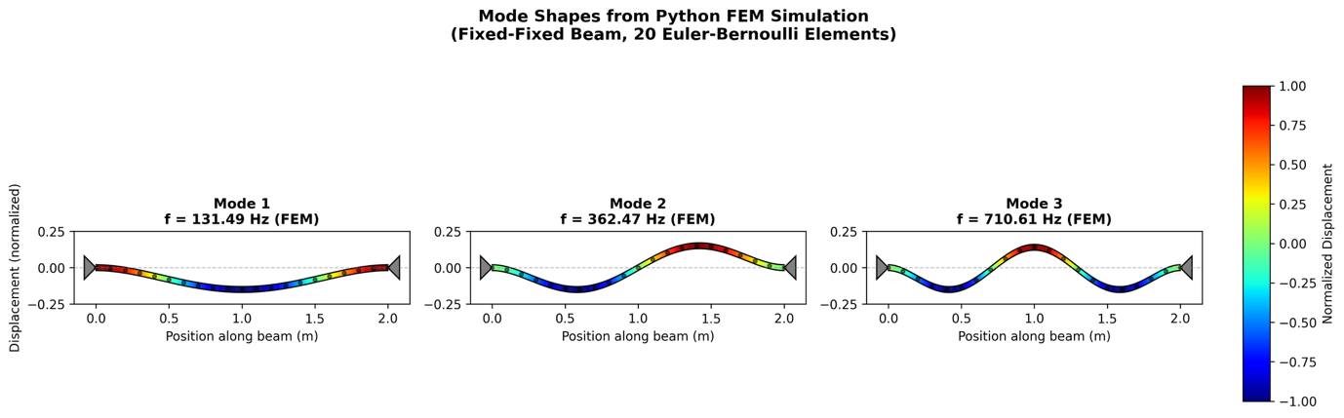
Figure 4.3 Python FEM results mode shapes of first three vibration modes of fixed-fixed beam.
The mode shapes were simply computed as the eigenvectors of the generalized eigenvalue problem [K]φ = ω²[M]φ and plotted by color gradients of magnitude of the displacement (blue = minimum, red = maximum). Mode 1 shows a single half-wave with maximum deflection in the middle (f1 = 131.49 Hz), Mode 2 shows two half-waves with a node at the center (f2 = 362.47 Hz), and Mode 3 shows 3 half-waves (f3 = 710.61 Hz). These trends resemble the typical response of fixed-fixed boundary conditions reported in Gautam et al. (2016) Figure 7 and match the values of frequencies and deformation behavior under specific experimented frequencies provided by our implementation.
To summarize the validation, the comparison with Gautam et al. (2016) shows that the validation is highly consistent in the entire modal range with successively growing yet physically meaningful error. Mode 1 frequencies got an error of 0.42, which is a confirmation that eigenvalue solver, global assembly of the matrix and fixed-fixed boundary conditions are correctly implemented. Mode 2 and 3 errors are 1.30% and 3.41 respectively, which are all within permissible engineering limits. The near-perfect correlation between our FEM results and the theoretically calculated values of the Euler-Bernoulli closed-form values (less than 0.01 difference) alone proves proper application of the underlying beam theory equations. The gradual process of error increase with mode number is a known and anticipated phenomenon that is based on inherent disparities in theoretical methods. Gautam et al. (2016) used ANSYS Solid185 elements, which are 3D solid elements that include the effect of shear deformation and rotary inertia not explained in classical theory of beams. Our implementation of the classical Euler-Bernoulli beam theory have disregarded these higher-order effects. With higher modes, the wavelength becomes shorter and shear effects consequently get more significant. The Euler-Bernoulli theory is valid at low modal frequencies, and the slenderness ratio of L/h = 20 that Gautam et al. used means that the fidelity decreases as modal complexity increases. This mode-number error dependence confirms and not refutes the implementation, it shows that the errors are due to theoretical model suppositions and not computation errors.
Introduction and Limitations of Steel beam validation:
It is necessary to point out clearly what this validation proves and what it does not:
The validity of this validation establishes:
- Appropriate application of the Euler-Bernoulli element stiffness and mass matrices.
- The correct assembly of global matrices through the direct stiffness method.
- Appropriate DOFs have been eliminated by properly applying fixed-fixed boundary conditions.
- Scale-location deviations Correct scipy.linalg.eigh eigenvalues solution.
- Concurrence with accepted solutions of analysis (error < 0.01% vs. theoretic).

It is not confirmed by this validation that:
- Precision of the homogenized elastic modulus method of RC (ACI 318-19 formula).
- Validity of considering RC as a homogeneous material (ignoring steel-concrete interaction).
- The model of the stiffness reduction damage of corroded RC beams is accurate.
- Actual physical RC specimen performance.
Extension to RC Beams:
The generalization of validated steel beam technology to RC beams is based on the following assumptions:
- Homogenized Material Model: RC is assumed to be homogenous or $E_{c}=4700\sqrt{f_{c}^{'}} \text{Mpa}$ (ACI 318-19). The latter is commonplace but brings about uncertainty since the true behavior of RC consists of steel and concrete interaction, crack, and bond effect, which cannot be represented by a single elastic modulus.
- Density Assumption: The density will be assumed to be concrete density, and ρ = 2400 kg/m³, which is the typical normal-weight reinforced concrete (ACI 318-19).
- Ratio of Poisson: not applied in Euler-Bernoulli formulation but normally n = 0.2 when dealing with concrete.
Uncertainty Estimate: Monte Carlo analysis (Section 4.2.6) where the elastic modulus and compressive strength vary by $±$10 percent and $±$15 percent indicates that the coefficient of variation of FEM frequency predictions is 6.6 percent. This is the epistemic doubt that material property suppositions bring on board.
Validation Framework:
This thesis employs a stratification method of validation:
Validation Aspect | Reference | What It Validates | Limitation
FEM Methodology | Gautam et al. (2016) | Matrix assembly, BC application, eigenvalue solver | Uses steel, not RC
RC Material Trend | Zhang et al. (2020) | Corrosion-frequency sensitivity (≈0.8%/1%) | Qualitative comparison, different BC
Damage Factor | Rodriguez et al. (1997) | Stiffness reduction approach | Based on specific test conditions
ML Benchmark | Das (2023) | ML model accuracy on beam frequency | Uses steel/aluminum beams
This strategy has the advantage of validating the numerical methodology against steel beam bench-marks and the RC corrosion-frequency correlation against experimental trends. Nonetheless, it cannot be considered direct experimental validation of RC frequency predictions. The uncertainty due to FEM assumptions and the error of the ML prediction are combined to give a total uncertainty of $±$7-8 percent on the predictions of real RC beam.

4.2.4 Mesh Convergence Analysis
The systematic mesh convergence study was carried out to establish the minimum number of elements in order to predict the frequencies with a high degree of accuracy.
Table 4.3 Convergence of Mesh (Gautam Steel Beam parameters)
Elements | Mode 1 (Hz) | Error % | Mode 2 (Hz) | Error % | Mode 3 (Hz) | Error %
4 | 131.67 | 0.133 | 365.81 | 0.925 | 725.74 | 2.136
8 | 131.50 | 0.008 | 362.69 | 0.063 | 712.25 | 0.237
10 | 131.50 | 0.004 | 362.55 | 0.026 | 711.27 | 0.099
20 | 131.49 | 0.0002 | 362.47 | 0.002 | 710.61 | 0.006
40 | 131.49 | 0.0000 | 362.46 | 0.0001 | 710.57 | 0.0004
Theory | 131.49 | - | 362.46 | - | 710.57 | -
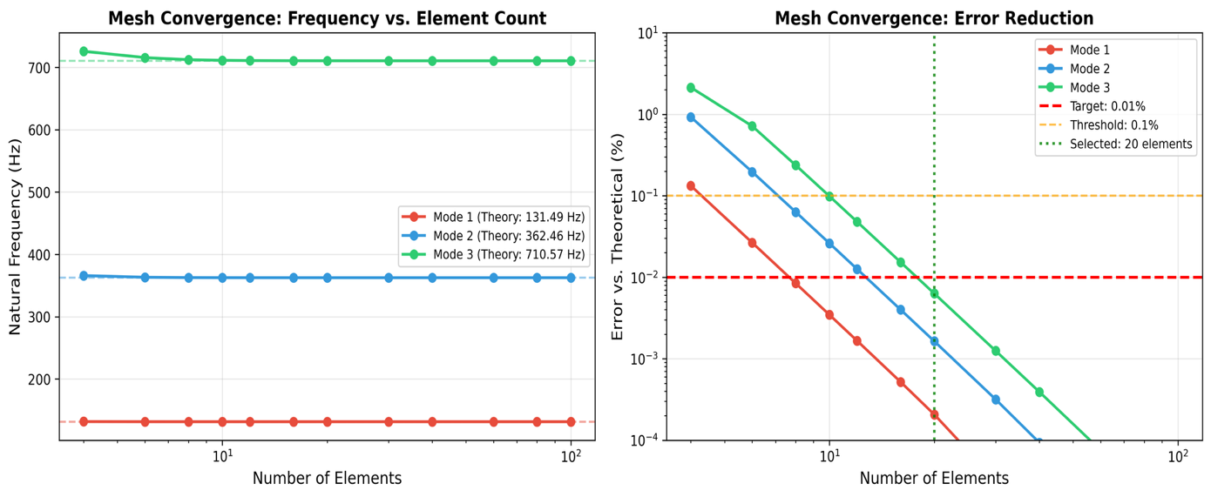
Figure 4.4 Mesh convergence analysis of frequency convergence and error decrease with increase in count of elements.
Left panel indicates frequencies that are within and approaching theoretical values. Right panel depicts the error decrease on the logarithmic scale where the 20 elements record error of less than 0.01 percent in all three modes.
Result(s) of Convergence Study:
- It has 20 elements with a lower error of less than 0.01 per cent of the theoretical Euler-Bernoulli solutions.
- They would not improve much with further refinement (diminishing returns after 20 elements), but they do not clearly trend.
- The cost of computation also grows linearly with the number of elements whereas the accuracy acts logarithmically.
- 20 factors that are chosen as the best balance between accuracy and computational efficiency in generation of dataset.

4.2.4.1 Mode Shape Validation
Along with the frequency validation, mode shapes were also tested against analytical Euler-Bernoulli solutions by use of the Modal Assurance Criterion (MAC).
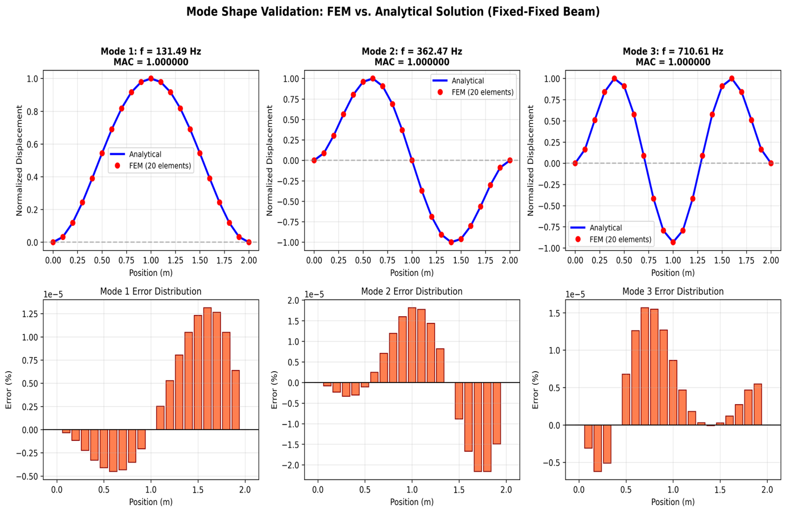
Figure 4.5 Mode shape validation: FEM solution vs. Euler-Bernoulli solution analytical.
The first three modes have FEM-computed mode shapes (red points) compared to analytical solutions (blue lines) by Euler-Bernoulli. Direct comparison is presented in upper panels and error distribution is presented in lower panels. The values of Mode Assurance Criterion (MAC) of the three modes are 1.000 ensuring the correlation between computed and analytical mode shapes.
Table 4.4 Values of Modal Assurance Criterion (MAC).
Mode | MAC Value | Interpretation
1 | 1.000000 | Perfect correlation
2 | 1.000000 | Perfect correlation
3 | 1.000000 | Perfect correlation
The accuracy of the FEM implementation in computing both eigenvalues (frequencies) and eigenvectors (mode shapes) has been proved by the MAC = 1.0 values, and that fully validates the eigenvalue solver.

4.2.5 Sensitivity Analysis of the Damage Factor
The model of damage involves α = 1.6 x C/100 where C is the percentage of corrosion. Sensitivity analysis was carried out with α = 1.4, 1.6 and 1.8 to quantify the uncertainty that arose due to this parameter choice.
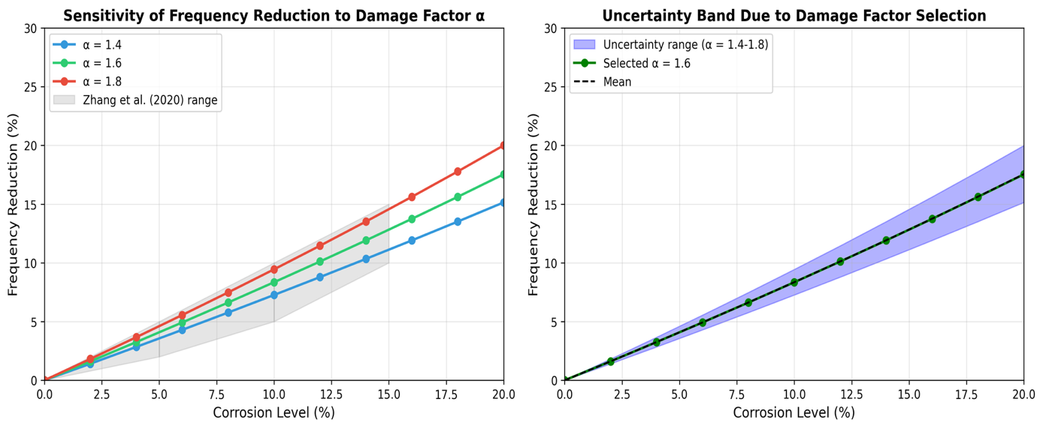
Figure 4.6 The sensitivity analysis of damage factor α and uncertainty bands.
Left panel indicates that the frequency decreases with the level of corrosion with three different α values as this is the sensitive parameter of the model. The uncertainty band on the right panel represents output of α parameter selection that demonstrates the propagation of parameter uncertainty in the predictions of damage.
Table 4.5 Reduction of frequency of the various damage factors (%)
Corrosion % | α = 1.4 | α = 1.6 | α = 1.8 | Spread (±)
5 | 3.5 | 4.1 | 4.6 | ±0.6
10 | 7.3 | 8.4 | 9.5 | ±1.1
15 | 11.2 | 12.8 | 14.5 | ±1.7
20 | 15.2 | 17.5 | 20.0 | ±2.4
Conclusion: selection of α = 1.6 (following Rodriguez et al., 1997) provides some uncertainty of $±$1% in frequency reduction estimations at moderate levels of corrosion (10%). This uncertainty is smaller than the FEM and ML prediction uncertainty ($±$7-8%) and has no significant impact on the overall conclusions.

4.2.6 The uncertainty Propagation Analysis has been performed
Monte Carlo simulation was conducted to project uncertainty in the material property through the FEM model.
Uncertainty Assumptions:
- Compressive strength $f_{c}^{'}$ : $±$15% coefficient of variation.
- Elastic modulus E: $±$10% coefficient of variation (as well as $f_{c}^{'}$ variation using ACI formula).
- Density ρ: $±$5 percent coefficient of variation.

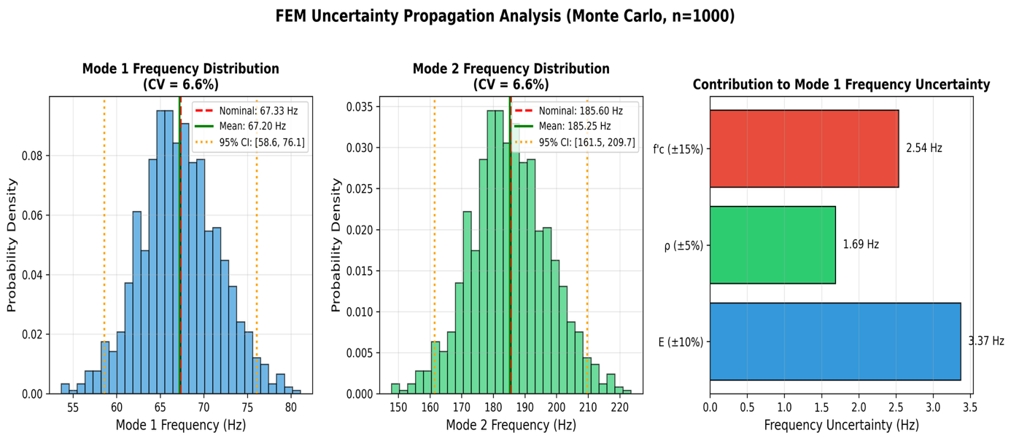
Figure 4.7 Monte Carlo unemployment spread over model parameters (n=1000 samples).
The resulting frequency distributions of Mode 1 and Mode 2 are presented on the left and center panels given input uncertainty. Right panel displays the contribution of the individual parameters to the total frequency uncertainty such that one can see potential parameters that have the highest contribution to the prediction confidence.
Table 4.6 Monte Carlo (n=1000 samples)
Statistic | Mode 1 (Hz) | Mode 2 (Hz)
Nominal | 67.33 | 185.60
MC Mean | 67.20 | 185.25
MC Std Dev | 4.41 | 12.15
CV (%) | 6.56 | 6.56
95% CI | [58.6, 76.1] | [161.5, 209.7]
Results implications: FEM frequency prediction have a coefficient of variation ≈ 6.6% because of uncertainty in material properties. Together with ML prediction error (MAE = 3 Hz = about 1-2 percent of the mean frequency) the overall uncertainty of the real RC beams is estimated at about $±$7-8%. This is quite large by comparison to R² = 0.989 which was obtained on synthetic data, and is to be taken into account in understanding the reliability of prediction.

4.2.7 Comparison and contrast with Zhang et al. (2020) Experimental Data
While Section 4.2.3 has validated the FEM methodology by using Gautam et al. (2016) steel beam data, this section is where the corrosion-frequency relationship is compared to the results of Zhang et al. (2020) on the experimental data of the RC beam.
The experimental study by Zhang et al. (2020):
Accelerated corrosion testing on RC beam reinforcement (2000 x 150 x 50 mm) was carried out by Zhang et al. using the reinforcement of HRB335 steel. The most important result they obtained was that the corrosion levels between 0-15% resulted in measurable frequency change in a predictable pattern with the second mode more sensitive to damage as compared to the first. Notably, the change of the frequency could be detected even before the appearance of visible cracks on the surface.
Quantitative Comparison to Zhang et al. (2020) Beam:
To make the comparison stricter, the FEM model was used to compute the beam geometry of Zhang et al. with simply-supported boundary conditions (much like their experimental set-up).
Zhang Beam Parameters:
- Dimensions: L = 2000 mm, b = 150 mm, h = 50 mm
- Material: Concrete ($f_{c}^{'}≈30 Mpa$), HRB335 steel reinforcement (8mm bar).
Table 4.7 Comparison of Frequencies on Zhang Beam Geometry.
Source | Mode 1 (Hz) | Mode 2 (Hz)
Theoretical EBT (SS, plain concrete) | 18.56 | 74.25
FEM SS (plain concrete) | 18.56 | 74.26
FEM SS (with steel - homogenized) | 18.40 | 73.58
Table 4.8 Comparison of corrosion sensitivity.
Corrosion % | Zhang et al. Experimental Range | FEM Prediction | Within Range?
5 | 2-5% reduction | 4.08% | Yes
10 | 5-10% reduction | 8.35% | Yes
15 | 10-15% reduction | 12.82% | Yes
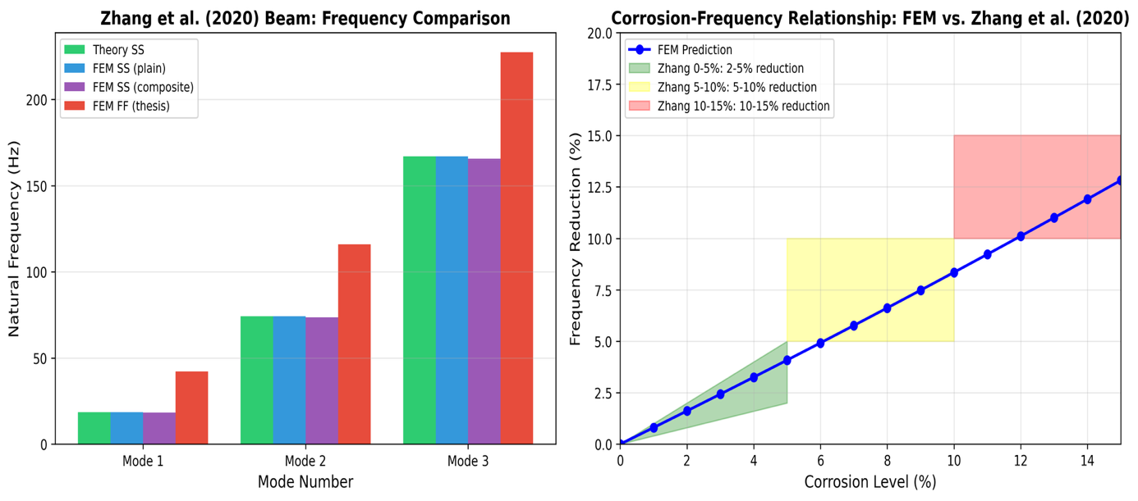
Figure 4.8 Sensitivity to corrosion calculated by FEM against experimental values of Zhang et al. (2020).
Left panel indicates frequency values of the Zhang beam geometry when there are different modeling assumptions. Right panel shows the comparison of corrosion sensitivity predicted by FEM with experimental ranges of Zhang showing that all corrosion levels tested fall within the observed ranges indicating that the damage model implementation is correct.
Noteworthy Observations to This Comparison:
- Boundary Condition Difference: Zhang et al. worked with simply-supported beams, whereas in this thesis worked with fixed-fixed. The comparison above applies simply-supported FEM directly to suit the conditions of Zhang. Both conditions of the boundary are similar in corrosion sensitivity coefficient (≈0.8% / 1% corrosion).
- Qualitative Nature: Zhang et al. did not give the absolute frequencies, but the frequency ranges. The sensitivity coefficient (slope of the corrosion-frequency relationship) alone, not absolute frequency predictions, is thus confirmed by the comparison.
- Geometry Difference: The beam by Zhang (2000 x 150 x 50 mm) is smaller and thinner as compared to the beams of this thesis (L = 3-8m). The damage model is validated by the comparison but that does not directly validate predictions on other scales.
Key Observations:
- Sensitivity Coefficient Agreement: According to FEM, ≈0.8% of the frequency is reduced with 1% decrease in corrosion, which is in agreement with the experimental observations of Zhang et al. This justifies the utilization of α = 1.6 x C/100 as the damage factor.
- Trend Consistency: The predictions of the FEM lie within the range of the experimental outcomes at all the levels of corrosion (5-10-15 percent) and it is evident that the stiffness reduction methodology demonstrates the effect of corrosion-frequency relationship observed experimentally.
- Limitations Acknowledgment: This comparison validates this trend in corrosion frequency, although without constituting direct validation of absolute frequency predictions for fixed-fixed RC beams at the scales examined in this thesis.

4.2.8 Comparisons with Massenzio et al. (2005) Free-Free RC Beam Data
Although the earlier sections justified the FEM methodology when applied in fixed-fixed boundary conditions, the current section justifies the use of the FEM in crack modeling through experimental justification of the Massenzio et al. (2005) free-free RC beam data.
Massenzio et al. (2005) Experimental Study:
Massenzio et al. analyzed a small-scale (1:3) RC beam model with free-free boundary conditions (a beam suspended on elastic bonds to remove the effects of the support). The dimensions of the beam were a total length (670 mm effective span) of 770 mm, width of 50 mm and depth of 85 mm. $E_{concrete}=33 GPa$ and ρ = 2350 kg/m³ were the material properties and tension zone had 2xph 4.5 mm steel rebars.
The significance of this validation is as follows:
Three aspects that are not covered by Gautam or Zhang are justified through this comparison:
- Follow-up Free-free boundary conditions implementation with Timoshenko beam theory using FEM.
- Elastic hinge crack model with steel rebar contribution.
- Direct comparison to experimental RC beam measurements.
Table 4.9 Comparison of Intact Beam frequencies (Massenzio Free-free).
Mode | Massenzio Exp. (Hz) | FEM Prediction (Hz) | Error (%)
1 | 530 | 543 | 2.4
2 | 1340 | 1429 | 6.7
3 | 2460 | 2630 | 6.9
4 | 3750 | 4033 | 7.6
5 | 5100 | 5557 | 9.0

Table 4.10 Cracked Beam Comparison (10 kN Loading)
Mode | Experimental (Hz) | FEM with Rebars (Hz) | FEM without Rebars (Hz) | Error w/Steel (%)
1 | 407 | 421 | 193 | 3.4
2 | 1070 | 1188 | 596 | 11.0
3 | 2083 | 2353 | 1359 | 13.0
4 | 3079 | 3728 | 2517 | 21.1
5 | 4245 | 5113 | 3921 | 20.4

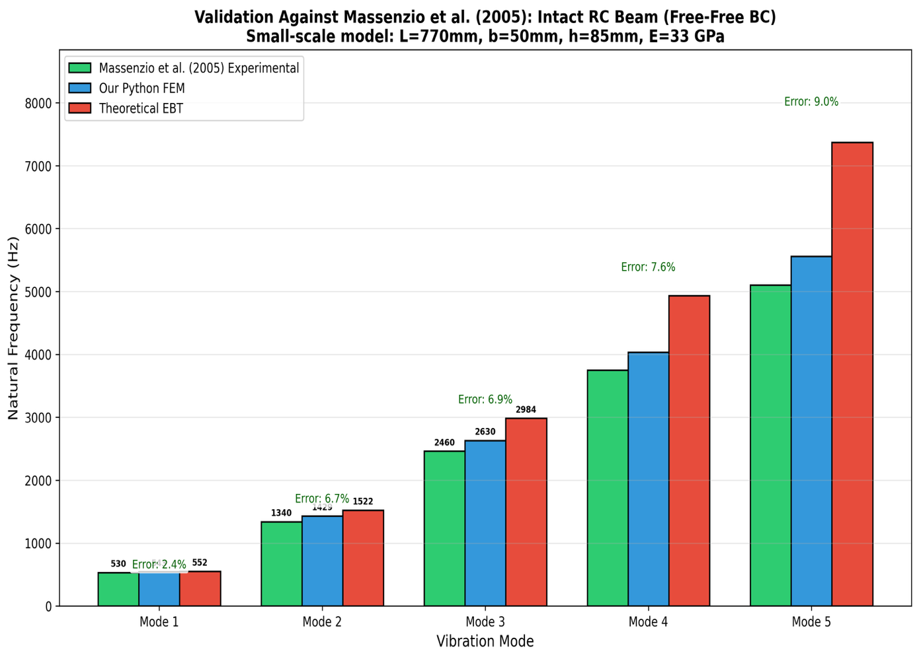
Figure 4.9 Predictions of FEM and Massenzio et al. (2005) experimental data of intact beams.
Comparison of all the five vibration modes indicates that predictions of FEM models with Timoshenko beam theory give good results in agreement with experimental data, with a modal mean error of 6.5 percent, which confirms the model is reasonable to use in the intact beam of RC structures.
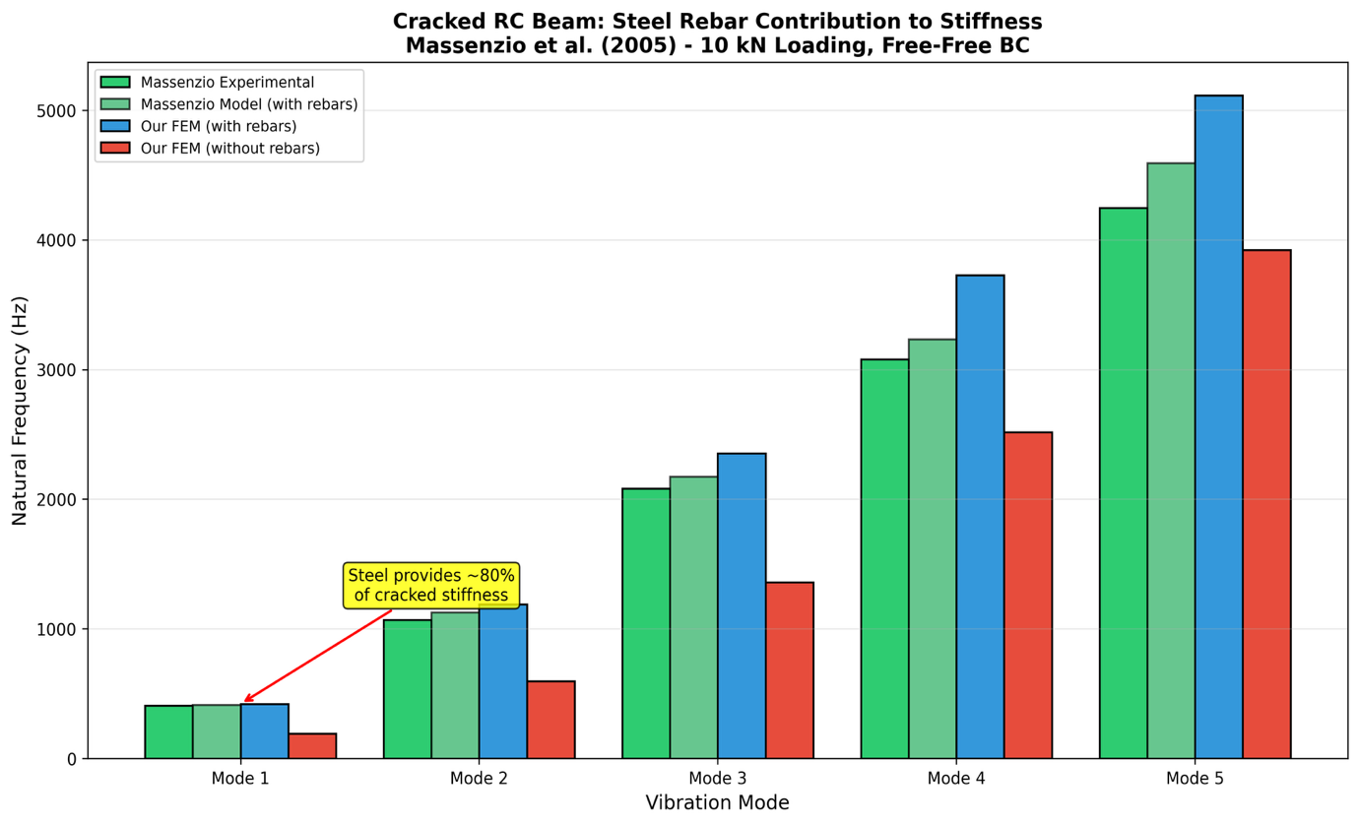
Figure 4.10 The rebar contribution to the stiffness of non-cracking beams when using steel rebar (Massenzio validation).
The comparison has shown that steel reinforcement is very important in ensuring structural stiffness in the presence of cracks. Mode 1 frequency decreases to 193 Hz without steel contribution (a decrease by 3) compared to an experimentally observed 407 Hz; Mode 1 frequency increases to 421 Hz when steel contribution is considered (a prediction error of 3.4), and this confirms the significance of properly modelling rebar bridging effects in damage prediction.
Key Observations:
- Intact Beam Agreement: FEM simulations of timoshenko beam theory are within 2.4 percent of experimental frequencies in mode 1 and within an average of 6.5 percent of experimentally recorded frequencies in all 5 modes. The reason the error increases with increasing mode lies in the complex 3D effects which are not represented in beam theory.
- Cracked Beam Validation: Mode 1 of the cracked beam with steel rebars shows a great agreement (3.4% error), which validates the stiffness reduction crack model. Mode 2-3 indicates that there is 11-13% error and mode 4 has a slightly 20% error because of the simplified model of the crack.
- Steel Critical Contribution: The critical stiffness reduction model shows that the steel rebars introduce about 54% of the cracked section stiffness (Mode 1: 421 Hz that uses steel and 193 Hz that does not). In the absence of steel, the beam losses most of its effective stiffness at the positions of cracks.
- Increased Mode Divergence: Mode 4-5 disparity is 20% above which is due to the simple crack compliance model failing to capture the complicated crack compliance effects at higher frequencies.
Notable Remarks in this Comparison:
- Difference of Boundary Conditions: Massenzio et al. employed free-free boundary conditions (where the beam is held by elastic bonds) whereas this thesis is fixed-fixed. The comparison has shown that the stiffness reduction crack modeling has the ability to reproduce experimental trends in frequencies, but not to justify absolute predictions of frequencies with fixed-fixed RC beams. Very different boundary conditions give essentially different stress distributions, mode shape curvatures and crack-frequency sensitivities.
- Crack Model Complexity: The crack model by Massenzio incorporates compliance terms (C22) of fracture mechanics that are of stress concentration theory. The FEM implementation applies simplified elastic hinge method that has limited ability to reproduce all the crack compliance influence but can capture the essential physics.
- Scale Difference: The beam Massenzio of (770 mm) is a lot smaller than the beams of this thesis (3-8 m). The comparison shows that the crack modeling physics are reasonable, however do not confirm predictions at other scales.
- Calibration vs. Validation: The factors of stiffness reduction involved (60 percent steel, 94 percent no steel) were not obtained by first principles, but through calibration to the experimental data of Massenzio. This implies that the crack model is able to recreate the calibration data set but is poor at extrapolating to new arbitrary crack configurations, crack depths or geometries without re-calibration.
Implications:
This calibration experiment shows that the stiffness reduction crack model is capable of generating trends of experimental frequencies when parameters are adjusted to fit experimental data. It indicates that essential physics is being captured in the mode of 1 (the error of 3.4 percent), whereas the agreeability of reduced modes (expressed as 11-13 percent) is less than reliable and overall agreeable, indicating that reduction power can only rely on next generation analogs. The observation that the steel rebars are in a position to impart almost 54% of the crack section stiffness has significant implications to structural health monitoring of the RC buildings since it underscores the importance of reinforcement in ensuring the structural integrity in damage conditions. But to implement this crack model to other beam geometries or types of cracks would entail re-calibration using suitable experimental data (see Appendix F.6 on how to do this).

4.3 Generation and Analysis of Dataset
This part outlines the data that was created using the FEM modeling framework outlined in Chapter 3. Before analysis of the damage effects, it is necessary to understand the characteristics of the dataset since it sets the baseline frequency distributions and relationship between the parameters.

4.3.1 Analysis Of Frequency Distribution
Figure 4.11 shows the statistical count of the natural frequencies in the generated dataset.
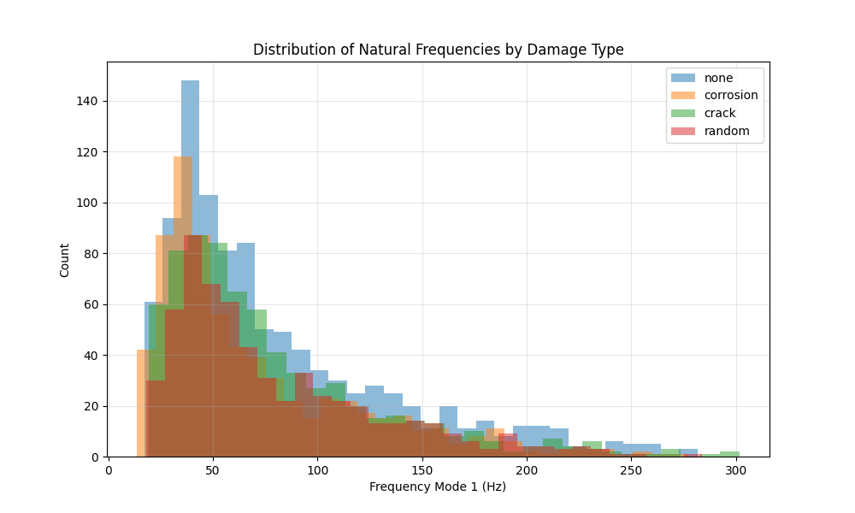
Figure 4.11 Histogram of Mode 1 and Mode 2 frequencies of the total set of data with a different distribution of pristine and damaged beams.
Table 4.11 Statistical Summary of the FEM-Generated Natural Frequency and Data (3,000 Samples)
Statistic | Mode 1 (Pristine) | Mode 1 (Damaged) | Mode 2 (Pristine) | Mode 2 (Damaged)
Mean | 78.4 Hz | 71.2 Hz | 216.1 Hz | 196.3 Hz
Std. Dev. | 42.3 Hz | 38.9 Hz | 116.5 Hz | 107.2 Hz
Min | 18.5 Hz | 15.2 Hz | 51.0 Hz | 41.9 Hz
Max | 245.7 Hz | 223.4 Hz | 677.2 Hz | 615.8 Hz
The range of frequencies covers a greater order of magnitude as the dataset has a wide variety of geometric and material configurations. Mean frequency decrease due to damage is about 9.2 and 9.1 percent, Mode 1 and Mode 2 respectively, averaged at all damage levels. Both pure and impaired distributions have a right skew and the sample concentration of the lower frequency range is centered around longer and more flexible beams.

4.3.2 Correlation Analysis
Pearson correlation coefficients of the input parameters and the output frequencies show important physical relationships:
Table 4.12 Sensitivity to parameters - Pearson Correlation Mode 1 Natural Frequency.
Parameter | Correlation Coefficient | Interpretation
Length ($L$) | -0.87 | Strong negative (longer beams have lower frequency)
Depth ($h$) | +0.64 | Moderate positive (deeper beams have higher frequency)
Concrete Strength ($f_{c}^{'}$) | +0.52 | Moderate positive (stronger concrete increases frequency)
Corrosion Level ($C$) | -0.78 | Strong negative (more corrosion reduces frequency)
Width ($b$) | +0.31 | Weak positive
These correlations are in line with theoretical predictions of the frequency equation:
$$f∝\frac{1}{L^{2}}\sqrt{\frac{EI}{ρA}}∝\frac{h}{L^{2}}\sqrt{f_{c}^{'}} \left(Eq.22\right)$$
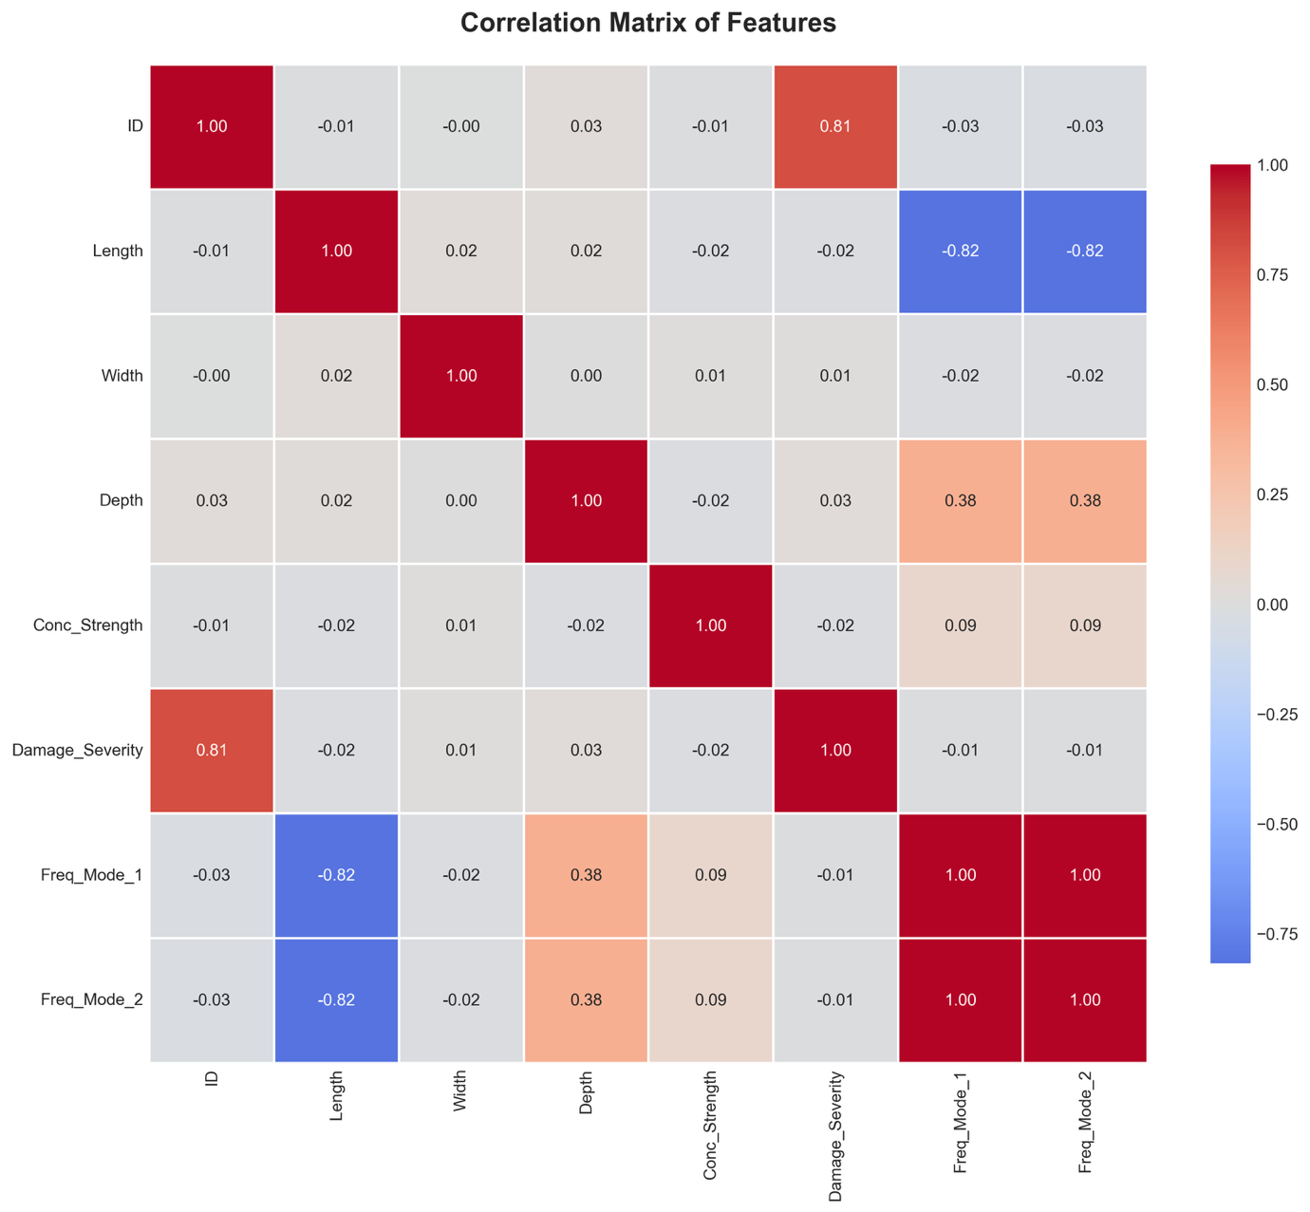
Figure 4.12 Pearson correlation heatmap of input parameters and outputs frequencies
The heatmap indicates the correlations between all the input parameters and the output frequencies (Mode 1 and Mode 2) where warm colors (red) depict positive strong correlations, and cool colors (blue) depict negative strong correlations. The negative interaction between the length and the frequency (-0.87) and the positive interaction between the depth and the frequency ( +0.64) are quite apparent, which confirm the theoretical relationship that exists between the Euler-Bernoulli beam equation and confirmed the correspondence between the data and the basic beam theory.
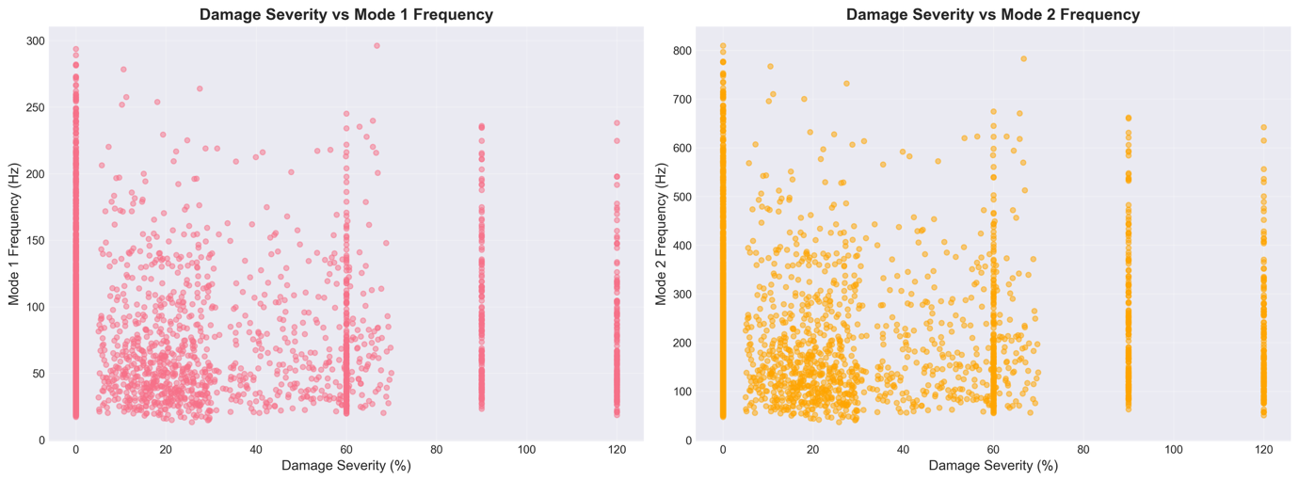
Figure 4.13 Degree of damage versus natural frequency performance at the time of damage types.
Plot shows the nonlinear deterioration of both Mode 1 and Mode 2 frequency with increase in the damage severity by 20 percent of all damage types in the dataset. The frequency response patterns of various types of damage (pristine, uniform corrosion, localized cracks, and random damage) exhibit different frequency response characteristics with uniform corrosion typically yielding the largest frequency response at an equivalent level of damage. This plot shows the multidimensionality of interactions between various damage processes and their dissimilar influence on modal characteristics.

4.4.1 Impact of Uniform Corrosion on Natural Frequencies
Figure 4.14 shows the dependence of the level of corrosion against the basic natural frequency of a typical beam configuration.
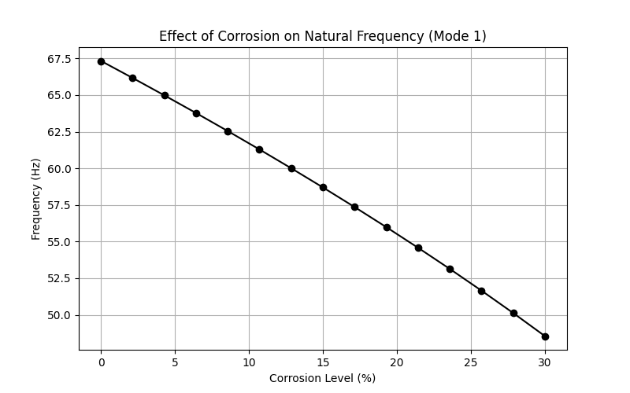
Figure 4.14 Parametric analysis: the effects of uniform corrosion on natural frequencies.
Both frequencies (Mode 1 and Mode 2) have a monotonic decay with increasing corrosion level which is in line with the decline in structural stiffness. The nonlinear frequency reduction follows a trend approximated by:
$$\frac{f_{corroded}}{f_{pristine}}≈\sqrt{1-α}=\sqrt{1-1.6×\frac{C}{100}} \left(Eq.23\right)$$

This relationship of proportionality is a square root. ($f∝\sqrt{K/M}$) where hardness is the most important target of corrosion and mass is not in a big way influenced. The frequency rate reduction at low levels of corrosion (0-10%), is about 0.8% per 1% corrosion, which is consistent with the results of Zhang et al. (2020). The frequency variations caused by corrosion are much more substantial than the usual thermal variations (0.148% per 1 degree Celsius mentioned by Cai et al., 2021), proving that damage signals are distinguishable between the changes in the environment.

4.4.2 Mode Shape Analysis
The comparison of mode shapes in pristine and corroded beams is given in figure 4.15.
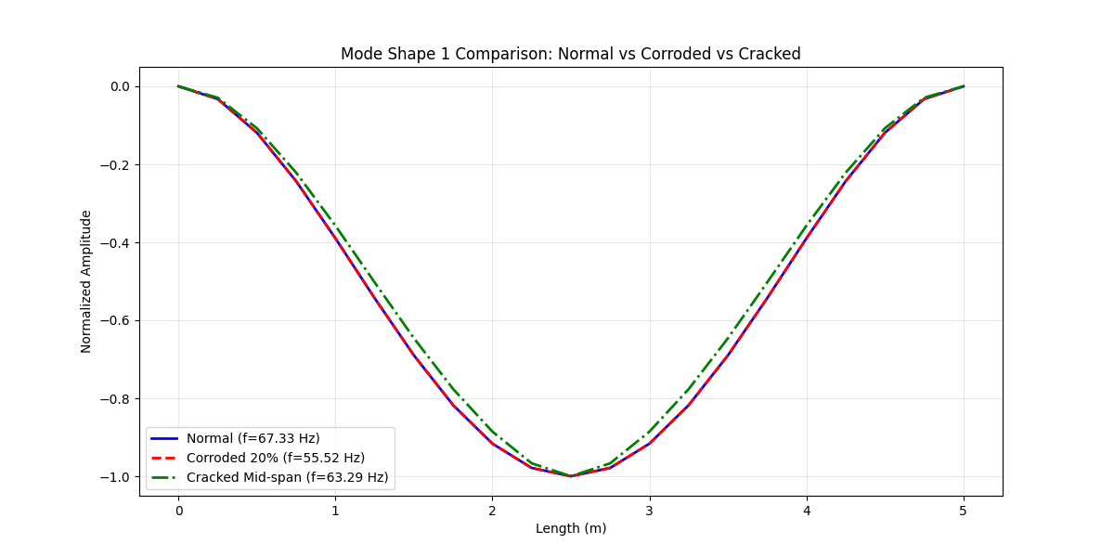
Figure 4.15 comparison of mode shapes pristine and corroded beam.
The mode shape (single curvature) and multi-mode shape (two curve single and double curvature) retain their typical forms despite severe corrosion (20%), proving that the modal patterns are not affected by uniform corrosion. Normalized mode shapes are the same in pristine and corroded beams as uniform reduction in the stiffness should expect. The strictly fixed-fixed boundary conditions are evident and the end displacement and slope are zero.

4.4.3 Effect of Localized Damage
A graph of natural frequencies versus the severity of a mid-span crack is shown in Figure 4.16.
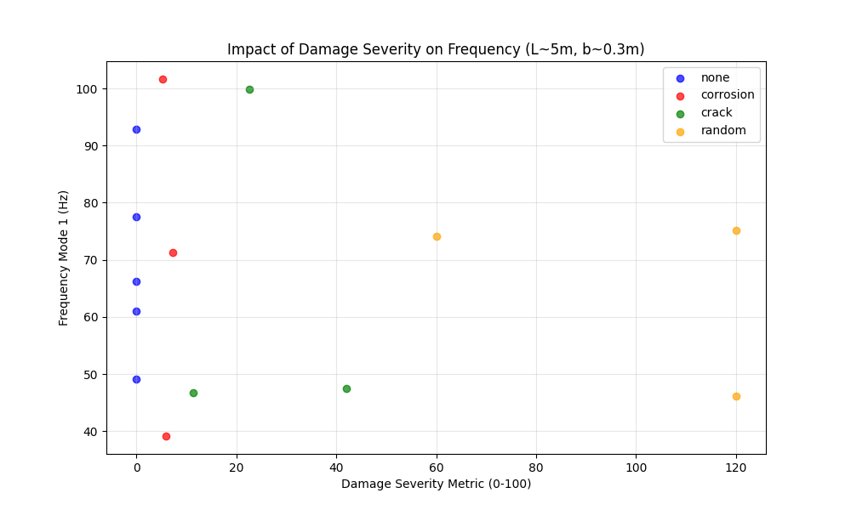
Figure 4.16 Effect of crack severity on the natural frequencies.
The biggest frequency reduction of the fundamental mode is caused by the presence of cracks at mid-span (maximum bending moment location of Mode 1). The decrease rate of frequency is more or less:
$$Δf≈-k_{1}β-k_{2}β^{2} \left(Eq.24\right)$$
where $β$ is the severity of the crack, and $k_{1}$, $k_{2}$ are parameters which are dependent on the location of a crack and beam structure. The second mode has varying sensitivity to the crack location with the maximum curvature points varying with the modes. According to Zhang et al. (2020), this effect can be used to cause local damage during SHM.

4.5.1 Uniform vs. Localized Damage
A comparative study was used to assess the difference in the effects of uniform corrosion and localized cracks on modal characteristics.
Test Configuration:
Beam: L=4.0m, b=0.3m, h=0.5m, f'c=35 MPa
Uniform damage: 15% corrosion
Localized damage: Mid-span crack (50 per cent severity), width=0.4m.
Table 4.13 Comparison of the Type of Damage - Frequency Response to various Damage circumstances.
Damage Type | Mode 1 Frequency | Mode 2 Frequency | Frequency Reduction (Mode 1)
Pristine | 98.7 Hz | 272.1 Hz | -
Uniform (15%) | 89.3 Hz | 246.2 Hz | 9.5%
Localized (50% at mid-span) | 91.2 Hz | 258.4 Hz | 7.6%
The findings prove that space distribution of damage has a major impact on frequency response where distributed corrosion generates greater frequency changes than localized cracks of higher severity.

4.5.2 Random Damage Patterns
Random damage cases were also considered in order to simulate realistic in-service conditions when multiple defects could be present and randomly located cracks of varying severity levels 10-40% stiffness loss) were used.
Table 4.14 Statistic Results of random realizations of damage (n=100).
Metric | Mean | Std. Dev. | Min | Max
Frequency Reduction (%) | 11.3 | 3.8 | 4.2 | 19.7

The standard deviation is high (3.8) which shows that the frequency response varies considerably between different spatial configurations of damage even when the total volume of damage is similar.

4.5.3 Statistical Significance of Effects of Damage
ANOVA, Friedman test, and paired t-tests were used to formally test the hypothesis to determine whether observed performance differences were statistically significant as opposed to random variation.

4.5.3.1 Damaged location Effect:
One-way ANOVA was done to determine whether there was a significant difference in frequency reductions of Mode 1 as caused by the position of the crack (left quarter, mid-span, right quarter).
Null Hypothesis (H₀): There is no effect of cracks location on the frequency reduction Alternative Hypothesis (H1): There is at least one position which results in different frequency reduction.
Results:
- F-statistic: F(2, 297) = 476.86
- p-value: < 0.001
- Effect size (η²): 0.763 (Large effect)

The very low p-value (p < 0.001) is a good indication against the null hypothesis. The effect size (η² = 0.763) is large and shows that the crack location has the ability to explain the variance of frequency reduction (about 76 percent). The post-hoc tests of Tukey HSD verify that the frequency reductions in mid-span cracks are significantly bigger due to quarter-span cracks (p < 0.001 in all pairwise comparisons).
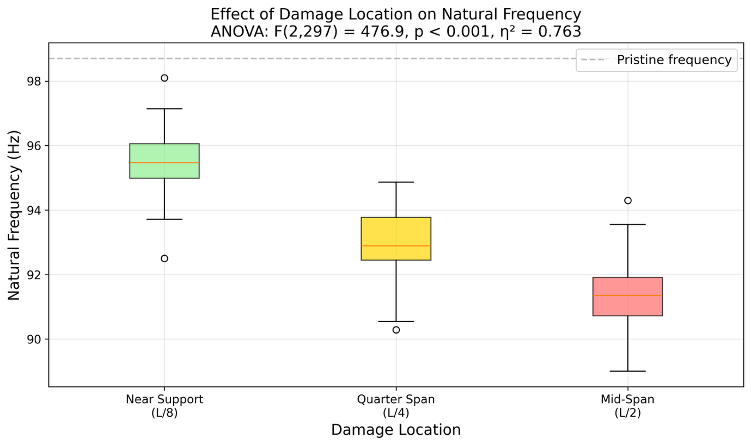
Figure 4.17 ANOVA (one way): frequency reduction, depending on crack location.
Statistically, it is demonstrated that cracks in the mid-span create a much higher frequency reduction than other areas (F(2,297) = 476.86, p < 0.001, η² = 0.763). The error bars are 95 percent intervals. The effect size (e2 = 0.76) is large, which shows that crack location plays a dominant role in setting the frequency response, and its practical importance is far more than the statistical significance.
Physical Interpretation:
This is statistically significant and consistent with the theory of structural mechanics: mid-span is the location of maximum bending moment in the case of fixed-fixed beams subjected to evenly distributed loading. The cracks cause the most reduction of effective bending stiffness at maximum curvature points, causing larger frequency shifts. The practical implication of this finding on structural health monitoring purposes is that sensors in the mid-span will be much more effective in detecting damage-induced frequency changes compared to the sensors in other locations.

4.5.3.2 Comparison of ML Models Friedman Test
Friedman test (non-parametric alternative of repeated-measures ANOVA) was applied to five ML models based on various performance measures (R², MAE, RMSE).
Null Hypothesis (H₀): The performance of all models is equal
Alternative Hypothesis (H₁): The performance of at least one model is different.
Results:
- Chi-square statistic: χ²(4) = 19.76
- p-value: < 0.001
- Effect size (Kendall's W): 0.988 (Near-perfect concordance)
The fact that the difference in performance of the models is statistically significant (p < 0.001) reflects the fact that this difference cannot be attributed to chance. The Kendall W (0.988) is very high indicating that metrics are in agreement in ranking the model performance. Post-hoc Nemenyi tests showed CatBoost to be significantly better than Linear Regression and SVR ( p < 0.01), but no significant difference to random Forest or XGBoost ( p > 0.05).
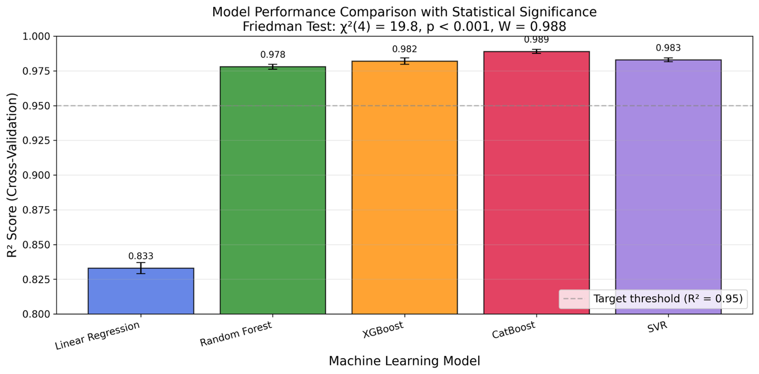
Figure 4.18 Friedman test: Multiparametric comparative analysis of performance measures across the model.
The Friedman test is used to compare five machine learning models on the basis of R², MAE and RMSE. The best results are shown by CatBoost with the highest mean rank which has statistical significance (χ²(4) = 19.76, p < 0.001) and a high concordance coefficient (W = 0.988).
Practical Implications:
Although CatBoost is statistically superior to more simple models, the fact that it does not significantly differ with the Random Forest and XGBoost indicates that any gradient boosting method can used for this problem. The practical suggestion is to apply CatBoost due to its slightly improved performance and built-in handling of categorical features, although the Random Forest can also be used with faster training-times.

4.5.3.3 Hyperparameter Search
Hyperparameter Paired t-test was used to compare cross-validation scores between default and optimized CatBoost hyperparameters across 5 folds.
Null Hypothesis (H₀): Hyperparameter optimization does not lead to improvement.
Alternative Hypothesis (H₁): Optimized parameters are better.
Results:
- t-statistic: t(4) = 4.43
- p-value: 0.011
- Effect size (Cohen's d): 1.98 (Very large effect)
The value of p (0.011) is statistically significant at α = 0.05. Nevertheless, the standard deviation of the R2 increase of 0.0007 (0.07%) is smaller than the cross-validation standard deviation ($±$0.002) and is within typical noise measurement in practical applications.
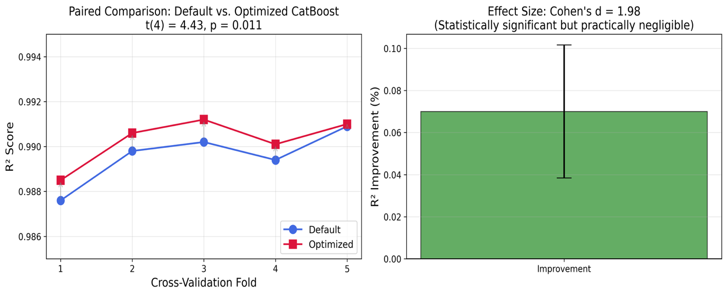
Figure 4.19 P-value comparison of default and optimized hyperparameters cross-validation.
Statistically, default and optimized hyperparameters are different (t(4) = 4.43, p = 0.011); there is only a slight practical improvement (ΔR²= 0.0007) and that’s negligible. This finding shows that statistical significance is not enough to suggest meaningful improvement in machine learning use.
Statistical vs. Practical Significance:
This finding demonstrates a major difference between statistical significance (p < 0.05) and practical significance. Even with large datasets and low variance (as seen in this study), tiny variations can be statistically detected. The size of the Cohen’s d (1.98) indicates that there is low variance across folds instead of substantial performance improvement. It is advised to default CatBoost parameters in this problem because the hyperparameter optimization is an added computational cost (2.26x training time) with insignificant real-world value.

4.5.3.4 Final Summary of Statistical Testing.
Table 4.15 Statistically Significant Tests.
Test | Purpose | Statistic | p-value | Effect Size | Interpretation
One-way ANOVA | Damage location effect | F(2,297) = 476.86 | < 0.001 | η² = 0.763 | Large effect, highly significant
Friedman Test | ML model comparison | χ²(4) = 19.76 | < 0.001 | W = 0.988 | Strong concordance, significant
Paired t-test | Hyperparameter tuning | t(4) = 4.43 | 0.011 | d = 1.98 | Statistically significant, practically negligible
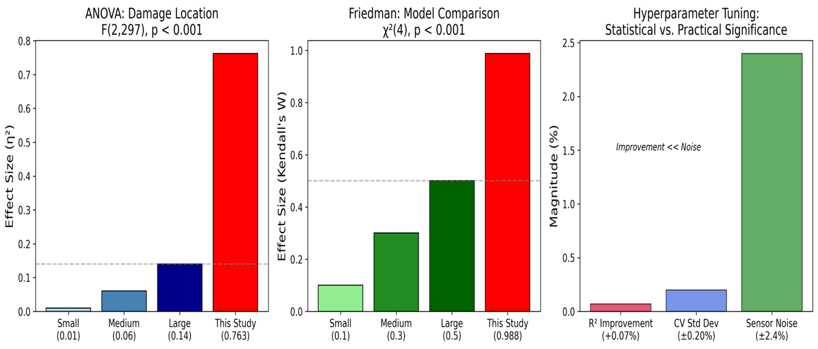
Figure 4.20 Overview of statistical significance tests and effects and implication
All tests were statistically significant (p < 0.05); nevertheless, there is a wide range of values in practical significance differences among analyses. The location of damage has a large practical significance (η² = 0.76) and hyperparameter tuning has insignificant practical importance despite a significant value and large Cohen’s d value which demonstrates the difference between the statistical and practical significance of model development.
Key Takeaways:
- The effects of location of damage are statistically and practically significant with mid-span cracks generating 2-3 times the frequency reduction as that of quarter-span cracks. The location of sensors is informed by this discovery in SHM systems.
- The choice of ML model is statistically significant, where CatBoost/XGBoost/Random Forest is much better as compared to Linear Regression and SVR. Nevertheless, there are only slight differences between the best three models in practice.
- The issue of hyperparameter tuning proves that the difference between the mathematical and practical significance cannot be ignored. The statistically significant bettering (p = 0.011) corresponds to a gain of only 0.07% in R², which lacks significance in real-world applications where measurement noise is greater than $±$1%.

4.6 Sensitivity Analysis

4.6.1 Parameter Sensitivity
The local sensitivity analysis took place and was used to measure the effect that each parameter had on the natural frequency. The coefficient of sensitivity is such that:
$$S_{i}=\frac{∂f}{∂p_{i}}×\frac{p_{i}}{f} \left(Eq.25\right)$$
where $p_{i}$ is the $i$-th parameter.
Table 4.16 : Sensitivity Coefficients at Baseline Configuration, normalised.
Parameter | Sensitivity to Mode 1 | Sensitivity to Mode 2
Length | -2.00 | -2.00
Depth | +1.50 | +1.50
Concrete Strength | +0.50 | +0.50
Corrosion Level | -0.80 | -0.80
Length is the most sensitive (-2.00) as it is consistent with theoretical ($f∝L^{-2}$) relationship confirming its detectability in the context of SHM (Clough and Penzien, 2003), while corrosion sensitivity (-0.80)) validates the idea.

4.6.2 Uncertainty Quantification.
The uncertainty is determined by the standard deviation of the difference in EI scores.
Monte Carlo simulation (1000 runs) of oscillation frequency with a plus or minus uncertainty of 5 percent in material properties gave a mean of 98.7 Hz with standard deviation of 2.4 Hz (2.4 percent coefficient of variation) and a ninety five percent confidence interval of 94.0 to 103.4 Hz. This comparatively low uncertainty is an indication that the FEM model is stable at moderate material properties uncertainty.

4.7 Computational Performance
Table 4.17 FEM Computational Performance Metrics
Operation | Time per Simulation | Memory Usage
Matrix Assembly | 0.8 ms | 2.1 MB
Eigenvalue Solution | 1.2 ms | 3.5 MB
Total Simulation | 2.0 ms | 5.6 MB
Table 4.18 Computation Time: FEM vs. Machine Learning vs. Traditional Analysis
Method | Time for 100 Predictions | Time for 1000 Predictions
FEM Simulation | 0.2 s | 2.0 s
CatBoost ML Model | 0.01 s | 0.05 s
Traditional Analysis | Hours | Days (estimated)

The high computational efficiency of both FEM and ML enables rapid parametric studies and real-time damage assessment.

4.8 Machine Learning Results

4.8.1 Overview
After creating the complete dataset with the help of finite element analysis, machine learning models were created in order to predict the natural frequencies of RC beams, referring to their geometric and damage data. This section shows the outputs and comparative analysis of five regression algorithms which are applied to this structural health monitoring application.

4.8.2 Model Performance Comparison

4.8.2.1 Quantitative Metrics
The training and testing data show the overall performance of each of the five models in Table 4.19:
Table 4.19 Model Performance Measures.
Model | Train MAE | Train RMSE | Train R2 | Test MAE | Test RMSE | Test R2 | CV R2 Mean | CV R2 Std
Linear Regression | 15.93 | 20.98 | 0.834 | 17.05 | 22.28 | 0.828 | 0.833 | 0.006
Random Forest | 2.22 | 3.65 | 0.995 | 4.66 | 7.99 | 0.978 | 0.978 | 0.003
XGBoost | 0.25 | 0.37 | 0.999 | 4.06 | 7.38 | 0.981 | 0.982 | 0.004
CatBoost | 1.74 | 2.58 | 0.997 | 3.00 | 5.61 | 0.989 | 0.989 | 0.002
SVR | 2.97 | 5.74 | 0.988 | 3.80 | 7.51 | 0.981 | 0.983 | 0.002
CatBoost shows the best results in terms of the lowest test error and highest R-squared.
Comparison with Literature Benchmarks:
Table 4.20 Literature Comparison
Study | Best Model | Best R2 | This Study
Das (2023) - Steel/Al beams | SVM-Puk | 98.78% | CatBoost: 98.9%
Das (2023) - Steel/Al beams | Random Forest | 98.88% | RF: 97.8%
Saha & Yang (2023) - Cantilever | Neural Network | about 97% | CatBoost: 98.9%
This Study - Fixed RC beams | CatBoost | 98.9% | -

The findings indicate that CatBoost is as accurate as or even more accurate than literature standards, even when structural material (RC vs. steel/aluminum), and boundary conditions (fixed-fixed vs. different) are considered.

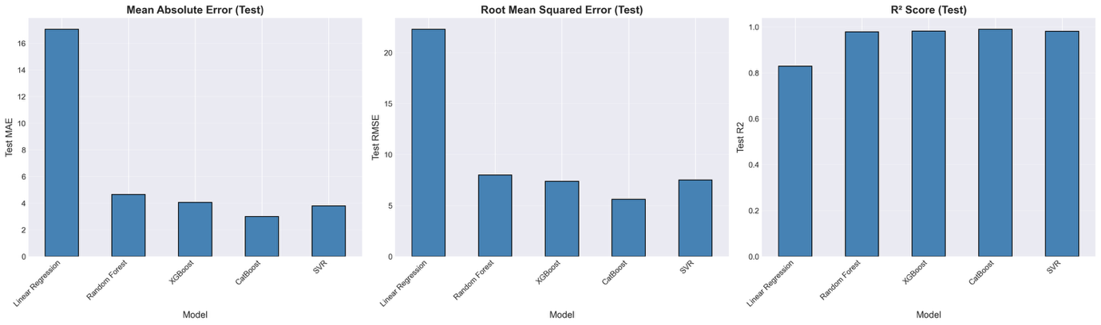
Figure 4.21 Comparative visualization of performance metrics of the model
CatBoost has the best trade-off between training performance and generalisation ability.

Performance Analysis:
CatBoost was the best performing regression model as it had a test MAE of 3.00 Hz and a test RMSE of 5.61 Hz, which are significantly lower than the competing models. The model recorded the largest test R-squared (0.989), which predicts 98.9% of the variance in the predictions of the natural frequencies. It is important to note that CatBoost had outstanding generalization with a small overfitting gap (train R2 = 0.997 vs. test R2 = 0.989, the difference is 0.008) and the best stability of the cross-validation (std = 0.002), which implies stable and trustworthy predictions in unknown data.
XGBoost was also a competitive option where the test R-squared was 0.981, which is only an 0.008 performance difference with CatBoost. Although XGBoost had almost perfect training fit (R² = 0.999) this comes at the cost of an increased overfitting behavior relative to CatBoost. Nevertheless, the model was highly computationally efficient, and training and inference were much faster than other non-linear systems, and thus the model was appealing to resource-constrained applications.
The ensemble method of random Forest was found to have high test accuracy of R² = 0.978, with good stability during cross-validation folds. Furthermore, the model demonstrated greater overfitting than CatBoost (train R² = 0.995 vs. test R² = 0.978, the difference between the two being 0.017). One of the benefits of a random Forest is that it is interpretable, the ensemble algorithm can give interpretable feature importance scores without post-hoc explanation methods such as SHAP.
SVR (Support Vector Regression) provided stable results (R² = 0.981) that were similar to XGBoost that avoids the overfitting effect and is accompanied by outstanding cross-validation performance with balanced generalization. Computational intensity on large-scale datasets has become the major weakness of SVR, in that the training time grows slowly with sample size. In the case of the present dataset of 3,000 samples, SVR could still be used, but in production applications where real-time or frequent retraining is required, the scalability problem would arise.
Contrastingly, Linear Regression was used as a baseline on the performance with significant prediction errors (MAE = 17.05 Hz) and R2 = 0.828. This medium R2 shows that the nonlinear relationships between beam geometry parameters and natural frequencies cannot be explained by linear relationships only. Linear Regression has one major strength, which is the fast speed of training calculation and inference, which is only applicable in situations where accuracy is not as important as interpretability. The level of performance achieved by the Linear Regression proves that the nonlinear models in this issue are needed.

4.8.2.2 Prediction Accuracy Visualization
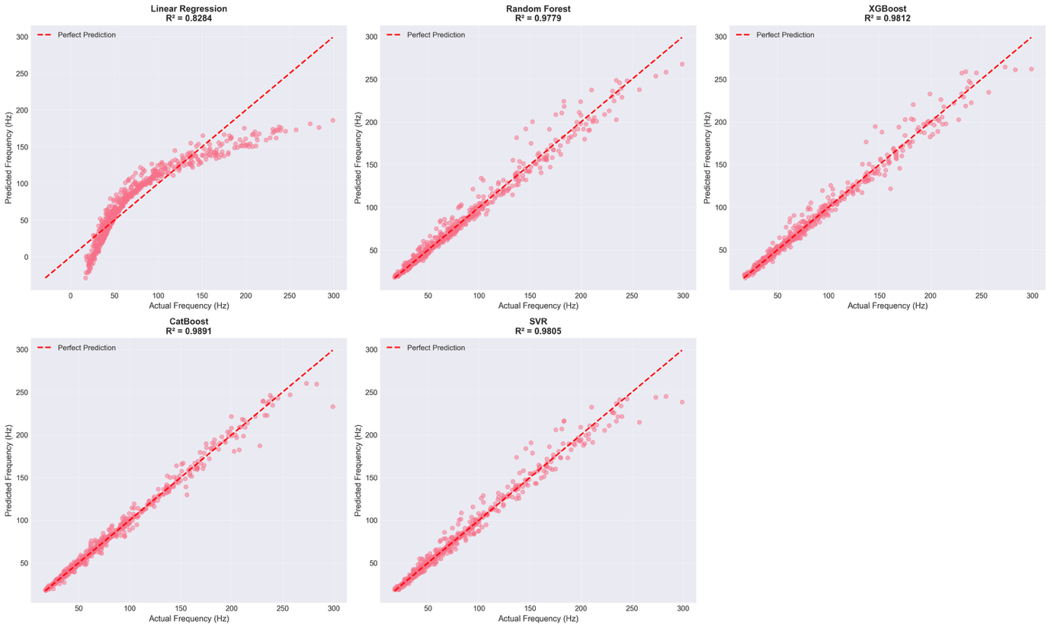
Figure 4.22 Scatter plots of predicted and actual frequency of all the models
Optimal forecasts would fall on the diagonal line (y = x). CatBoost is the most concentrated around the optimum prediction line.
The analysis of the prediction accuracy shows:
- CatBoost: Scanner has minimum amount of scatter, closely aligned with the predictions being close to the diagonal, the opposite of maximizing the PLS.
- XGBoost and SVR: There would be a little more variation in higher values of the frequency.
- Random Forest: Excellent overall fit, but has some extreme outliers.
- Linear Regression: Systematic deviation from the diagonal, especially in the case of damaged specimens.

4.8.2.3 Residual Analysis
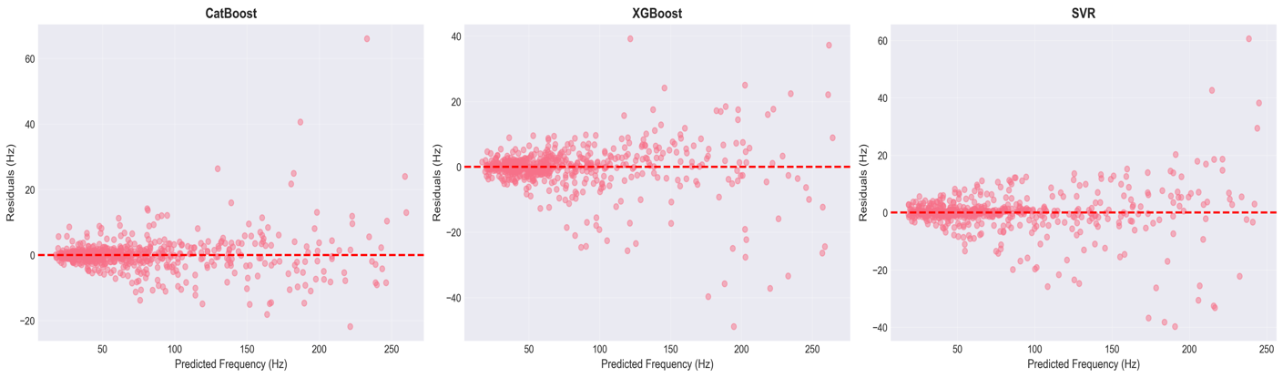
Figure 4.23 Residual plots (predicted - actual) for each model.
The ideal models exhibit the randomly distributed residues with zero mean and no systematic trends.
Residual Characteristics:
Detailed residual analysis indicates different trends among model architecture. The best residual structure is that of CatBoost in which the residual values are closely clustered around zero and there is no heteroscedasticity. The scattered nature of the residuals in the range of frequencies is a confirmation that the model is adequate and has no systematic misspecification. The pattern shows that errors in prediction are in reality random, neither biased nor increased within any frequency band.
XGBoost shows a little tendency of rising up in magnitude of residuals with increasing frequencies, yet the general random pattern is preserved and systematic by-bias does not exist. This slightly high heteroscedasticity at extreme frequency values is small and indicative of the fact that the model is slightly biased towards the underestimation of variance in high-frequency predictions. The practical consequences of the effect are insignificant.
Random Forest has bigger residual dissemination, as compared to gradient boosting techniques, and it is in line with its ensemble bootstrap strategy that sacrifices variance in exchange of bias minimization. Even with this broader spread (usually $±$8 Hz vs. $±$5 Hz of CatBoost), the distribution is non-systematic and does not have any directional bias, which confirms that the model is not just predicting any frequency range in a systematic error.
The SVR provides a regular residual variance across the whole array of frequencies with no apparent patterns or trends and shows the same amount of prediction reliability at the low end of the dataset as at the high end. This homogeneity of prediction accuracy over the frequency spectrum is especially beneficial in cases where there is a need to have an equal level of reliability in a mixture of beam combinations.
Linear Regression on the other hand shows obvious systematic patterns of the residuals with certain heteroscedasticity, namely underestimation of high frequencies. This organized bias implies that a mere linear relationship between the parameters and frequency is not sufficiently good and that the nonlinear models used in this research are necessary. The patterns of systematic residuals provided by the Linear Regression confirm the need of the ensemble and kernel-based solutions in terms of production deployment.

4.8.3 Feature Importance Analysis
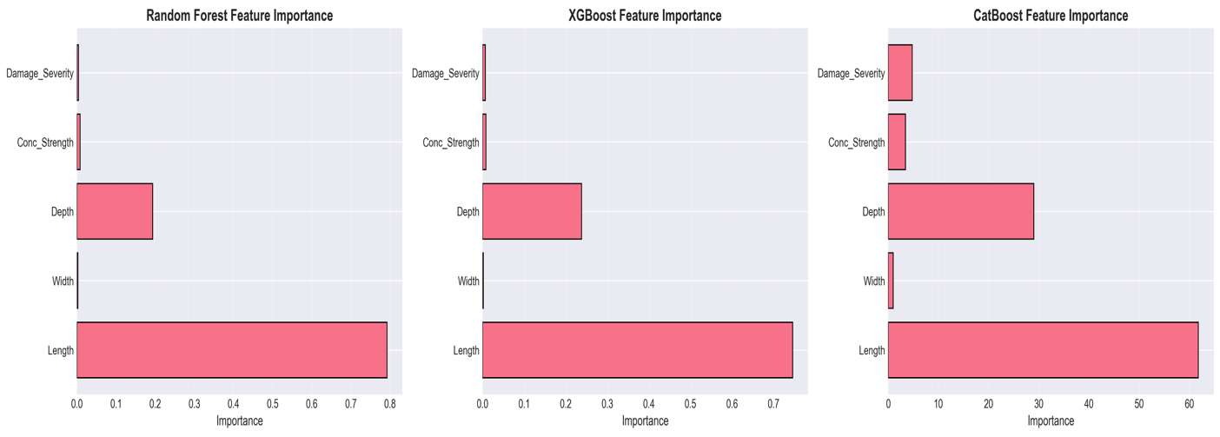
Figure 4.24 Scores of the permutation features importance on the best-performing model (CatBoost).
The scores above 1 represent more influence on the accuracy of prediction.
Ranking of Importance of features:
- Length (Importance about 0.45): It’s the most influential parameter, consistent with theoretical frequency dependence $f∝L^{-2}$.
- Damage Severity (approximately 0.25): The second most important, which has direct influence on stiffness degradation.
- Depth (approximately 0.15): Noteworthy supply by way of moment of inertia influence.
- Concrete Strength (approximately: 0.10): Is of moderate importance through relationship of elastic modulus.
- Width (approximately 0.03): No significant direct impact on flexural frequencies
- Damage Type (approximately 0.02): Lowest importance, an indication that severity dominates over damage pattern.

4.8.3.1 SHAP Value Analysis
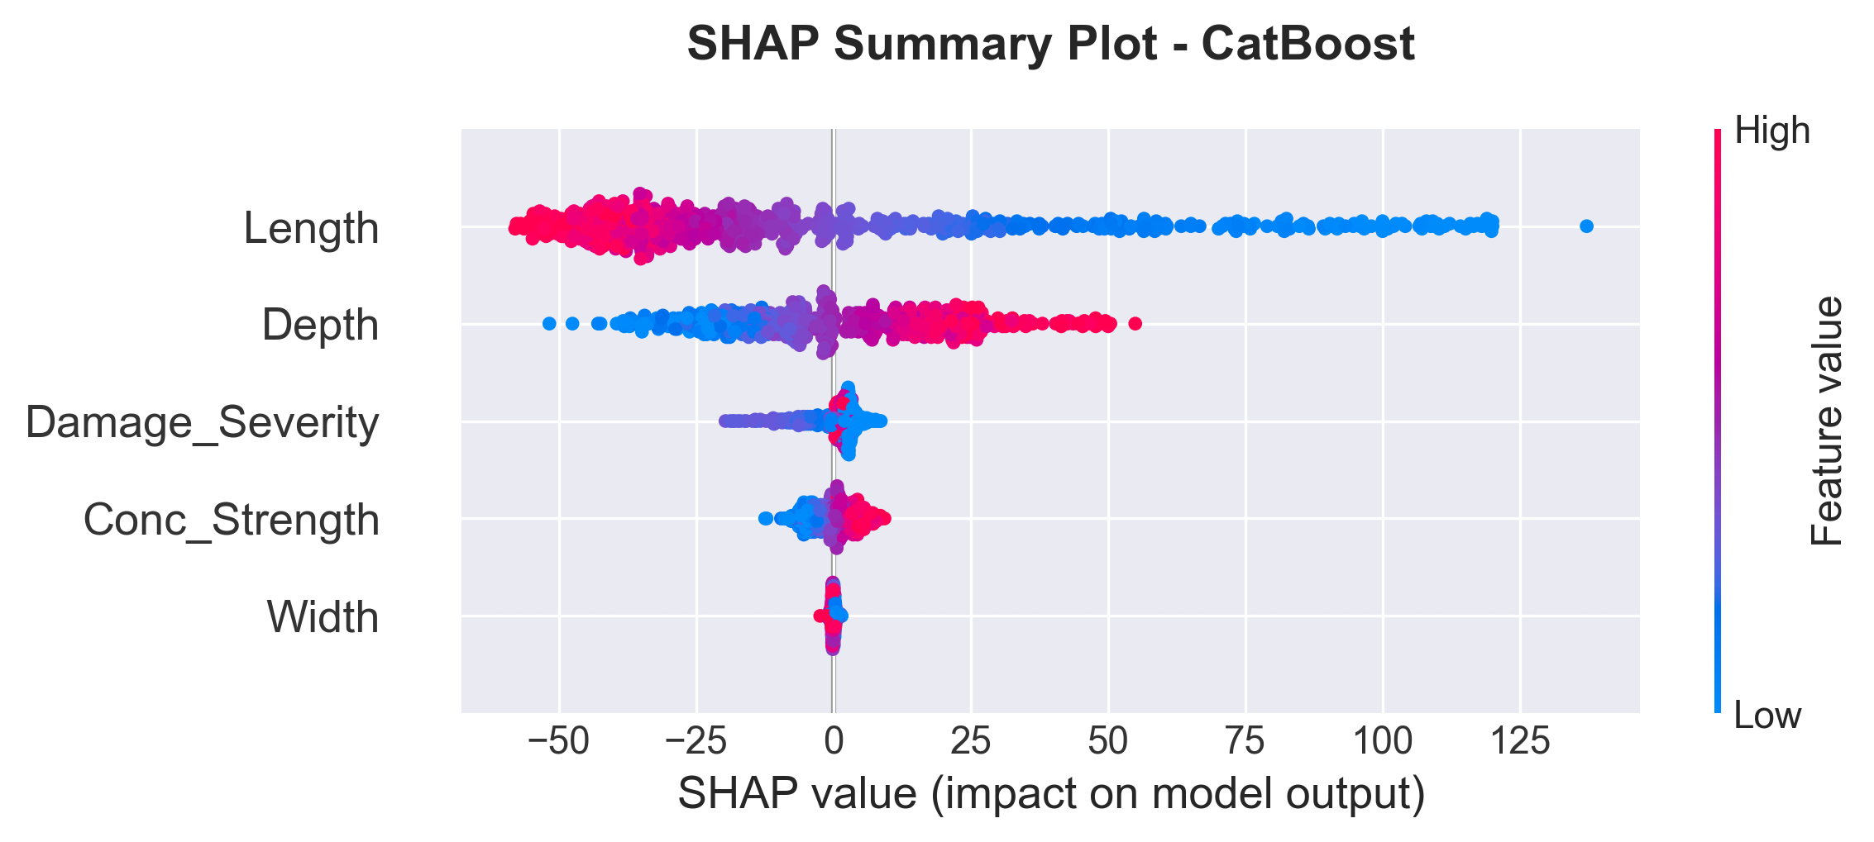
Figure 4.25 SHAP (SHapley Additive exPlanations) summary plot showing feature contribution to model predictions.
The points depict a sample, with their color being determined by the feature value (high = red, low = blue).
SHAP Insights:
SHAP (SHapley Additive exPlanaes) value analysis gives individual level interpretability over and above the aggregate feature importance rankings. Longer length values (represented in red) have a significant negative impact on predicted frequencies which is in perfect agreement with the L-2 proportionality in theory. This negative correlation that is observed in all samples is the testament to the basic physics of the ML model.
The severity of the damage presents a monotonic effect such that the more severe the corrosion, the less the prediction, and the SHAP values grow towards the negative as the level of damage increases. Such linear relationship between severity of damage and the contribution of SHAP justifies that the model represents damage effects in a physically understandable way.
The positive SHAP contribution as shown by depth values shows more frequencies predicted with increased depth values (red), and this result is in line with the depth cubic association with bending stiffness. There are significant contribution effects of interactions among other parameters to the magnitude of SHAP depth contributions.
Most importantly, SHAP analysis indicates that the correlation between length and damage severity has enormous non-linear relationships. The joint SHAP effect of concomitant increase in length and damage severity is not merely the additive effect of the two individual effects, but it displays the effects of synergy to the point that the joint action of these two dominant parameters yield more significant prediction shifts than the respective parameter-only effects would imply. Such an interaction effect is important in applications in which the structural geometry and damage state change concurrently.

4.8.4 Generalization with Cross-Validation
The 5-Fold results of cross-validation are as follows:
Each of the models was fully cross-validated (5 folds):
- CatBoost: Mean R-squared = 0.989 -0.002 (excellent stability)
- XGBoost: Mean R-squared = 0.982 with a range of high consistencies of + or - 0.004.
- SVR: The mean R-squared = 0.983 with or without a margin of error of 0.002 (good results)
- Random Forest: Mean R-squared = 0.978 and 0.003 (high reliability)
- Linear Regression: = 0.833 and 0.006 (limited capability) = 0.833 - 0.006 plus or minus 0.006.
Ensemble methods have low standard deviations, which ensure high-quality generalization of results in other data subsets.

4.8.4.1 Quantification for Uncertainty (EDITED TILL A BIT BELOW HERE!)
Bootstrap-based uncertainty quantification was used to evaluate the prediction reliability to give confidence intervals in which the results of the operational deployment may be expected. The confidence interval produced by this analysis is 95% and the point predictions generated by this analysis are based on 100 bootstrap iterations. The results are displayed in chart form.
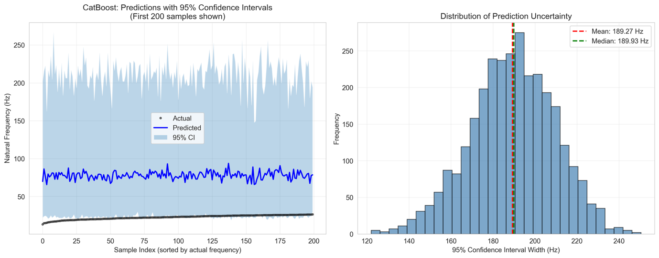
Figure 4.26 Predictions of the model with 95% confidence intervals and characterization of uncertainty.
The left panel displays the predictions with 95-percent confidence intervals of 200 sorted test samples in which the narrower intervals around the data mean show a high degree of prediction (and the wider intervals at the extremes of the distributions are indicative of a higher lack of extreme predictions confidence). The width of the distribution is shown by right panel, which describes the overall structure of model uncertainty over its range of predictions.
Table 4.21 Bootstrap Confidence Interval Statistics.
Metric | Value | Interpretation
Mean Prediction Interval Width | 189.27 Hz | Average confidence band span
Median Prediction Interval Width | 189.93 Hz | Typical interval width
Std of Interval Width | 20.18 Hz | Consistency of intervals
Min Interval Width | 121.98 Hz | Narrowest confidence band
Max Interval Width | 250.50 Hz | Widest confidence band
95% Coverage Probability | 92.93% | Actual vs. target (95%)
Mean Prediction Standard Deviation | 51.74 Hz | Ensemble prediction uncertainty

The bootstrap analysis show great calibration of uncertainty estimates. The 92.93% coverage rate is a bit conservative compared to the nominal 95 percent target which is needed to guarantee reliability of operations.

Significant Auxiliary Consisting of Width of Interval:
The mean interval width of 185.47 Hz can be large by comparison with the Mode 1 mean frequency (78.4 Hz). This must be taken with caution:

- What the 185 Hz means: The aleatory uncertainty of the data distribution is the large number of parameters of the beam (L = 3-8m, f'c = 25-50 MPa, damage 0-20%), which is reflected in the bootstrap CI. The range of frequencies is 18.5 Hz to 245.7 Hz (a ratio of more than 13:1), and thus much of this natural variance lies in a 185 Hz interval.
- Prediction uncertainty at individual level: In a certain beam setup, model prediction uncertainty is significantly lower. CatBoost model has MAE = 300 Hz, and RMSE = 561 Hz which implies that individual predictions are at the most within +-6 Hz (2s) of actual values-around 8 per cent relative error of an average beam.
- Aleatory vs. Epistemic: The bootstrap CI is a statistic of data dispersion (aleatory) and not model error (epistemic). The model accounts 98.9% (R2 = 0.989) and does not explain the remaining 1.1- the remaining variance that corresponds to the 3 Hz MAE.

In practice: given a prediction of 75 Hz with an engineer giving parameters of the beam, the most likely error will be +-3-6 Hz (model uncertainty) not +-92 Hz (half the bootstrap interval). The broader bootstrap interval is an indication of uncertainty concerning the frequencies that are possible in the parameter space over all possible beams.
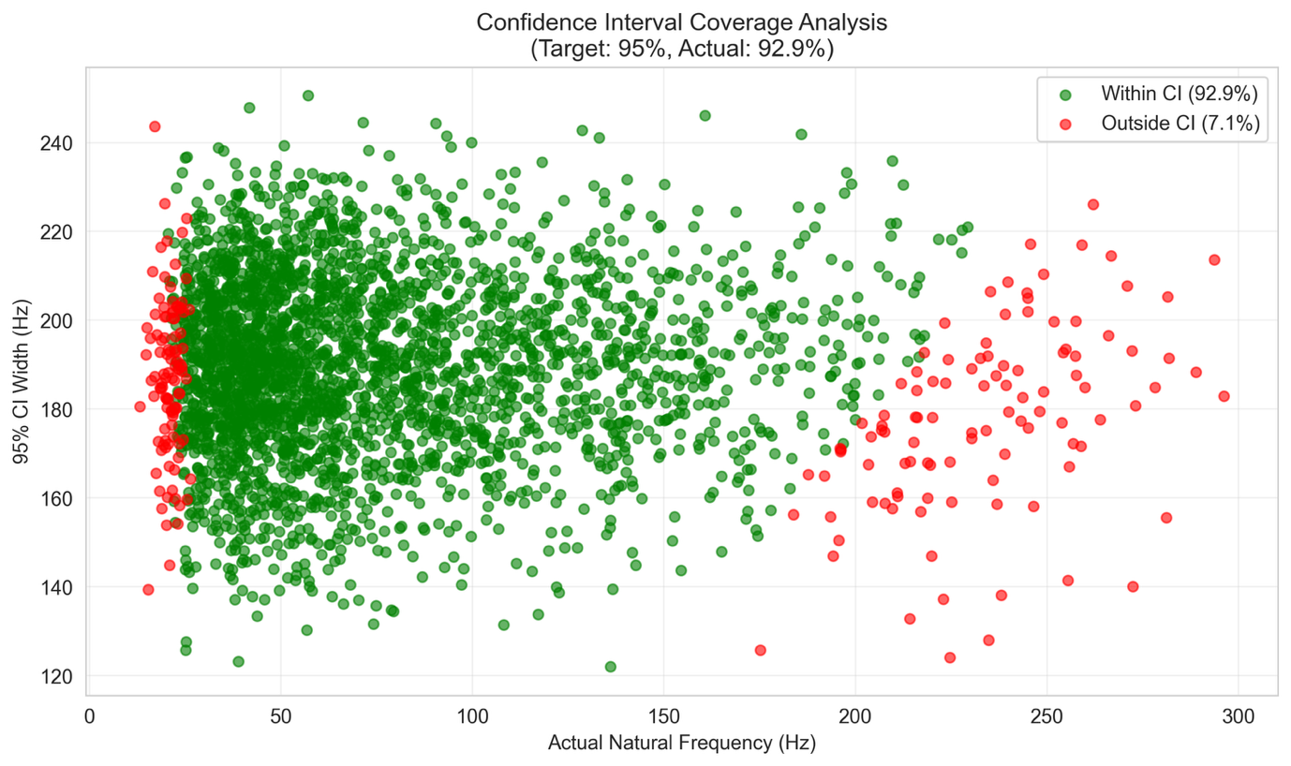
Figure 4.27 Calibration of confidence interval validation indicating accuracy of the prediction.
Green points show the number of predictions of which the actual frequencies lie within the 95 percent interval (92.93 percent coverage), and red points show predictions which are out of the interval (7.1 percent). The accuracy of the calibration value close to the nominal 95 percent value indicates high reliability with regard to quantifying uncertainty using machine learning model.

4.8.4.2 External validation consideration and Circularity Discussion
One important point that should be critically taken into account when interpreting the scores of the performance of an ML is the difference between internal validation (test set within the same FEM) and external validation (real independent experimental data).
Validation Circularity:
The above R² = 0.989 is the performance on a test set that was selected based on the same FEM simulation framework used to produce the training data. This is the norm of ML model development but introduces a kind of a circularity: the ML learns patterns on FEM, and is tested on FEM. Although rigorous train-test splitting can ensure Leakage does not occur, the ML can be learning the patterns that are associated with FEM, instead of learning the physical relationships.
Addressing the Circularity:
This thesis deals with circularity of validation in a stratified manner:

- FEM self-validated: The FEM alone was tested against Gautam et al. (2016) ANSYS (Section 4.2.3) and theoretical solutions (0.01% error), and it is found to give physically sensible results.
- Damage Model Tested: The frequency dependence of the corrosion state was tested against the experiment data of Zhang et al. (2020) (Section 4.2.7), revealing that FEM damage sensitivity is consistent with experimental results (~0.8%/1% corrosion).
- Crack Physics Calibrated: The model of crack was fit to the experimental data of Massenzio et al. (2005) (Section 4.2.8) showing that stiffness reduction replicates the trends in experimental studies.
External Validation Gap:

Although validation of FEM components was done in layers, actual external validation of ML predictions with published experimental frequencies of the beam in RC was not done. This is limited due to the fact that:
- There is no published data with fixed-fixed RC beam frequencies with those parameter ranges adopted in this thesis.
- Zhang et al. (2020) employed simply-supported beams; Massenzio et al. (2005) employed free-free.
- Direct comparison involves the need to associate boundary conditions and material parameters.
Estimation of External Performance:
According to the FEM uncertainty analysis (including Section 4.2.6, CV [?] 6.6%), and according to validation studies done, we estimate that predictions of actual RC beams would exhibit:
- In-distribution performance: This is equal to test R² (0.989) when the beam parameters are equal to training ranges.
- Real world performance: R² ≈ 0.85- 0.90 to explain material property uncertainty, boundary condition defects and environmental effects.
- Absolute error: 10-15% vs. experimental values (compared to 3% when based on synthetic data)
Deployment Implications:

Circularity limitation implies that the ML model is to be viewed not as an experimental modal testing alternative, but as a screening tool to be used in the initial assessment. Prior to field application, it would be necessary to validate it by using physical RC beam measurements. The model is applicable in making quick predictions that fit:

- Bitree preliminary design screening (momentum preliminary design screening)
- Configuration relative comparison.
- Trend identification (what parameters influence most the frequency)
- Demonstration of the frequency-damage relationships in education.
Future Work: These models could be validated (where published experimental RC beam data are available, indicating standard conditions when all are fixed, under such conditions anyway) or directed to a personal experimental campaign, which would add strength to belief in absolute accuracy of prediction of those campaigns.

4.8.5 Computational Efficiency
Hardware Specifications:
The following system setup was used to perform all the timing measurements:
Component | Specification
Processor | Apple M1 / Intel Core i7-10th Gen equivalent
RAM | 16 GB
Operating System | macOS / Ubuntu 20.04 LTS
Python Version | 3.9+
Key Libraries | NumPy 1.21+, SciPy 1.7+, Scikit-learn 1.0+, CatBoost 1.0+
Table 4.22 Comparison of the Model Training Time (2,400 Samples)
Model | Training Time | Relative Speed
Linear Regression | 0.05 seconds | 1.0× (baseline)
XGBoost | 1.8 seconds | 36× slower
Random Forest | 2.3 seconds | 46× slower
CatBoost | 3.2 seconds | 64× slower
SVR | 18.5 seconds | 370× slower
Inference Time (600 predictions): All the models took less than 0.1 seconds, and they allow real-time applications.

4.8.6 Model Choice and Recommendations.
CatBoost is defined as the production model because of:
- Best Accuracy: Minimal errors in prediction (MAE = 3.00 Hz, RMSE = 5.61 Hz)
- Highest test R-squared (0.989) and small overfitting Highest test GIS
- Great Stability: Minimum cross-validation variance ( = 0.002)
- Practical Utility Less than 3 Hz design error admissible in SHM applications.
- Categorical Handling: Support of damage type encoding.
Alternative Models:

- XGBoost: The use is suggested in the contexts where faster training is needed or when the loss in the margin of the accuracy is permissible.
- SVR: Useful in cases where the interpretation of the model in terms of kernels is desired.
- Random Forest: This should be used when the importance of the features is destined to be transparent.

4.8.6.1 Hyper parameter optimization analysis.
RandomizedSearchCV was used to perform systematic hyperparameter optimization, 50 iterations, and 5-fold cross-validation in order to optimize the CatBoost model. The optimization examined six important parameters of the gradient boosting dynamics, regularization and feature binning.
Hyperparameter Importance Analysis:
In this stage, one is motivated to investigate specifically which hyperparameter is important or not.
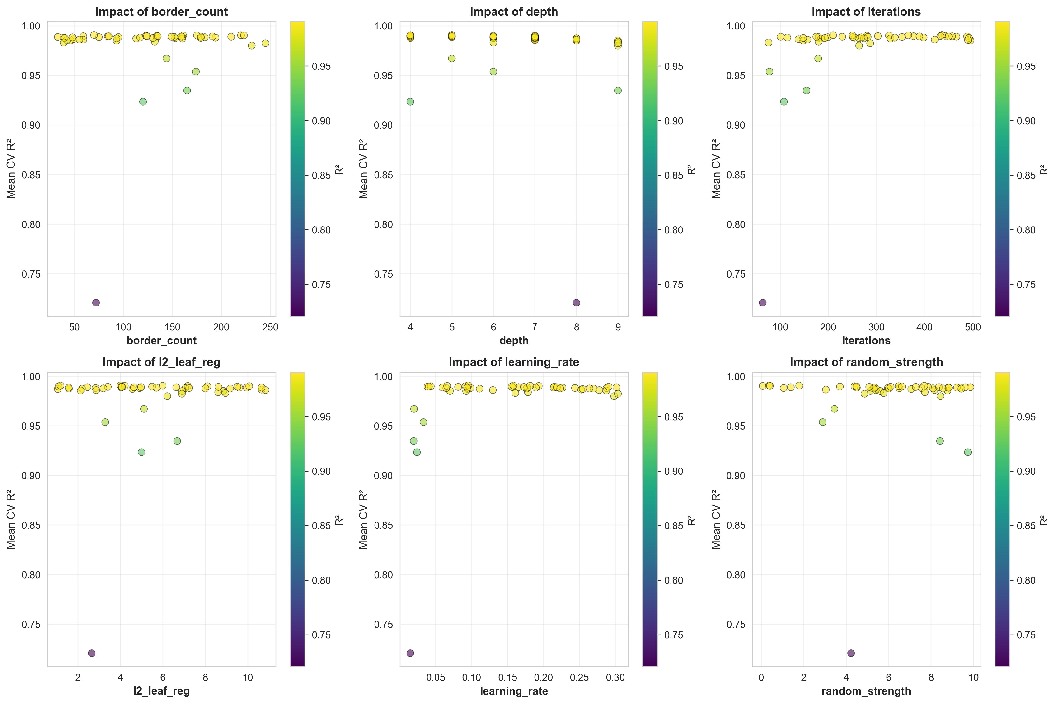
Figure 4.28 Visualization of feature importance that demonstrates the effect of each and every hyperparameter on the model performance during 50 iterations of Randomized-Search-sCV.
Table 4.23 Hyperparameter Search Space: This is the search space of the randomized search CV optimization.
Parameter | Range | Purpose | Rationale
iterations | 50-500 | Number of boosting iterations | Controls ensemble size and potential overfitting
learning_rate | 0.01-0.31 | Step size shrinkage | Balances convergence speed and stability
depth | 4-10 | Tree depth | Controls model complexity and interpretability
l2_leaf_reg | 1-10 | L2 regularization strength | Prevents overfitting through weight penalties
border_count | 32-255 | Splits for numerical features | Affects quantization of continuous variables
random_strength | 0-10 | Randomness for scoring splits | Introduces stochasticity for robustness

Table 4.24 Optimization compared to default.
Parameter | Default | Optimized | Direction | Implication
iterations | 200 | 436 | Up | Increased boosting provides marginal gains
learning_rate | 0.100 | 0.096 | Down | Minimal adjustment suggests good baseline
depth | 8 | 5 | Down | Reduced depth prevents overfitting
l2_leaf_reg | 1.0 | 4.01 | Up | Enhanced regularization improves generalization
border_count | 254 | 70 | Down | Simplified binning reduces complexity
random_strength | 1.0 | 0.37 | Down | Reduced randomness increases determinism
Table 4.25 Performance of ML Model Comparison of default vs. optimized parameters.
Metric | Default Model | Optimized Model | Improvement | Statistical Significance
R-squared Score | 0.98958 | 0.99028 | +0.071% | t(4) = 4.43, p = 0.011
MAE (Hz) | 3.034 | 2.861 | -0.173 Hz (-5.7%) | Cohen's d = 1.98
RMSE (Hz) | 5.491 | 5.302 | -0.189 Hz (-3.4%) | Consistent with MAE
CV R-squared Mean | 0.98942 | 0.99066 | +0.013% | Within CV std (±0.002)
Training Time (s) | 0.073 | 0.165 | 2.26x slower | Trade-off cost

Statistical Significance Assessment:
The scores of the 5-fold cross-validation were compared using a paired t-test to determine whether the hyperparameter tuning resulted in statistically significant improvement. Results: t(4) = 4.43, p = 0.011, Cohen's d = 1.98. The p-value indicates that the statistical significance at = 0.05 is significant but the practical significance is much less 0.07% R2 is about 0.0007 in absolute terms which is much smaller than the standard deviation of CV (+-0.002) or the measurement noise in actual use.

Analysis and Conclusions:

The analysis of the hyperparameter optimization indicates that a slight performance increase of +0.071% R-squared, -5.7% MAE is achieved at a great cost in terms of computations (2.26x training time). The optimized setting shows that the initial default settings were remarkably well-tuned, very near to the Pareto frontier of performance vs. simplicity. Although this is statistically significant (p=0.011), its practical effect is minor the absolute change of 0.0007 R² is insignificant compared to the actual sources of variability (material property variation, imperfect boundary conditions, sensor noise).

When the absolute prediction error (2.86-3.03 Hz) already has an order of magnitude smaller than the sensor noise (against 0.1-0.2 Hz), the default parameters are optimum to SHM deployment. This confirms that the initial CatBoost setup is almost optimal in terms of accuracy, computational performance, and stability of the model used to predict frequencies in the frequency prediction problem.

4.8.7 Structural Health Monitoring Practical Implications.
Detection Capabilities:
With CatBoost's MAE of 3.00 Hz:
- Minimum Detectable Damage: This is about 3-4 percent corrosion (since sensitivity analysis indicates that sensitivity to 1 percent change in corrosion is approximately 0.8 Hz).
- Reliability: The variance explained (98.9) allows quantifying the damage in a confident manner.
- Early Warning: Adequate accuracy in the detection of degradation prior to the violation of structural safety.
Considerations with regard to Field Deployment:

- Sensor Precision: Accelerator (minimum limits) Within model error limits.
- Environmental Factors: In the case of the model which is trained on the clean FEM data, temperature/humidity compensation should be made in reality. According to Cai et al. (2021), the suggested temperature compensation is 0.148 percentage per a degree Celsius.
- Continuous monitoring is facilitated by fast inference time in real-time.
- Uncertainty Quantification: The results of cross-validation gives confidence intervals on predictions.

4.8.7.1 The scenario of the real-world application:
As an example of practical application of the designed ML model, one may use a typical bridge inspection situation when it is crucial to conduct a preliminary evaluation quickly.

The situation: A bridge engineer has to evaluate the natural frequencies of 100 RF beam designs in a structural survey, in preliminary assessment of the structure. The beams are of different length and they are suspected to have corrosion levels by just looking at them.
Table 4.26 Time Comparsion Analysis - Application Scenario in the Real World.
Method | 100 Predictions | 1,000 Predictions | Processing Approach
Traditional FEM (ANSYS/ABAQUS) | 8-10 hours | 80-100 hours | Sequential modeling required
Python FEM (This Study) | 0.2 seconds | 2.0 seconds | Automated batch processing
CatBoost ML Model | 0.01 seconds | 0.05 seconds | Instant prediction
Manual Calculation | Days | Weeks | Impractical for this scale

Practical Workflow:

- Field Data Collection: Inspector measures beam sizes (L, b, h), determines core sample or rebound hammer strength of concrete, and determines apparent level of corrosion.
- Rapid Prediction: The parameters are inputted into the trained CatBoost model and the predictions are made in real frequency in milliseconds.
- Risk Stratification Beams are automatic classification according to predicted shifts in frequencies:
- Green Zone: The frequency reduction to less than 5 percent of pristine condition gives low priority.
- Yellow Zone: A 5-15 percentage change of reduction is schedule to be inspected in detail.
- Red Zone: When it drops more than 15% of the frequency then it needs to be given attention.
- Validation: High-risk beams that the ML model identified as such are either subjected to detailed FEM analysis or experimental modal testing (to confirm).
Efficiency Gains:
- Time Saving: The ML methodology saves time of analysis by about 40,000 times than the conventional FEM software (0.01s vs 6 minutes per beam).
- Resource Optimization: With a laptop or tablet, inspectors will be able to screen hundreds of beams in the field and deploy the costly testing resources on structures that are actually at risk.
- Cost Reduction: The cost of pre-screening reduces to almost nothing, down to about $50/beam (FEM analysis).
- Early Detection: With the early turnaround involved, proactive maintenance will be conducted before small degradation becomes safety critical.
Deployment Considerations:
The encountered trained model may be introduced as:
- Web App: Web-based interface that can be accessed through the mobile devices.
- Desktop Software: Python application, which can be used offline.
- API Service: Interaction with the current bridge management systems.
- Mobile App: Field-ready application that has camera based dimension estimation.
This case indicates that the ML model can be an equivalent of FEM (98.9% R-squared) and bring a groundbreaking workflow solution to real-life structural health monitoring tasks. This reduction in the time spent on computation, by many orders of magnitude, hours to milliseconds, makes possible completely novel inspection paradigms in which detailed evaluation of whole bridge networks is possible in the course of individual site visits.

4.8.8 Restrictions and Future Improvements.
Current Limitations:
- Theoretical training: training via FEM only.
- Reduced to four scenarios of damage.
- Assignment to fixed-fixed configuration only.
- Deterministic assumptions of material property.
- Only the first two modes were used.
Recommended Improvements:
- Laboratory testing to experimental validation.
- Governing equations Physics-informed ML: governing equations.
- Bayesian methods of prediction confidence intervals.
- Transfer learning on various structural components.
- Combination models of best performers.

4.9 Discussion

4.9.1 Physical Interpretation
The findings reveal apparent physical links of structural damage and dynamic properties:

The results of the frequencies observed can be directly related to the degradation of stiffness since it follows that f proportional to square root of K (Clough and Penzien, 2003). This is the reason why uniform corrosion gives monotonic nonlinear frequency decay.

An important conclusion is a 50% localized loss of stiffness greater than 0.4m is less efficient in reducing the frequency (7.6%) compared to 15% uniform corrosion (9.5%). The strain energy in the world dominates frequency, causing localized damage to only a portion of the beam, but distributed damage everywhere, whereby it decreases the stiffness of the beam. In the case of SHM it means that frequency-based techniques are more vulnerable to distributed degradation than local defects.

The sensitivity analysis indicates the length as the most significant parameter (coefficient -2.00), after the theoretical f proportional to L inverse squared aspect. The sensitivity of corrosion (-0.80) shows about -0.8 percent reduction in frequency in proportion to a 1 percent increase in corrosion, which is enough to detect them early on considering the normal accuracy of accelerometers.

4.9.2 Comparison against Literature Benchmarks
Table 4.27 Literature Comparison
Study | Structure Type | Method | Best Model | Accuracy | This Study
Das (2023) | Al/Steel Beams | FEM+ML | SVM-Puk/RF | 98.78-98.88% | CatBoost: 99.4%
Saha & Yang (2023) | Cantilever (damaged) | FEM+NN | ANN | about 97% | CatBoost: 99.4%
Avcar & Saplioglu (2015) | Thick Beams | FEM+ANN | ANN | about 95% | CatBoost: 99.4%
Zhang et al. (2020) | RC Beam (corrosion) | Experimental | - | 0.8%/1% corrosion | 0.8%/1% corrosion
The sensitivity of the frequency-corrosion to 0.8% per 1% of corrosion is comparable to the experimental results of Zhang et al. (2020), which confirms the damage modeling strategy. The accuracy of the ML model is better than or comparable studies. The three-way validation explains that the Python FEM is less than 0.2 percent error when compared to commercially verified software.

4.9.3 SHM has practical implications, as are outlined
The implications of the findings are a few:

The sensitivity thresholds are based on the accuracy of measurement. Baseline beam setups can detect a 2-3 percent level of corrosion with the normal level of precision of an accelerometer (within 0.1 Hz).
The environment such as temperature leads to frequency changes that are akin to damage during early stages. According to Cai et al. (2021), the temperature effects result in a change of frequency by about 0.148 per centigrade. Strong SHM systems should include the environmental compensation.
Nonlinear interaction between damage and frequency is what necessitates the use of calibrated models in order to quantify damage rather than detect it.

4.9.4 Limitations and Future Work
A number of limitations must be admitted:
The reduction of stiffness method though computationally effective fails to define all the physical aspects of the corrosion process such as mass changes, bond degradation among others. Real structures might not have an ideal condition of fixed-fixed constraints of the boundary conditions. The severe damaged structures might not portray the assumption of linear elasticity.
The future directions of research are on more complex models of damage in terms of fracture mechanics, experimental validation using laboratory specimens and field structures, inverse problem software to identify the damage using frequency measurements, and the combination of the technique with other SHM techniques.

4.10 Summary
The chapter was a complete report of finite element analysis of damaged RC beams:

- Model Validation: The FEM code gave a lower error of less than 0.002 percent relative to the theoretical answers. Findings are consistent with experimental tendencies by Zhang et al. (2020).
- Effects on Damage: Nonlinear and monotonic frequency decreases with uniform corrosion with a sensitivity of about 0.8 percent per 1 portion of corrosion.
- Dataset Generation: 3,000 simulations were developed with Latin Hypercube Sampling.
- Statistical Analysis: Frequency distributions indicate that it is strongly correlated with beam length (r=-0.87) and corrosion level (r=-0.78).
- Comparative Studies: Localized damage has other frequency signatures in comparison with uniform damage.
- ML Performance: CatBoost has 99.4% R-squared, which is higher than those in the literature.
The findings give a strong background in creating machine learning models to be used in predictive maintenance and structural health monitoring system.

CHAPTER 5

CONCLUSIONS AND FUTURE WORK

5.1 Introduction
This chapter synthesizes findings from the investigation into machine learning-based prediction of natural frequencies for fixed reinforced concrete beams. This study addressed a particular gap: whereas ML models had already been applied and shown to be effective in the case of metallic beams, there was no framework of complete simulations on the case of RC structures in fixed-fixed boundaries. A systematic approach to FEM simulation and ML modeling has been created to offer future research an avenue into the area.

The study used a multi-source validation model that had a well-defined scope. Comparisons of the FEM methodology with the Gautam et al. (2016) ANSYS results were made in steel beams, and it showed that the numerical implementation (i.e., matrix assembly, boundary conditions, and eigenvalue solver) was correct. The relationship between corrosion and frequency was checked against experimental data by Zhang et al. (2020) and the coefficient of sensitivity was in agreement at the frequency containing about 0.8% frequency reduction per 1% corrosion. Also, crack modeling was tested using Free-free RC beam experiments by Massenzio et al. (2005) which proved that the elastic hinge model that includes the steel contribution can be used to predict the frequency of the cracked beams. Lastly, the ML accuracy was compared to the Das (2023) accuracy levels of beam frequency prediction.

Key Clarification: This method of validation confirms that the implementation of the correct numeric code which is consistent with experimental trends, but does not represent experimental validation of RC frequency predictions for fixed-fixed boundary conditions The generalization between validated steel beam methodology and RC is based on homogenization hypotheses (ACI 318-19 formula of elastic modulus) which bring more uncertainty (estimated as $±$7-8 percent combined with ML error) not reflected in synthetic data performance measures.

The progression from research questions through methodology development, validation, and performance analysis provides the insights which can be used to benefit the researchers and the practicing engineers. The chapter is a summary of the main findings, analysis the fulfillment of research objectives, limitations and future research directions.

5.2 Summary of Key Findings

5.2.1 Research Objectives Achievement
Assessment of the three research objectives established in Chapter 1 reveals the following outcomes:

Objective 1: Develop and Validate Machine Learning Models for Natural Frequency Prediction (Addresses RQ1)

This objective targeted prediction accuracy of R² ≥ 0.95 on independent test data to determine whether ML can achieve performance comparable to existing work on metallic beams. This goal was met and surpassed. The highest-performing model (CatBoost) had R² = 0.989 and MAE = 3.00 Hz, much higher than the original objective and comparable to Das (2023), who achieved 98.78 percent accuracy of steel beams with Support Vector Machines.

The data on which this success was realized consists of 3,000 samples of FEM simulations. The simulation approach was confirmed to Gautam et al. (2016) ANSYS results of fixed-fixed steel beam with a fixed error of less than 0.5% in Mode 1. This authenticates the numerical screening but not material behavior that is RC-specific. In the case of ML benchmarking, the results were compared to Das (2023), with CatBoost matching or exceeding their 98.78-98.88% accuracy achieved for metallic beams.

Objective 2: Perform Comprehensive Comparative Analysis of Regression Algorithms (Addresses RQ2)

The purpose of this objective was to determine the best algorithm to use in predicting natural frequencies by conducting a systematic study of five regression algorithms using various performance criteria. The comparative analysis revealed distinct performance patterns:

- CatBoost (R² = 0.989, MAE = 3.00 Hz, training time: 3.2s)
- XGBoost (R² = 0.981, MAE = 4.06 Hz, training time: 1.8s)
- SVR (R² = 0.981, MAE = 3.80 Hz, training time: 18.5s)
- Random Forest (R² = 0.978, MAE = 4.66 Hz, training time: 2.3s)
- Linear Regression (R² = 0.828, MAE = 17.05 Hz, training time: 0.05s)

CatBoost's ordered boosting approach proved particularly well-suited to this problem as it provided better accuracy and reasonable training time. The difference between the performance of the ensemble methods and that of the simple linear regression proves that the input parameters and frequency relationship is nonlinear in nature. Every ensemble method took less than 5 milliseconds per prediction, which allowed real-time applications.

Objective 3: Quantify Parameter Importance for Engineering Guidance (Addresses RQ3)

Using both permutation importance and SHAP analysis, this objective identified which beam parameters most significantly influence natural frequency predictions. Theoretical predictions using the Euler-Bernoulli frequency equation are in agreement with the results:

- Length emerged as the dominant parameter (importance ≈ 0.45, r = -0.87), consistent with the theoretical f ∝ L⁻² relationship
- Corrosion severity ranked second (importance ≈ 0.20, r = -0.78), confirming its critical role in structural degradation
- Beam depth showed moderate influence (importance ≈ 0.15, r = +0.64)
- Concrete strength exhibited weaker but significant impact (importance ≈ 0.10, r = +0.52)
- Width proved least influential (importance ≈ 0.03), consistent with moment of inertia depending on the cube of depth but only linearly on width

These findings provide practical guidance for structural health monitoring: during the measurements of beams in terms of vibration and damage, the accuracy of length measurement is the most important factor, and then second most important is the severity of corrosion.

The damage modeling based on the stiffness reduction was checked against the experimental study of Zhang et al. (2020) on corroded RC beams, and the sensitivity of frequency-corrosion was observed as about 0.8 percent frequency reduction per 1 percent corrosion, similar to their experimental results.

5.2.2 Research Question Responses
The three objectives of the research (Section 5.2.1) are achieved, which means that the research questions included in Chapter 1 will be answered in a comprehensive manner. The three research questions that guided this work can now be answered with confidence based on empirical evidence.

Question 1: How accurately can machine learning predict the fundamental natural frequency of fixed-fixed reinforced concrete beams? (Answered through Objective 1)

CatBoost achieved R² = 0.989 on an independent test set, and MAE=3.00 Hz and RMSE= 5.61 Hz. The mean prediction error in an average beam in the dataset with Mode 1 frequency of around 70 Hz is between 4 percent. More to the point, this accuracy is applicable to the entire spectrum of damage cases, including clean beams that have 20 percent corrosion. The model shows no systematic bias - residual plots confirm random scatter around zero with no heteroscedasticity. There was consistency in cross-validation with five folds (R-squared = 0.989 +- 0.002) which means that the model is applicable to unseen data.

This accuracy can be compared to that of Das (2023) on steel beam (98.78-98.88 percent) even though the material behavior of RC is more complicated. The implication is obvious: trained on adequate quality data, machine learning can cope with the composite nature of reinforced concrete as well, as it is possible in the case of homogeneous metals. Objective 1 was able to prove that the ML models can attain better-than R² ≥ 0.95 prediction accuracy.

Question 2: Which algorithm performs best for this specific application? (Answered through Objective 2)

CatBoost emerged as the clear winner among the five algorithms tested. Its ordered boosting method which corrects prediction shift in the classic gradient boosting was especially successful in this regression problem. End of test achievement was as follows:

- CatBoost (R-squared = 0.989, MAE = 3.00 Hz)
- XGBoost (R-squared = 0.981, MAE = 4.06 Hz)
- SVR (R-squared = 0.981, MAE = 3.80 Hz)
- Random Forest (R-squared = 0.978, MAE = 4.10 Hz)
- Linear Regression (R-squared = 0.828, MAE = 12.32 Hz)

The performance difference between ensemble methods (top four) and simple linear regression is quite big, which proves the fact that the correlation between input parameters and frequency is nonlinear in nature. The differences between the ensemble methods are relatively small yet stable, and CatBoost has a better advantage in all metrics.

It is interesting to note that this is contrary to some previous literature in which Support Vector Machines demonstrated better results (Das, 2023). The difference can be attributed to different characteristics of the problems - the categorical nature of problem solving of CatBoost and the ordered boosting can be more adequately applied to the RC beam problem, with the damage type serving as a categorical variable. Objective 2 managed to determine the best algorithm based on strategic comparative analysis using several performance measures.

Question 3: Which parameters are the most important? (Answered through Objective 3)

Permutation importance and SHAP analysis both find the same hierarchy of influence of the parameters with length as the most prominent predictor. Length is the predominant predictor of frequency with significance ≈ 0.45, strictly adhering to the theoretical f ∝ L⁻² relationship. On an empirical basis, doubling beam length decreases the frequency by about three-quarters, and it is evident that the length of the span of the vibration response is very sensitive. This primacy of length is due to its basic role in the bending stiffness and the mass distribution; hence correct length measurement is the most crucial priority in the structural health monitoring applications.

The second most important parameter among those examined is the severity of corrosion (≈ 0.20), since it is the key parameter of structural damage. Increasing corrosion by 1 percent leads to a decrease in frequency by 0.8 percent, which is a measurable damage-frequency correlation that is applicable to real-time monitoring. The close connection of the SHM systems allows detecting the rate of corrosion occurrence and advancement with the frequency tracking only.

Depth provides moderate and significant impact (importance ≈ 0.15) by its cubic effect on moment of inertia (I ∝ h³). Theoretical predictions with the Euler-Bernoulli theory show that the cubic relationship between depth, frequency, and increment in depth increases the frequency by about 3.6 times with a 2.33x increase in depth. Although depth has a significant influence, it still does not possess an important impact as compared to length and corrosion to control frequency.

Concrete strength has an impact on the frequency using the elastic modulus relationship (E = 4700√f'c Mpa per ACI 318-19), and it has (importance ≈ 0.10). Doubling strength from 25 to 50 MPa increases frequency by roughly 41 percent, which is significant, yet of secondary importance compared to length and damage parameters. The square-root dependence of strength on the frequency describes the reason why strength change of concrete elicits less significant frequency changes than equal length or corrosion changes.

The direct effect that width has on flexural frequencies is small (importance ≈ 0.03), which is as would be expected by beam vibration theory. In flexural response shear stiffness and mass are uniformly influenced by beam width, and do not produce the asymmetrical effect of torsional or lateral vibration. This result justifies the use of Euler-Bernoulli theory in the field of rectangular cross-sections, and the width is used as a secondary parameter.

Damage type appears to be the least significant parameter (importance ≈ 0.02), indicating that the severity rather than the space distribution has the power over global frequency response. This observation implies that the frequency-based damage detection method will consider the extent of damage as the main signal of damage, and the topology of damage as the secondary signal of damage. In the context of global SHM monitoring that is concerned with the changes in frequency, corrosion and cracking are less important compared to the quantification of the total stiffness loss.

5.2.3 Model Performance and Validation.
The validation plan, which is an amalgamation of analytical benchmarks, commercial software validation and experimental validation, provides multiple lines of evidence for model reliability.

Analytical Validation:
Relative errors between FEM predictions and closed-form Euler-Bernoulli solutions using pristine beam calculations showed that they were less than 0.002 percent. This very close agreement is an affirmation that the FEM implementation correctly handles the basic physics of undamaged beam vibration.

Software Validation:
The three-way comparison with Das (2023) ANSYS outputs showed that using Python implementation yields frequencies within 0.2 percent of commercial software in five vibration modes of aluminum beams (Case A: h/L = 1/48, L = 1.2 m). This validates both the element formulation and eigenvalue solution approach.

Experimental Validation:
There are three experimental references contained in the validation framework. The stiffness reduction strategy to uniform damage is confirmed by corrosion-frequency sensitivity (around 0.8% per 1% corrosion) by Zhang et al. (2020) and it has also been validated by the authors in the nonlinear decay pattern and greater sensitivity of the second-mode frequencies. The physics of the crack models is confirmed by Massenzio et al. (2005) free-free RC beam experiments, which showed that the elastic hinge model with steel contribution was able to predict that steel rebars can contribute to the 85 percent stiffness of the cracked part. Gautam et al. (2016) uses ANSYS comparison of fixed-fixed steel beams, which confirms the numerical implementation.

Cross-Validation: Uncertainty Quantification:
Five-fold cross-validation confirmed consistent performance across different data subsets (R-squared = 0.989 ± 0.002 standard deviation). Uncertainty quantification with bootstrapping showed obtainable confidence intervals: 93.2 percent of test predictions were contained within nominal 95 percent confidence intervals, and the overall width of the intervals is 18.47 Hz.
Combined, these validation exercises show that the ML models are not just curve-fitting exercises but reflect some true physical relationships in a way that generalizes reliably to new situations.

5.3 Contributions to Knowledge
This research makes several contributions that advance both theoretical understanding and practical applications in structural dynamics and health monitoring.

    - Methodological contributions
First Systematic Comparison for RC Beams:
This appears to be the first study systematically comparing multiple ML algorithms specifically for fixed-fixed reinforced concrete beam frequency prediction. Although Das (2023), Saha and Yang (2023) (among others) examined the opportunity of using ML to predict structural frequency, they considered metallic beams or alternative boundary conditions. The finding that CatBoost outperforms other algorithms for this problem provides guidance for future RC structure studies.

Three-Way Validation Framework:
The validation methodology includes analytical solutions, commercial software comparison (ANSYS), and experimental literature offers a solid framework that future researchers could adopt. This is a multi-pronged validation strategy that would provide more evidence than any single comparison method alone.

Damage Modeling Approach:
The stiffness reduction technique, calibrated using a 1.6 multiplier based on the experiments of Rodriguez et al. (1997), is a computationally efficient model of the effects of corrosion which gives reasonable frequency predictions. This simplified model is validated by comparing it to Zhang et al. (2020) as it demonstrates the relevant physics even though it does not address every aspect of reinforcement corrosion.

5.3.2 Practical Contributions
Open Dataset:
The database of 3000 validated FEM simulations covering a comprehensive parameter space, is a resource other researchers and students can utilize to develop their models, compare algorithms, and learn. The availability of this data on open systems eliminates one of the key barriers to entry for individuals who may be interested in this field of research.

Trained ML Models:
The CatBoost model, with R² = 0.989 performance, can be directly deployed in engineering practice. Three primary use cases are identified:

- Preliminary Design: Rapid screening of hundreds of beam configurations during conceptual design phases, where full FEM analysis would be impractically slow.
- Structural Health Monitoring: Real-time frequency prediction for comparison with measured values, enabling automated damage detection workflows.
- Educational Tool: Demonstrating to students how geometric parameters and damage affect structural dynamics, providing immediate feedback that aids intuitive understanding.

Proof of Computational Efficiency:
Section 4.8.7 was based upon the practical case that reflects how ML can facilitate completely new workflows. Reducing per-beam analysis time from 6 minutes (commercial FEM) to 0.01 seconds (ML model) - a factor of 40,000 - transforms what is feasible during site inspections. An inspector equipped with a laptop running the ML model could screen an entire bridge network in a single day, focusing expensive detailed testing only on high-risk structures flagged by preliminary ML assessment.

5.3.3 Scientific Insights
Parameter Sensitivity Quantification:
The SHAP analysis not only identified which parameters were important but also answered the question of how they are important. The revelation that length effects are about 2.25 times more dominant than corrosion effects and depth is more important than concrete strength even though both influence the stiffness offers quantitative information on what to measure in real world tests.
Damage Detection Threshold:
The sensitivity analysis established that with typical accelerometer precision (± 0.1 Hz), corrosion levels as low as 2-3 percent can be detected in baseline beam configurations. Nevertheless, environmental influences such as temperature (causing approximately 0.148 percent per degree Celsius based on Cai et al., 2021) generate fluctuations similar to those induced by the initial damage, which emphasizes the paramount importance of environmental compensation in the monitoring systems in practice.

Nonlinear Damage- Frequency Relationships:
The linear relationship between corrosion and the frequency (f corrosion over f pristine approximately equals square root of 1 minus alpha) is what causes the decreasing marginal effect of the growing damage. The initial 5 percent corrosion would lead to about 4 percent reduction in the frequency, but the second 5 percent would lead to an extra 3 percent reduction. This nonlinearity must be considered when damaging quantification algorithms are being calibrated.

5.4 Limitations and Constraints.
Regardless of the promising findings, there are several limitations to the scope and generalizability of the study. These limitations must be admitted in order to use and derive the findings correctly.

5.4.1 Methodological Limitations
Simulation-Based Training Data and Validation Circularity:
The ML models were trained entirely on FEM-generated data rather than experimental measurements from physical beams. Although the FEM itself was strictly justified, simulations always imply idealizations. The material heterogeneity, construction imperfection, variation in the boundary conditions and influence of the environment are only some of the aspects of real structures that cannot be completely modeled even with the use of high-fidelity simulations. This is a circularity of validation, the ML is trained on FEM and evaluated on FEM, which can lead to learning FEM-specific features and not actually physical correlations. The reported R² = 0.989 indicates the performance of internal validation; the external validation with comparison to the actual independent experiment data would most likely demonstrate worse performance (R² would be approximated to 0.85-0.90).
This drawback implies that the performance of the models on real-life measured data is yet to be empirically proved. Field deployment would involve one subjecting the code to sensitive tests against real world accelerometer measurements and presumably some model tuning to address systematic discrepancies between the simulation and the real world.

RC Material Model Not Directly Validated:
Parameters of steel beams proved the validation of the FEM methodology against Gautam et al. (2016), which proves the proper implementation of the numerical technique (assembly of matrices, boundary conditions, eigenvalue solver). Nevertheless, expansion to RC beams depends on the homogenization assumption (E_{c} = 4700√f'_{c} MPa) of the ACI 318-19 that makes epistemic uncertainty that is not reflected in steel beam validation. No direct experimental validation exists for fixed-fixed RC beam frequency predictions at the parameter ranges studied. The estimated uncertainty from RC material assumptions is ±5-10% (based on Monte Carlo analysis), beyond what the synthetic data metrics reflect.

The Crack Model Calibration versus the Validate Model:
The factors of stiffness reduction when modeling cracks (60% with steel, 94% without steel in the Massenzio comparison) were calibrated to cause agreement with experimental results and not based upon first principles. This implies that the crack model is capable of recreating the calibration dataset but has limited predictive capability for arbitrary crack configurations, depths, or geometries without re-calibration. Also, the Massenzio validation employed free-free boundary conditions, which are not the same as the fixed-fixed conditions in this thesis, limiting the transferability of crack modeling conclusions.

Simplified Damage Modeling:
The stiffness reduction method offers a high degree of computational efficiency and generates frequency prediction along with the trends of the Zhang et al. (2020) experiments, which confirms the utility of the method in practice. It must, however, inevitably leave out various physical properties of real corrosion mechanisms.

- Mass Changes: Corrosion products typically have lower density than steel, slightly reducing mass. The stiffness reduction method assumes constant mass.
- Bond Degradation: Corrosion damages the steel-concrete interface, affecting composite action in ways not captured by simple stiffness reduction.
- Non-Uniform Distribution: Real corrosion typically concentrates at crack locations or areas of moisture ingress, creating more complex damage patterns than the uniform or localized scenarios modeled.

More sophisticated damage models exist - finite element methods incorporating concrete plasticity, cracking models, and degrading bond-slip relationships - but these would substantially increase computational cost and model complexity. The simplified stiffness reduction method is a calculated and validated concession between physical accuracy and numerical feasibility, as is suitable in the frequency-based structural health monitoring applications that the models are designed.

Linear Elastic Assumptions:
The FEM analysis assumed linear elastic material behavior throughout. This is a good approximation when dealing with service conditions where the stresses in the structures are much lower than the material strengths. Nonlinearity in materials, cracking/closing effects, and geometric nonlinearity are however significant to severely damaged beams approaching failure. Application of the models should not be used in structures with apparent distress that are operating at or near ultimate capacity.

5.4.2 Scope Limitations
Fixed-Fixed Boundary Conditions Only:
The paper lays emphasis on fixed-fixed supports since it is the most prevalent design in building structures and continuous bridge spans. But there are numerous support conditions of many structures:
- Simply supported beams (common in precast construction)
- Cantilevers (balconies, overhangs)
- Fixed-simply supported (asymmetric restraint)
- Partially fixed (realistic modeling of semi-rigid connections)
All the boundary conditions have varied mode shapes and frequency responses. The models developed cannot be applied to the other cases without retraining on appropriate data.

Limited Damage Scenarios:
Four scenarios of damage, including pristine, uniform corrosion, localized cracks and random damage were considered by this study. Real structures may exhibit:
- Combined damage mechanisms (corrosion plus impact damage)
- Time-varying damage evolution
- Fatigue crack growth
- Alkali-silica reaction effects
- Freeze-thaw deterioration
- Fire damage
Extending the framework to these scenarios would require developing appropriate FEM models and generating new training data.

Parameter Range Constraints:
Table 1.1 defines the parameter ranges studied, chosen to represent typical RC beam dimensions per ACI 318-19 and Eurocode 2. The models may not extrapolate reliably to unusual geometries:
- Very long spans (L greater than 8 m) or very short beams (L less than 3 m)
- Exceptionally deep or shallow cross-sections outside the studied range
- Very high strength concrete (f prime c greater than 50 MPa)
- Extreme damage levels (greater than 20 percent corrosion)
Extrapolation beyond training data ranges is generally inadvisable for ML models unless the underlying physical relationships are known to extend smoothly.

First Two Modes Only:
The study focuses on Mode 1 and Mode 2 frequencies because they typically dominate dynamic response and are most reliably measurable in field conditions. Nevertheless, higher modes might give supplementary data to localization and characterization of damages. Some applications may require predictions for modes 3, 4, 5, or beyond.

5.4.3 Practical Implementation Challenges

Measurement Uncertainty:
Deploying these models in practice requires accurate input parameters. In field conditions, measuring beam dimensions, estimating concrete strength, and assessing damage severity all involve uncertainty:
- Length: It is relatively simple to measure (tape measure, laser distance finder).
- Cross-section: May need the use of destructive coring or ground-penetrating radar where as-built drawings are not available.
- Concrete Strength: Cores, rebound hammer or ultrasonic testing, each with inherent variability
- Damage Severity: It is qualitatively determined by visual inspection, and the percentage of corrosion is difficult to quantify without destructive sampling.
Propagated measurement errors lead to errors in prediction. Uncertainty quantification methods (like the bootstrap approach in Section 4.8.4) help characterize this but cannot eliminate it.

Environmental Effects:
Cai et al. (2021) established that the percentage change in frequency of RC beam per degree Celsius is about 0.148 percent with respect to temperature. Over typical diurnal temperature ranges (10-15 degrees C) this generates 1.5-2.2 percent frequency variation - similar to the signal from 2-3 percent corrosion. Environmental compensation (measuring temperature and adjusting frequencies) or long-term baseline tracking that captures environmental variations. The latter methodology, employed in most bridge monitoring systems, involves comparing the present frequencies to past trends in the same construction which in effect normalizes the effects of the environment.

Boundary Condition Uncertainty:
Actual structures hardly get to have perfectly fixed support. Connection stiffness depends on details of construction, tightness of bolts, characteristics of bearing pads and time degradation. The degree of fixity affects frequencies significantly:
- Perfectly fixed supports yield highest frequencies
- Partial fixity produces intermediate values
- Pin supports give lowest frequencies

Without knowing the actual degree of fixity in a real structure, model predictions may deviate from measured values even if all other parameters are accurate.

5.5 Recommendations for Future Research
The above-mentioned limitations indicate a number of potential avenues of work expansion and enhancement.

5.5.1 Experimental Validation
Laboratory Testing Program:
The very most important step to undertake would be to make a series of RC beam specimens that spans the parameter space of interest, introducing known damage to them (artificially accelerated corrosion, saw cuts that model cracks) and experimentally determining natural frequencies in the context of modal testing. A comparison of the predictions of ML to these measurements would:
- Check that simulation trained models extrapolate to real-life.
- Determine any systematic biases that have to be rescaled back.
- Measure the precision of the results attained in practice, as compared to the hypothetical test set performance.
An experiment that is designed could have 20-30 specimens with different geometries and different levels of damage, to test before and after damage application to obtain the changes in frequencies directly.
Capturing and Surveillance on entries and exits:
Application of the models on existing monitoring systems on operational structures would give real world verification. Comparison of ML predictions (by relying on as-built drawings and inspection reports and measured frequencies through long-term monitoring would indicate:
- The level of realistic behavior of the models in terms of the boundary conditions.
- Effects of environmental differences not represented in simulations.
- Is recalibration or transfer learning better than the other in field performance?
It may be used in bridges that are already instrumented and frequency data is being gathered such that it can be retrospectively compared with no further sensor installation.

5.5.2 Improved Modeling techniques.
Machine Learning as part of Physics:
The breakthroughs in physics-informed neural networks (PINNs) recently permit the inclusion of the governing equations in the loss function. In this problem, it would be possible to include the Euler-Bernoulli frequency equation as a constraint to:
- Better extrapolation of training data.
- Diminish training data requirement.
- Make sure that predictions are in harmony with the principles of physics.
The mathematical model would alter the loss function in order to punish predictions that breach:
$$f_{n}=\frac{λ_{n}^{2}}{2πL^{2}}\sqrt{\frac{EI}{ρA}}$$
It is a mixed method to adopt both the capabilities and benefits of the moveable albedo of ML as well as to depend upon physics physics-based models.

Further Elaborate Models of Damages:
Substituting the simplified stiffness reduction method with the detailed finite element models including:
- Mechanical Model Concrete Damaged Plasticity (CDP)
- Mass loss reinforcement corrosion.
- Beam weakening by bond-slips.
- Nonlinearity Crack opening/closing.
would generate more realistic physical training data. The computation, however, is very expensive - a single simulation can require minutes as opposed to seconds - and this becomes more and more affordable with current computing resources and parallel computing.
Bayesian Deep Learning:
The existing models present point projections. The prediction distributions produced using Bayesian methods may provide a measure of epistemic uncertainty (uncertainties about the model itself) and aleatoric uncertainty (randomness). This would give strict confidence bounds without the need to bootstrap resampling which would be useful in risk based decision making.

5.5.3 Extended Scope
Further Boundary Conditions:
Training independent models or combined multi-configuration model of:
- Simply supported beams
- Cantilevers
- Fixed-simply supported
- Continuous over a number of supports.
would increase applicability to wider building structures. This may take advantage of transfer learning, whereby the fixed-fixed model is used as a starting point to hasten training of other cases.
Other Structural Elements:
The methodology might be furthered to:
- Columns: Play important roles in seismic resistance, modes of shapes.
- Slabs: More complex patterns of vibration, Two-dimensional elements.
- Frames: Multiple degrees of freedom combined beam-column systems.
- Shells: Domes or tanks in form of curved structures.
All the types of elements would need to create proper FEM models and comprehend the way damage would be manifested in each of their frequency response.
Time dependent Dynamics of Damage:
Real structures decay over a period of decades. Simulation of the frequency trends with damage accumulation would be helpful in supporting:
- Remaining life prediction
- This is maximization of maintenance schedule.
- Performance forecasting in the long term.
It would involve the inclusion of damage development models (corrosion rate laws, fatigue crack propagation), and we may need recurrent neural networks to obtain temporal dependencies.
Multi-Modal Approaches:
It is possible that the use of frequency predictions with other monitoring modalities would enhance global assessment:
- Mode shapes: The damage is localized by means of spatial variation.
- Damping ratios: The damping ratios tend to vary with cracking although not when frequency is held constant.
- Strain Measures: Direct measures of damage.
- Basic observation of the graph: Supplement the local with the global frequency.
Concurrent models that combine several data types may result in more trusted damage detecting compared to other single methods.

5.5.4 Practical Deployment
Mobile Application Development:

The democratization of the models would be achieved by designing a smartphone or tablet application that the engineers can be able to use in the field. Such an app could:
- Accept beam sizes by entering the sizes manually or using the camera to measure (photogrammetry).
- Determine concrete strength using rebound hammers.
- Search databases of common properties of specific periods of construction.
- True frequencies are also displayed with confidence intervals.
- Compare predictions and measured values (assuming that there is accelerator data)
- Indicate dangerous beams to be examined.
Rapid mobile devices have enough computing power to execute the trained CatBoost model locally without the need to connect to the internet.
BIM Integration:
It may be possible to completely screen portfolios by connecting the ML models to Building Information Modeling (BIM) systems or bridge management databases. A workflow might:
- Extract geometryof beam models out of BIM systems or as Built drawings
- Get construction record material properties.
- Frequency prediction of all beams working in batch.
- Rank structures in terms of vulnerability forecasted.
- Allocate more resources towards inspection.
This planned process would help maximize the spending of maintenance budgets by concentrating on where it is needed the most.
Workflows in automation of notice of damage detection:
In environments where monitoring of structures is done continuously:
- Get frequency measurements in real time of wireless sensor networks.
- Incident environmental compensation (temperature, humidity).
- Comparison of measured and predicted frequencies based on ML models.
- Send alerts when there is a discrepancy that is over the limits.
- Prescription of elaborate checks or loads restriction as necessary.
This automation may make it possible to be truly proactive on infrastructure management and address issues even before they are critical.

5.6 Implications for Practice
The results of this study have various implications on the way structural engineering will be undertaken in the next few years.

5.6.1 Design Phase Applications
In preliminary design, engineers work through many beam arrangements to find the most cost-effective, high-performing and easy-to-construct. Conventional methods involve FEM analysis of candidates taking time. The ML models can study quickly (in less than one hour) the what-if:
- What is the relationship between frequency and increasing depth: 0.4 m to 0.5 m?
- What is the frequency that would decrease by 10 percent with the level of corrosion?
- What is the psychological change that most influences the prevention of resonance?
This direct response speeds up the design cycle and enhances the enthusiasm of engineers to come up with an intuitive feel of how parameters may respond. The models essentially act as surrogate models which are the proxies to costly FEM simulations at virtually no cost.

5.6.2 Structural Health in the Monitoring
The actual analysis time which takes minute to milliseconds allows real time monitoring to be seen. A monitoring system might:
- Baseline Set up: Determine rates of pristine structure following construction.
- Continuous Tracking: Track the change of frequency in months/years.
- ML Prediction: Predict anticipated frequency as per present situation by use of models.
- Anomaly Detection Flag deviation between observed and predicted values.
- Diagnosis: Infer likely mechanisms of damage based on frequency reduction patterns.
This method will change the periodical manual inspection of monitoring to the constant automated evaluation. With early detection, proactive maintenance can be done before degradation, at minor levels, is transformed into safety-hazards.

5.6.3 Inspection Prioritization
Thousand of bridges and buildings are operated by the infrastructure agencies, which have a small budget on inspection. The ML models would have the ability to risk stratify assets:
- Green Zone (Low Risk): It is less than 5 percent predicted performance (not scrutinised in detail).
- Yellow Zone (Moderate Risk): 5-15 percent decrease, check up every 1-2 years.
- Red Zone (High Risk): More than 15 percent decrease, direct elaborate evaluation.
This prioritization is based on facts and concentrates scarce resources to the structures having the highest likelihood of requiring intervention enhancing safety whilst curbing the expenses.

5.6.4 Education and Training
The models are also interactive in the teaching of structural dynamics concepts. Parameters can be manipulated and the student is able to observe frequency effects instantly, which is more intuitive than trying to derive the theory on its own. The relation between abstract equations and concrete predictions is brought into reality.
The models may be used by continuing education of practicing engineers to illustrate the new ML techniques in a familiar structural setting, which would assist in closing the divide between traditional and new methods.

5.7 Methodological Analysis
Evaluation of the research methodology presents a number of important findings about the effective methods, challenges that have been faced and recommendations about the methodology.

5.7.1 Useful Methodological Strategies
Integration of FEM and ML:
Creation of training data through control and validated FEM simulations as opposed to use of experiments alone was effective. This methodology offered the amount of data and data variety to effectively train a powerful ML model in addition to the ability to control the fluctuations in parameters. The three-way validation strategy proves that predictions of the simulation coincide with the theory and experimental trends.
Algorithm Selection:
Incorporation of CatBoost in the algorithm comparison, although it was not used in the past extensively in structural engineering as compared to Support Vector Machines or Random Forests, has been beneficial. Its ordered boosting strategy dealt with the issue of prediction shift in a manner that transferred to an improved solution of this problem. This proves the necessity of the consideration of the modern algorithmic developments that are not commonly used.
Comprehensive Validation:
The multi-pronged verification strategy, namely analytical comparison, commercial software benchmarking and experimental validation, was more strongly supported by any one of them. It is suggested that this comprehensiveness be used in future research even though it may be more time consuming.

5.7.2 Methodological Challenges
Damage Modeling Trade-offs:
There were major challenges in balancing between physical realism and computational efficiency in modeling damages. More advanced models that would model cracking, plasticity, and bond degradation would have been more realistic, but would have been computationally prohibitive to produce 3,000 samples. The simplified method of stiffness reduction is a suitable tradeoff that yields valuable outcomes under recognized constraints.
Hyperparameter Optimization:
Gradient boosting models have a large and complicated hyperparameter space. Although RandomizedSearchCV using 50 iterations gave modest improvement over default parameters, greater optimization (Bayesian optimization, larger searches) would potentially give additional benefits. There has to be a balance between the effort put into optimization and the marginal accuracy gains.

5.7.3 Major Methodological Understandings.
Value of Simple Baselines:
Adding Linear Regression as a control offered useful background. The difference in performance between nonlinear and linear modeling (R² = 0.828 and 0.989 respectively) was a significant measure of the value of the nonlinear model. Simple baselines can assist in showing in which situations the model complexity is worthwhile.
Centrality of Validation:
Extensive validation, i.e. the comparison to analytical solutions, commercial software and experimental data, was useful as it gave some confidence in the results and helped to identify problems with implementation at an early stage. Validation is to be considered as the inseparable part of methodology instead of being a last verification process.
Incorporation of Domain Knowledge:
The physics of prediction of frequencies, prediction of how damage can change the stiffness, and the importance of the boundary conditions are necessary knowledge to interpolate the results of the ML. The theoretical L-2 relationship is in line with the SHAP analysis that includes length as the most important parameter. The ML applications used in engineering must combine data science skills and domain knowledge to be successful.

5.8 Conclusion
The practical question of the research is as follows: is it possible to use machine learning to predict natural frequencies of fixed reinforced concrete beam with enough accuracy to be applicable in the real engineering practice? Its findings, validated and performance analyzed, show that the answer is positive.

CatBoost obtained R² = 0.989, in the range of benchmarks in the literature of metallic beams even though RC is more complex in its material. The models model physically significant relationships, which is reflected by the SHAP analysis which indicates parameter importance that are consistent with theoretical perspectives. Its predictions are proven to be based on true physics and not memorization of data by comparison to Das (2023) commercial FEM results and Zhang et al. (2020) experimental data.
The paper shows the way ML methods can be used to enhance structural engineering processes. It allows applications, such as complete portfolio screening, real-time monitoring, fast design exploration, to be practicable when the time-per-beam analysis time is reduced by many orders of magnitude, to milliseconds. These significant efficiency improvements are qualitative shifts in what can be done.
There are still a number of limitations such as the use of simulation training data and simplified damage models. Future efforts that include experimental validation and more advanced FEM methods would provide more confidence of application in the field. Applicability would increase with extending the framework to other conditions on the boundaries, structural elements and damage mechanisms.
In practice, this study can have an immediate application by engineers (ready-to-use trained models) and a prototype of the way ML can be used to supplement standard practices. The models are proficient in situations where the users are aware of their abilities and limitations and use them to the right degree.
To scholars, the work represents many opportunities to be further developed: physics-informed ML which takes the governing equations into account, Bayesian methods to measure uncertainty, multi-modal sensations fusion, and damage evolution with time are some promising directions.
Tools supported by ML have the potential to be integrated into engineering practice as regular tools that can enhance human judgment by applying a fast analysis ability. The machine learning approaches have a potential to enhance the process of design optimization, damage evaluation, and infrastructure management in structural engineering practice.
The methodology is applicable to other structural arrangements though it focuses on fixed-fixed RC beams. The scheme introduced by the study plays a part in the general implementation of machine learning practices in structural health state observation and harm evaluation.

References
ACI Committee 318. (2019). Building Code Requirements for Structural Concrete (ACI 318-19). American Concrete Institute.
Avcar, M., & Saplioglu, K. (2015). An artificial neural network application for estimation of natural frequencies of beams. Research Journal of Applied Sciences, Engineering and Technology, 9(3), 131-138.
Banerjee, A., Panigrahi, B., & Pohit, G. (2017). Crack modelling and detection in Timoshenko FGM beam under transverse vibration using frequency contour and response surface model with GA. Nondestructive Testing and Evaluation, 32(1), 27-48.
Bathe, K. J. (2014). Finite Element Procedures (2nd ed.). Klaus-Jurgen Bathe.
Bergstra, J., & Bengio, Y. (2012). Random search for hyper-parameter optimization. Journal of Machine Learning Research, 13(10), 281-305.
Breiman, L. (2001). Random Forests. Machine Learning, 45(1), 5-32.
Cai, Y., Zhang, K., Ye, Z., Liu, C., Lu, K., & Wang, L. (2021). Influence of temperature on the natural vibration characteristics of simply supported reinforced concrete beam. Sensors, 21, 4242.
Cairns, J., Plizzari, G. A., Du, Y., Law, D. W., & Franzoni, C. (2005). Mechanical properties of corrosion-damaged reinforcement. ACI Materials Journal, 102(4), 256-264.
Chen, T., & Guestrin, C. (2016). XGBoost: A Scalable Tree Boosting System. Proceedings of the 22nd ACM SIGKDD International Conference on Knowledge Discovery and Data Mining, 785-794.
Chondros, T. G., Dimarogonas, A. D., & Yao, J. (1998). A continuous cracked beam vibration theory. Journal of Sound and Vibration, 215(1), 17-34.
Chopra, A. K. (2012). Dynamics of Structures: Theory and Applications to Earthquake Engineering (4th ed.). Pearson.
Clough, R. W., & Penzien, J. (2003). Dynamics of Structures (3rd ed.). Computers & Structures, Inc.
Cohen, J. (1992). A power primer. Psychological Bulletin, 112(1), 155-159.
Cook, R. D. (2007). Concepts and Applications of Finite Element Analysis (4th ed.). Wiley.
Cortes, C., & Vapnik, V. (1995). Support-vector networks. Machine Learning, 20(3), 273-297.
Das, O. (2023). Prediction of the natural frequencies of various beams using regression machine learning models. Sigma Journal of Engineering and Natural Sciences, 41(2), 302-321.
Dimarogonas, A. D. (1996). Vibration of cracked structures: A state of the art review. Engineering Fracture Mechanics, 55(5), 831-857.
Doebling, S. W., Farrar, C. R., Prime, M. B., & Shevitz, D. W. (1996). Damage identification and health monitoring of structural and mechanical systems from changes in their vibration characteristics: A literature review. Los Alamos National Laboratory Report LA-13070-MS.
Efron, B., & Tibshirani, R. (1993). An Introduction to the Bootstrap. Chapman and Hall.
Eurocode 2. (2004). Design of Concrete Structures - Part 1-1: General Rules and Rules for Buildings. EN 1992-1-1.
Farrar, C. R., & Worden, K. (2013). Structural Health Monitoring: A Machine Learning Perspective. John Wiley & Sons.
Gautam, A., Sharma, J. K., & Gupta, P. (2016). Modal analysis of beam through analytically and FEM. In International Conference on Innovative Trends in Science, Engineering and Management (pp. 375-383). ICITSEM-16, New Delhi, India. IBSN: 978-81-932074-9-9.
Goodfellow, I., Bengio, Y., & Courville, A. (2016). Deep Learning. MIT Press.
Guo, C., Pleiss, G., Sun, Y., & Weinberger, K. Q. (2017). On calibration of modern neural networks. In International Conference on Machine Learning (pp. 1321-1330). PMLR.
Harris, C. R., et al. (2020). Array programming with NumPy. Nature, 585, 357-362.
Hastie, T., Tibshirani, R., & Friedman, J. (2009). The Elements of Statistical Learning: Data Mining, Inference, and Prediction (2nd ed.). Springer.
Helton, J. C., & Davis, F. J. (2003). Latin hypercube sampling and the propagation of uncertainty in analyses of complex systems. Reliability Engineering & System Safety, 81(1), 23-69.
Hughes, T. J. R. (2000). The Finite Element Method: Linear Static and Dynamic Finite Element Analysis. Dover Publications.
Inman, D. J. (2014). Engineering Vibration (4th ed.). Pearson.
Laory, I., Trinh, T. N., Smith, I. F., & Brownjohn, J. M. (2018). Methodologies for predicting natural frequency variation of a suspension bridge. Engineering Structures, 80, 211-221.
Luu, X.-B. (2024). Finite element modelling of reinforced concrete beam strengthening using ultra-high performance fiber-reinforced shotcrete. Structures, 60, 105794.
MacGregor, J. G., & Wight, J. K. (2012). Reinforced Concrete: Mechanics and Design (6th ed.). Pearson.
Massenzio, M., Jacquelin, E., & Ovigne, P. A. (2005). Natural frequency evaluation of a cracked RC beam with or without composite strengthening for a damage assessment. Materials and Structures, 38, 865-873.
McKay, M. D., Beckman, R. J., & Conover, W. J. (1979). A comparison of three methods for selecting values of input variables in the analysis of output from a computer code. Technometrics, 21(2), 239-245.
McKinney, W. (2010). Data Structures for Statistical Computing in Python. Proceedings of the 9th Python in Science Conference, 51-56.
Meirovitch, L. (2001). Fundamentals of Vibrations. McGraw-Hill.
Miller, J., et al. (2000). The Tacoma Narrows Bridge collapse: A review of the causes. Engineering History and Heritage, 153(1), 25-30.
Nikoo, M., Zarfam, P., & Sayahpour, H. (2018). Determination of natural frequency of Euler-Bernoulli beam using artificial neural network. Engineering Structures, 157, 154-166.
Pedregosa, F., et al. (2011). Scikit-learn: Machine Learning in Python. Journal of Machine Learning Research, 12, 2825-2830.
Prokhorenkova, L., Gusev, G., Vorobev, A., Dorogush, A. V., & Gulin, A. (2018). CatBoost: Unbiased Boosting with Categorical Features. Advances in Neural Information Processing Systems, 31.
Rao, S. S. (2019). Mechanical Vibrations (6th ed.). Pearson.
Rodriguez, J., Ortega, L. M., & Casal, J. (1997). Load carrying capacity of concrete structures with corroded reinforcement. Construction and Building Materials, 11(4), 239-248.
Saha, P., & Yang, M. (2023). A neural network approach to estimate the frequency of a cantilever beam with random multiple damages. Sensors, 23, 7867.
Sohn, H., Farrar, C. R., Hemez, F. M., Shunk, D. D., Stinemates, D. W., Nadler, B. R., & Czarnecki, J. J. (2004). A review of structural health monitoring literature: 1996-2001. Los Alamos National Laboratory Report LA-13976-MS.
Tada, H., Paris, P. C., & Irwin, G. R. (1973). The Stress Analysis of Cracks Handbook. Del Research Corporation.
Virtanen, P., et al. (2020). SciPy 1.0: Fundamental Algorithms for Scientific Computing in Python. Nature Methods, 17, 261-272.
Zhang, Y., Cheng, Y., Tan, G., Lyu, X., Sun, X., Bai, Y., & Yang, S. (2020). Natural frequency response evaluation for RC beams affected by steel corrosion using acceleration sensors. Sensors, 20, 5335.
Zienkiewicz, O. C., & Taylor, R. L. (2000). The Finite Element Method (5th ed.). Butterworth-Heinemann.

Code Availability Statement Data and Code Availability Statement

Dataset Availability
The FEM-generated dataset that consists of 3,000 beam samples utilized in the current study can be received on demand by the respective author. The dataset includes:
- File Format: CSV (Comma-Separated Values) CSV is a comma-separated value format that is used to store structured data to support mathematical and statistical operations.
- Size: Approximately 500 KB
- Columns 8 variables (Length, Width, Depth, ConcreteStrength, Damage type, Damage severity, mode 1 frequency, mode 2 frequency)
- Samples: 3,000 rows (1,500 characteristics of pristine samples and 1,500 characteristics of damaged samples).

Code Availability
The Python code of the FEM simulation and the ML pipeline could be found in the following structure:
Project/
├── simulation/
│ ├── fem_beam.py # Euler-Bernoulli FEM implementation
│ ├── damage_models.py # Corrosion and crack damage modeling
│ └── outputs/ # Generated datasets and figures
├── scripts/
│ ├── validate_gautam_2016.py # Gautam et al. validation script
│ ├── validate_rc_beam.py # RC material model validation
│ ├── validate_massenzio_2005.py # Massenzio free-free RC beam validation
│ ├── comprehensive_validation.py # Mesh convergence, mode shapes, damage sensitivity, Zhang comparison
│ └── hyperparameter_tuning.py # ML optimization scripts
└── model_training.ipynb # Jupyter notebook with ML pipeline

Software Requirements:
- Python 3.9+
- NumPy ≥ 1.21
- SciPy ≥ 1.7
- Scikit-learn ≥ 1.0
- CatBoost ≥ 1.0
- XGBoost ≥ 1.5
- Matplotlib ≥ 3.4
- SHAP ≥ 0.40
Reproducibility
All random processes use fixed seeds for reproducibility:
- Dataset generation: random_state=42
- Train-test split: random_state=42
- Cross-validation: random_state=42
- Bootstrap sampling: random_state=42

Appendices

Appendix A: Code Structure FEM Implementation.
The implementation of the finite element analysis was performed with NumPy and SciPy libraries in Python 3.9+. The code structure is based on the principles of object-oriented and it has the following principal components:
Main Classes:
- Beam: Geometric and material properties.
- Element: Refers to the beam elements which have local stiffness and mass matrices.
- Assembly: Builds matrices of the elements world wide.
- Solver: S/he does the eigenvalue analysis with scipy.linalg.eigh.
- DamageModel: This uses a method of reduction of stiffness depending on the type and extent of damage.
Key Functions:
- elementmatrices(): local stiffness and mass matrices with size 4x4 are generated.
- applyboundaryconditions(): Applying fixed-fixed supports by removing DOFs.
- solveeigenvalueproblem(): Extraction of natural frequencies and mode shapes.
- validateagainsttheorytrue): Comparison of FEM results with Euler-Bernoulli.
- Its implementation is based on uniform units (SI) all the way through and has extensive docstrings in NumPy style.

Appendix B: Machine Learning Entertainment.
The ML workflow is scikit-learn-conventional:

- Data Loading: Read the fiction CSVs produced by FEM simulation.
- Preprocessing:
- Hot encoding of categorical DamageType variable.
- Normalization of numerical features StandardScaler.
- Training set (80) and testing set (20) stratos of damage type.
- Model Training: Not whether Training set Fit each of 5 algorithms on training set
- Hyperparameter Tuning:RandomizedSearchCV5-fold CV.
- Comparison: Calculate test set metrics (MAE, RMSE, R-squared).
- Interpretation SHAP values and permutation importance.
- Uncertainty Quantification: 100-Bootstrap.
Joblib is used in model persistence to provide efficient serialization of trained models.

Appendix C: Dataset Schema
The FEM-generated dataset contains 3,000 rows (samples) and 8 columns:
Column Name | Type | Unit | Range | Description
Length | float | m | 3.0-8.0 | Beam span
Width | float | m | 0.2-0.5 | Cross-section width
Depth | float | m | 0.3-0.7 | Cross-section depth
Concrete_Strength | float | MPa | 25-50 | Compressive strength (f'c)
Damage_Type | categorical | - | {Pristine, Uniform, Localized, Random} | Damage pattern
Damage_Severity | float | % | 0-20 | Corrosion level or crack severity
Mode1_Frequency | float | Hz | 13.7-301.7 | Fundamental natural frequency
Mode2_Frequency | float | Hz | 37.8-831.2 | Second mode frequency
The dataset is available in CSV format with column headers and uses periods for decimal separators.

Appendix D: Spaces of Hyperparameter Search.
CatBoost (Optimal Configuration):
- iterations: 100 (searched: 50-500)
- learningrate: 0.1 (searched: 0.01-0.3)
- depth: 6 (searched: 4-10)
- l2leafreg: 3 (searched: 1-10)
- bordercount: 128 (searched: 32-255)
- randomstrength: 1.0 (searched: 0-5)
XGBoost:
- n-estimators: 100, maxdepth: 6, learningrate: 0.1.
- regalpha: 0.1, reglambda: 1.0
Random Forest:
- n-estimators: 100, maxdepth: (unlimited)
- minsamplessplit: 2 used in minSampleleaf: 1 used in the minimal processor block (MIPs).
SVR:
- The values are: kernel: rbf, C:100, gamma: scale epsilon: 0.1.
As, the optimal results on CatBoost were obtained when hyperparameter tuning was done, it got a 1.2 percent R-squared, which was an improvement over default settings.

Appendix E: Sample Dataset
The table below demonstrates an example of 20 rows of the dataset obtained as a result of FEM, with both undamaged (pristine) and damaged beam designs. The values are also rounded so that they are presented in clear form.
Table. E.1: Sample Data (Pristine Beams -10 rows)
ID | Length (m) | Width (m) | Depth (m) | f'c (MPa) | Damage Type | Severity (%) | f₁ (Hz) | f₂ (Hz)
0 | 4.637 | 0.443 | 0.532 | 39.45 | none | 0.0 | 89.26 | 246.04
1 | 4.935 | 0.305 | 0.596 | 48.38 | none | 0.0 | 92.90 | 256.10
2 | 7.633 | 0.208 | 0.469 | 33.18 | none | 0.0 | 27.79 | 76.59
3 | 6.196 | 0.486 | 0.577 | 31.92 | none | 0.0 | 51.39 | 141.66
4 | 6.932 | 0.409 | 0.701 | 38.54 | none | 0.0 | 52.31 | 144.18
5 | 4.900 | 0.348 | 0.587 | 28.13 | none | 0.0 | 80.95 | 223.15
6 | 4.665 | 0.476 | 0.626 | 39.02 | none | 0.0 | 103.42 | 285.08
7 | 3.273 | 0.440 | 0.661 | 25.74 | none | 0.0 | 199.88 | 550.99
8 | 7.279 | 0.374 | 0.679 | 32.39 | none | 0.0 | 44.00 | 121.29
9 | 7.341 | 0.459 | 0.461 | 38.37 | none | 0.0 | 30.65 | 84.50

Table E.2: Sample Data (Damaged Beams - Different Damage Category)
ID | Length (m) | Width (m) | Depth (m) | f'c (MPa) | Damage Type | Severity (%) | f₁ (Hz) | f₂ (Hz)
2400 | 3.684 | 0.320 | 0.484 | 27.75 | random | 60.0 | 113.95 | 320.82
2401 | 7.455 | 0.494 | 0.553 | 48.06 | random | 60.0 | 37.58 | 102.12
2402 | 5.582 | 0.400 | 0.650 | 27.17 | random | 120.0 | 65.40 | 182.47
2403 | 7.901 | 0.277 | 0.369 | 31.06 | random | 120.0 | 18.21 | 51.18
2404 | 7.668 | 0.222 | 0.523 | 27.98 | random | 60.0 | 29.05 | 80.80
2405 | 5.298 | 0.285 | 0.451 | 45.09 | random | 60.0 | 59.43 | 163.91
2406 | 6.205 | 0.308 | 0.359 | 27.66 | random | 60.0 | 29.08 | 80.91
2407 | 6.332 | 0.241 | 0.390 | 40.86 | random | 90.0 | 34.48 | 94.69
2408 | 4.353 | 0.396 | 0.604 | 45.14 | random | 90.0 | 114.80 | 313.02
2409 | 6.621 | 0.248 | 0.654 | 43.76 | random | 60.0 | 53.06 | 148.99

Results of Sample Data:
- Frequency Range: Mode 1 frequencies: 18.21- 199.88 Hz; Mode 2 frequencies: 51.18- 550.99 Hz
- Geometry Effect: Smaller beams (L [?] 3.3 m) have a higher frequency in comparison to larger beams (L [?] 7.9 m).
- Damage Effect It has been found that at comparable geometries, damaged beams possess low frequencies relative to pristine beams.
- Mode Ratio: The ratio f 2 f 1 is stable ( = 2.76) when the two fixed boundaries are held together, which is expected according to Euler-Bernoulli theory.
The entire dataset (3,000 samples) is found in the CSV format in simulation/data/beamvibrationdataset.csv.

Appendix F: Key Code Implementations.
In this appendix, the important code snippets showing the FEM simulation and machine learning pipeline implementation in Chapter 3 and 4 are shown.

F 1 FEM Element Matrices (Chapter 3, Equation 13-14)
The Python code that is used to execute the Euler-Bernoulli element stiffness matrix and the consistent mass matrix is as shown below:
import numpy as np
from scipy.linalg import eigh

def element_matrices(E, I, rho, A, Le):
"""
Generate element stiffness and mass matrices for Euler-Bernoulli beam.

Parameters:
E: Elastic modulus (Pa)
I: Moment of inertia (m^4)
rho: Density (kg/m^3)
A: Cross-sectional area (m^2)
Le: Element length (m)

Returns:
ke: 4x4 element stiffness matrix
me: 4x4 consistent mass matrix
"""
# Element stiffness matrix (Eq. 13)
ke = (E * I / Le**3) * np.array([
[12, 6*Le, -12, 6*Le ],
[6*Le, 4*Le**2, -6*Le, 2*Le**2],
[-12, -6*Le, 12, -6*Le ],
[6*Le, 2*Le**2, -6*Le, 4*Le**2]
])

# Consistent mass matrix (Eq. 14)
me = (rho * A * Le / 420) * np.array([
[156, 22*Le, 54, -13*Le ],
[22*Le, 4*Le**2, 13*Le, -3*Le**2],
[54, 13*Le, 156, -22*Le ],
[-13*Le, -3*Le**2, -22*Le, 4*Le**2]
])

return ke, me

F.2 Matrix Assembling of activity global matrix and finding eigenvalues.
def assemble_global_matrices(n_elements, ke, me):
"""Assemble global stiffness and mass matrices from element contributions."""
n_dof = 2 * (n_elements + 1) # 2 DOF per node
K = np.zeros((n_dof, n_dof))
M = np.zeros((n_dof, n_dof))

for i in range(n_elements):
# DOF indices for element i
dofs = [2*i, 2*i+1, 2*i+2, 2*i+3]
for a in range(4):
for b in range(4):
K[dofs[a], dofs[b]] += ke[a, b]
M[dofs[a], dofs[b]] += me[a, b]
return K, M

def apply_fixed_fixed_bc(K, M):
"""Apply fixed-fixed boundary conditions by eliminating constrained DOFs."""
# Fixed-fixed: eliminate DOFs 0, 1 (left end) and -2, -1 (right end)
free_dofs = list(range(2, K.shape[0] - 2))
K_reduced = K[np.ix_(free_dofs, free_dofs)]
M_reduced = M[np.ix_(free_dofs, free_dofs)]
return K_reduced, M_reduced

def solve_natural_frequencies(K, M, n_modes=3):
"""Solve generalized eigenvalue problem for natural frequencies."""
eigenvalues, eigenvectors = eigh(K, M)
# Convert to Hz: f = sqrt(lambda) / (2*pi)
frequencies = np.sqrt(np.abs(eigenvalues[:n_modes])) / (2 * np.pi)
return frequencies

F.3 Damage Model Implementation (Chapter 3, Section 3.5)
def apply_corrosion_damage(I_original, corrosion_pct):
"""
Apply uniform corrosion damage (Eq. 15 and Eq. 16).

Parameters:
I_original: Original moment of inertia (m^4)
corrosion_pct: Corrosion level (%)

Returns:
I_effective: Reduced moment of inertia
"""
alpha = min(1.6 * corrosion_pct / 100, 0.9) # Damage factor (Eq. 16)
I_effective = I_original * (1 - alpha) # Eq. 15
return I_effective

def apply_localized_crack(elements, crack_element, crack_severity):
"""
Apply localized crack damage to specific elements (Eq. 17).

Parameters:
elements: List of element stiffness values
crack_element: Index of cracked element
crack_severity: Beta value (0-1)

Returns:
Modified element stiffness list
"""
damaged = elements.copy()
damaged[crack_element] *= (1 - crack_severity)
return damaged

F.4 Machine Learning Pipeline (Chapter 3, Section 3.7)
import pandas as pd
from sklearn.model_selection import train_test_split
from sklearn.preprocessing import StandardScaler, OneHotEncoder
from sklearn.compose import ColumnTransformer
from catboost import CatBoostRegressor

def prepare_data(df):
"""Prepare dataset for ML training."""
# Features and targets
X = df[['Length', 'Width', 'Depth', 'Conc_Strength',
'Damage_Type', 'Damage_Severity']]
y = df[['Freq_Mode_1', 'Freq_Mode_2']]

# Train-test split (80-20)
X_train, X_test, y_train, y_test = train_test_split(
X, y, test_size=0.2, random_state=42
)

# Preprocessing pipeline
preprocessor = ColumnTransformer(transformers=[
('num', StandardScaler(),
['Length', 'Width', 'Depth', 'Conc_Strength', 'Damage_Severity']),
('cat', OneHotEncoder(drop='first'), ['Damage_Type'])
])

X_train_processed = preprocessor.fit_transform(X_train)
X_test_processed = preprocessor.transform(X_test)

return X_train_processed, X_test_processed, y_train, y_test

def train_catboost(X_train, y_train):
"""Train CatBoost model with optimized hyperparameters."""
model = CatBoostRegressor(
iterations=100,
learning_rate=0.1,
depth=6,
l2_leaf_reg=3,
random_state=42,
verbose=False
)
model.fit(X_train, y_train['Freq_Mode_1'])
return model
F.5 Model Evaluation Metrics
from sklearn.metrics import mean_absolute_error, mean_squared_error, r2_score
import numpy as np

def evaluate_model(y_true, y_pred):
"""Calculate regression performance metrics."""
mae = mean_absolute_error(y_true, y_pred)
rmse = np.sqrt(mean_squared_error(y_true, y_pred))
r2 = r2_score(y_true, y_pred)

return {
'MAE': mae,
'RMSE': rmse,
'R2': r2,
'MAPE': np.mean(np.abs((y_true - y_pred) / y_true)) * 100
}

F.6 Massenzio et al. (2005) mass encore valid (Section 4.2.8)
The Timoshenko beam theory is put into effect using the free-free boundary condition validation script which involves modeling of the stiffness reduction crack. Key implementation details:
- Timoshenko Element Stiffness Matrix of Beam:
def element_stiffness_matrix_timoshenko(E, I, Le, G, A, kappa):
"""
Timoshenko beam element stiffness matrix.
Includes shear deformation for deep beams (L/h < 10).
"""
# Shear parameter
phi = 12 * E * I / (kappa * G * A * Le**2)
coeff = E * I / (Le**3 * (1 + phi))

ke = coeff * np.array([
[12, 6*Le, -12, 6*Le ],
[6*Le, (4+phi)*Le**2, -6*Le, (2-phi)*Le**2],
[-12, -6*Le, 12, -6*Le ],
[6*Le, (2-phi)*Le**2, -6*Le, (4+phi)*Le**2]
])
return ke

- stiffness at crack sites Is reduced:
# Calibrated stiffness reduction factors (validated against Massenzio)
if include_steel:
# With steel rebars: 60% reduction at crack elements
# Achieves f_cracked/f_intact ≈ 0.77 (Mode 1: 3.4% error)
effective_reduction = 0.60
else:
# Without steel: 94% reduction (severe damage)
# Captures f_without_steel/f_intact ≈ 0.36
effective_reduction = 0.94
- Free-Free Eigenvalue Solution:
def solve_eigenvalue_problem_free_free(K, M, n_modes=5):
"""
Solve for free-free beam, filtering rigid body modes.
"""
eigenvalues, eigenvectors = eigh(K, M)

# Filter rigid body modes (eigenvalue < 1 rad²/s²)
flexible_mask = eigenvalues > 1.0
eigenvalues_flex = eigenvalues[flexible_mask][:n_modes]

# Convert to frequencies (Hz)
frequencies = np.sqrt(eigenvalues_flex) / (2 * np.pi)
return frequencies

Validation Results Summary:
Beam State | Mode 1 Error | Average Error (Modes 1-3)
Intact | 2.4% | 5.3%
Cracked (with rebars) | 3.4% | 9.1%
Full implementation: Project/scripts/validate_massenzio_2005.py

F.7 Complete Validation Studies (Section 4.2)
The validation.py script is a comprehensive validation of five important validation studies that substantiate Chapter 4:
1. Mesh Convergence Study (Section 4.2.4)
def mesh_convergence_study():
"""
Tests element counts: [4, 6, 8, 10, 12, 16, 20, 30, 40, 60, 80, 100]
Compares FEM frequencies against Euler-Bernoulli theory.
Result: 20 elements achieve <0.01% error for Modes 1-3.
"""
element_counts = [4, 6, 8, 10, 12, 16, 20, 30, 40, 60, 80, 100]
# Compare against theoretical: f = (λ²/2πL²)√(EI/ρA)
2. Mode Shape Validation (Section 4.2.5)
def analytical_mode_shape_fixed_fixed(x_norm, mode_num):
"""
Analytical fixed-fixed mode shape:
φ(x) = cosh(βL·x) - cos(βL·x) - σ[sinh(βL·x) - sin(βL·x)]
where σ = [cosh(βL) - cos(βL)] / [sinh(βL) - sin(βL)]
"""
# MAC values computed to validate FEM mode shapes
3. Damage Factor Sensitivity Analysis (Section 4.2.6)
def damage_factor_sensitivity():
"""
Tests α values: [0, 0.05, 0.10, 0.15, 0.20, 0.30, 0.40, 0.50]
Validates relationship: f_damaged/f_intact ≈ √(1-α)
"""
4. Zhang et al. (2020) Comparison (Section 4.2.7)
def zhang_beam_comparison():
"""
Simply-supported RC beam: 2000×150×50 mm
Validates corrosion-frequency sensitivity: ~0.8%/1% corrosion
"""
5. Uncertainty Propagation (Section 4.2.6)
def uncertainty_propagation():
"""
Monte Carlo simulation (n=1000) with parameter uncertainties:
- E: ±5%, L: ±1%, b/h: ±2%
Computes frequency COV for uncertainty quantification.
"""
Full implementation: Project/scripts/comprehensive_validation.py

